Bangor University Access Centre
Canolfan Access Prifysgol Bangor
Neuadd Rathbone
Ffordd y Coleg
Bangor, Gwynedd
LL57 2DG

Tel/Ffôn: 01248 388101
email/e-bost:
access_centre@bangor.ac.uk
Web: www.bangor.ac.uk/access-centre

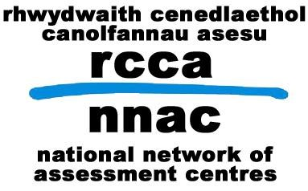

Bangor Access Centre - Complaints Form
Full Name

Address

Postcode

Email Address

Daytime Tel number
How would you prefer us to contact you?
What do you think Bangor Access Centre did wrong? Please include dates of contact if possible.

How has this affected you?

What do you think Bangor Access Centre can do to put things right?

Please continue on a separate sheet if necessary

Please print out and send this form to:

Centre Manger
Bangor Access Centre
Rathbone Hall
College Road
Bangor
Gwynedd
LL57 2DG

You should expect to receive a reply within five working days.

