 |  |  | SAMPLE  Weekly Vehicle Inspection / Maintenance Checklist |  |  |  |  |  |  |  | Note Vehicle Damage:  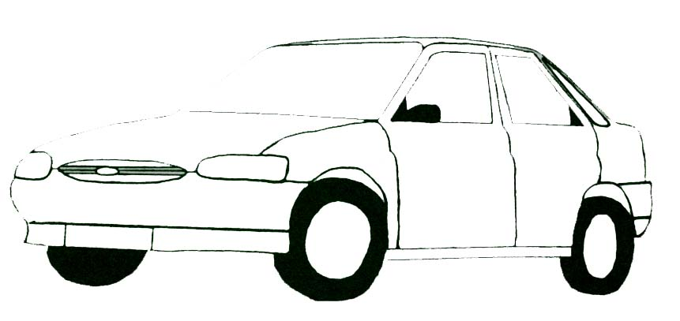  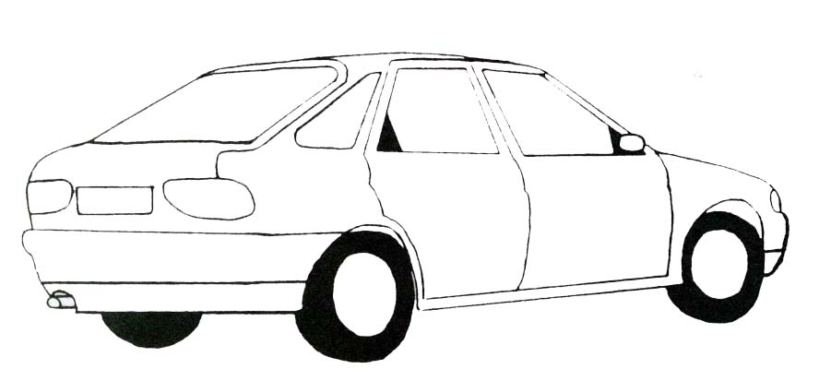
Vehicle:
Registration: |  |  |  |  |  | Mileage:
Mark each item to side with:
 | Satisfactory |  |  |  | Defective |  | N/A |  | Not Applicable
Include any relevant comments:
Windscreen / Windows
(clean / undamaged)
Mirrors
(present / undamaged)
Lights (reversing / head / brake / side / indicators / number plate)
(working / undamaged)
 | Tyre Pressure (incl. spare wheel)  (correct as per guidance) |  |  |  |  |  |  |  |  |  | General Remarks / Further Action:
Tyre Wear (incl. spare wheel)
(minimum 1.6mm tread depth and even wear pattern)
Seat Belts
(available / working)
General Cleanliness
(good / poor)
 | Number Plates  (visible) |  |  |  |  |  |  |  |  |  | Check Completed By:
 | Electric Vehicles: Charging Cable / Connection Point (vehicle & charging point)  (good order / clean) |  |  |  |  |  |  |  |  |  | Date: | Time:

