International Experience Report
Introduction
After finishing the third year of my bachelor’s degree in Sport and Exercise Psychology, I decided to participate in Erasmus+ International Exchange. This program offers a unique opportunity for students to try studying in a different country, or to lay their hands on a real-world work experience. With a help of my professor, Hans-Peter Kubis, I was offered an internship placement in one of the world-leading healthcare technology companies, Philips. My internship started in September 2019 in Eindhoven, the Netherlands, which is the headquarters for Philips Research and the birthplace of the whole company. Prior to the departure, I submitted the risk assessment, which addressed all issues I could possibly encounter before and during my placement (see Appendix A).

Settling down
The first obstacle I had to face was finding accommodation. The Netherlands, and especially university cities, is known for its lack of affordable student housing options. Luckily, after a several months long search, I found a room within a cycling distance from the High Tech Campus Eindhoven, where my internship was taking place. I arrived a few days before the start of my internship and my program for the days was following: firstly, get a bicycle and secondly, register at the municipality and apply for the BSN (Burgerservicenummer, similar to the British NIN). It is illegal to work in the country without BSN, and everyone is obliged to apply for BSN within four months after arrival to the country.
My first day at Philips was full of anticipation. I arrived at the campus, equipped with a map of the place (see Appendix B), which was, at 8.45 am, buzzing with life. I navigated my way to the main Philips Research building, a seven-storey HTC34. Firstly, I had to get a badge, which served as an identification, and it mediated the access to my building and some other places on the campus. I met my supervisors, Nathalie and Francesco, who showed me into my office, which I shared with three other students. Then they explained how the life at the campus works. During my first week, my job was to get to know my workplace, meet other interns, and complete the remaining paperwork in order to begin my internship. Before I dived into my assignment, I had to complete four courses at the Philips University. Employees are not allowed to participate in any research project unless they complete those courses: Introduction to Regulations for Research, Introduction to ICBE processes for Research, Basics in Bioethics: Research Ethics Training for Philips Research EU & USA, and Privacy Compliance in Human Studies (see Appendix C).

My project
My internship fell under the Collaborative Care Solutions. Accordingly, my project topic included an intervention for chronic conditions, namely sleep problems. The matters of managing and treating chronic condition using non-pharmacological methods have been my interest for several years. Some of the modules I took at Bangor University offered an insight into this research area, for instance Introduction to Mindfulness Approaches, Biological Psychology, Physical Activity and Health, and Exercise for Clinical Population. Knowing the expertise of my supervisors, the subject matter of studies currently running in the department and having an idea of what interests me, I had no problems coming up with a research topic.
I and my supervisors decided to design an intervention involving physical activity, stress reducing methods such as mindfulness meditation, and the combination of both (namely yoga) targeting problem sleepers. In order to get the necessary funding, we had to show how my project fitted within the current agenda of the whole department. This was not an issue since there were other sleep-focused studies running at the time and my project was a good complement to it. Soon we received the budget and the green light from the head of the department.
After conducting an extensive literature search, I found that the most common sleep issues are obstructive sleep apnoea (OSA) and insomnia. Firstly, the idea of my internship was as follows: review the available literature on non-pharmacological treatment of sleep issues and the role of behavioural change theories in health interventions, design an online/phone app intervention to improve sleep. The next step was to test the intervention proposal via an online survey tool, adjust the intervention based on the responders’ feedback, test the improved version of the app with real participants (using subjective and, if possible, objective measures), and finally, write a report. Looking back at it, our plan was quite optimistic. In reality, there was not enough time to test the intervention with real participants. I would have needed at least four extra months for that.
In October, I have collected enough information to have a picture of what the intervention should include. Afterwards, I started putting the survey together, as an inspiration I used questions from previous sleep-related survey my supervisors created for different projects. First part of the survey was assessing the nature of participants’ health status, sleep problem, socio-economic background, and their current knowledge of available treatments and their attitude towards different types of treatments. Second part comprised of pictures (screens) of the intervention as a phone app. To do this, we hired an illustrator and held several meetings in which I had to explain the aim of the intervention to a person with no expertise in this area. This was a great experience because interventions like ours are focusing on population with no or little knowledge of this particular research area. Therefore, it is important to be able to explain different problematics in lay terms and make it attractive to potential users. It showed me that there is a large group of people from different backgrounds behind every project. It took a few weeks to finalize the screens of our concept (see Appendix D). The goal of presenting the screens was to get feedback from participant on whether they would use such program, and to examine its strengths and weaknesses.
The most time-consuming part of the process was going through the privacy procedures, which were necessary to get a final approval to launch the survey. Had held meetings with the privacy officer and other people, such as de-identification experts, over the course of four months. We had to consider whether we should ask participants questions about their ethnicity and similar sensitive personal data. We had to break the whole process of data collection down to pieces to examine if every step is in accord with Philips rules. We had to justify why we want to collect different types of data, whether it is necessary and how exactly will the data be used. I learned how to complete Legitimate Interest Assessment document and how to put together a comprehensive privacy notice. The whole process of getting the final approval was stressful, I could see that everyone was busy, especially the privacy officers, and we would spend a considerable amount of time revising what was already agreed a we would triple check everything. It is because the rules are very strict since Philips is a company that makes profit from research. Not complying would have had bad consequences not only for my internship, but also for the whole department.
Once I had all the survey questions ready, I needed to create the final version of the survey in the EFM tool (enterprise feedback management). I have never worked with this tool before, so it was an enriching experience. My supervisor created some other surveys in the program before, so that I had a guide of what it should look like. I could choose functions, such as compulsory question/hidden question, etc. The survey consisted of the short and the long version of privacy notice, click through consent, exclusion criteria, and questions about the participant (age range, gender, health, and sleep problems), concept evaluation, and finally a screen with a code, which participants could use to get a financial compensation for participating in the survey.
Because many products from Philips target American market, we decided to test our concept with US population. This also ensured that the participants would be proficient in English and we would not have to worry about language barriers. We launched the survey via Amazon MTurk (mechanical turk). MTurk displays advertised surveys to Amazon users who, in return for completing them, receive an Amazon voucher. To do this, I created an MTurk advertisement (see Appendix E), which briefly described the nature of the survey and our inclusion criteria. I have never heard about MTurk before and working with it was useful, it is good to know where to create surveys and how to launch them and collect data. Furthermore, the fact that that Philips use EFM and MTurk provides a certain guarantee that they are trustworthy as third parties. At the same time, MTurk was one of the reasons why the privacy processes took so long. We had to examine the mechanisms of data storage and transfer, look into how long the data is normally stored, whether Amazon can access the data and so on. I had no idea that launching a simple questionnaire without any personal data involved (such as names, addresses) would take so long and involve so many people.
Once we finally got the final approval from the ICBE committee (internal committee for biomedical experiments), we published the survey on MTurk and within three days we had data from more than 400 participants. Once we had enough data to have a good statistical power for the analysis, I closed the survey. Firstly, the data went to a de-identification expert, who had to go through all surveys and de-identify free-text fields. It was because although we did not collect names and addresses, the participants could have typed identifiers (such as their name) in open field questions. If one of the research team members saw the identifiable data, it would have been considered a non-compliance.
After receiving the de-identified data set from the de-identification expert, I divided the participants into four groups so I could look for differences between them. The groups were younger males, younger females, older males, and older females. The hypothesis was that older females would be keener on participating in such program as literature suggests that they are the most vulnerable to sleep disturbances, mainly due to menopause and associated physiological, psychological, and social changes. I excluded outliers (those who completed the survey in less time that was needed to carefully attend to each question), and started analysing the data. For the analysis, I was using Excel and SPSS. Although there will not be enough time to test the intervention with real people and measure their sleep improvement (which is a shame because it would have been exciting), I started writing a research report. Unfortunately, the report and the analysis will not be completed before I submit this assignment, so I will not be able to share our exact findings. Furthermore, there are strict confidentiality rules at Philips that do not allow students to share details about Philips projects.

Insights
This internship fit well in the curriculum of my bachelor’s degree. During the course of three years of studying Sport and Exercise Psychology at Bangor University, I learned about the link between mental and physical health and about psychological phenomena, which impair physical performance. Although I cannot see myself as a sport psychologist working with professional athletes or a sport team, the topics we covered during lectures at Bangor can be applied on general population and in any context, not solely high-level sport. Therefore, during designing the intervention I considered the impact of stress and mind set on sleep, whereof I have only heard in the context of sport. It was a valuable experience to see how with a little adjustment, things I have learned about at university can be implemented into public health interventions and beyond.
Working for Philips was a great opportunity to look into the non-academic research world. I had the pleasure to meet researchers and interns from various backgrounds, mainly artificial intelligence, computer science, product design, and biomedical engineering. I would compare the whole company to a beehive where each bee does its job, which may seem small and not very significant, but altogether they create a great functioning organism.
I deepened my knowledge of statistics and for the first time I did a qualitative analysis. I analysed the free-field questions where our participants shared their concerns and motivations regarding engagement in a behavioural change intervention towards better health. I believe it was useful as in the field of psychology it is important to recognize repetitive patterns and address them in interventions. I have learned to use tools I did not know before (MTurk, EFM), and I got a notion of what my career path could look like if I decide to do a PhD or if I apply for a job in a big company. My internship helped me to develop better communication skills. In meetings, I had to talk to people who come from a different background as well as the experts in the area. I enhanced my sense of responsibility. My supervisors were busy with other projects, and often left me in charge of the whole project, for which I am grateful. Except for my academic knowledge, I had to use a great deal of common sense and self-management skills. Apart from working on my project, my supervisors would let me participate in other studies running in the department, for which I am thankful too.
After I finished the third year of bachelor’s I felt like I did not possess great skills and knowledge and I was uncertain about my employability options. This internship encouraged me and showed me that I can pursue more than I thought I could. Furthermore, working for a healthcare company gave me a direction of where I want to go with my education. I decided to apply for MSc in Health Psychology, which was partially because I grew more interested into the link between the body and the mind.

(Out-of)-work experience
Philips has an intern community (PIC-Phillips intern community) which members run both, Philips-related, and Philips-unrelated activities. I became a member of the PIC board and every Monday we would meet for lunch and discuss next week’s plan. Except for weekly PIC lunches and at the campus, we would go out together during the weekends, for instance, to visit the Philips museum or to take a trip to Amsterdam. Especially interesting were the biweekly knowledge-sharing activities in which one of the interns prepared a short presentation about their project (as long as it was not strictly confidential) or would talk about what they studied at university. A senior Philips employee whom we called ‘The Professor’ was partaking in the PIC events as well, in the role of a supervisor. Every month he presented a lecture about writing a thesis, designing a research study or a similar topic. Those lectures were taking place in the auditorium on the HTC and many students attended. There were interns from all round the world including Dutch interns who introduced us to the local culture.
There are many expats in the Netherlands, and Eindhoven, with its two universities and the High-Tech campus is not an exception. Mostly everybody speaks English, which I knew before arrival, so I was not concerned about the language barrier. Furthermore, my (limited) knowledge of German made it considerably easier to understand written Dutch. In October, the Dutch Design Week (DDW) took place. Eindhoven, as a high-tech city with a design academy is a perfect place for such events. During the course of nine days, there were art installations of well-known artists, night museum tours, social happenings, and one of the building of former Philips factories turned into place where artists presented their work. It was an exciting week and I hope to come back to see this event in 2020.
A few weeks later, there was a GLOW festival of light. Each year, there is a different theme for the festival, and it reminds people of the beginnings of Philips, which started by selling light bulbs. There were art exhibitions in public places all around Eindhoven from local and international artists. I was surprised how much local people and the city council cherish their heritage and organize various events, which attract people from all around the world. DDW and GLOW were just a fraction of what Eindhoven had to offer during the first semester of my internship. There were live concerts, cinemas (most of screenings were in English), public lectures, museums and galleries.
Eindhoven has a convenient location, so I got the chance to visit Antwerp in Belgium, and other beautiful Dutch cities such as Leiden, Rotterdam, and Maastricht. However, I planned the majority of travelling and exploring the country for spring and summer. After I returned to the Netherlands after the Christmas break, there was another event to attend, the Carnaval. The Dutch Carvanal starts six weeks before Easter and it is a time of feast, colourful costumes, and joy. It celebrates the beginning of spring and the transition from dark to light. In practice, it looked like a huge celebration of life and people dressed into the most bizarre costumes, sang, and danced. I was already familiar with the concept of Carnaval, there is a similar tradition in the Czech Republic and, I believe, in neighbouring Germany as well. Unfortunately, Carnaval was the last major even before the COVID-19 outbreak.

Lockdown in the Netherlands
After the majority of European countries declared the state of emergency and started preparing anti-COVID measures, I had two options. I could have flown back to the Czech Republic or stay in the Netherlands. I decided to stay. Philips employees were instructed to work from home if possible. Fortunately, I did not need to access any facilities at the HTC to work. Other interns had to postpone their graduation dates because they could not access labs and could not finish their projects. I enjoyed working from home as it was more flexible and I did not have to cycle for 20 minutes every morning regardless of the weather (which was similar to the Welsh weather, windy and rainy). Every week we would receive collective e-mails from the Philips CEO in which we were informed about the current course of events, how it affects Philips, and predictions for the proximal future. Of course, the lockdown slowed down the work process and made communication with my supervisors more challenging. However, I appreciated the way Philips dealt with the situation and kept all employees informed.
Looking at the situation in the Czech Republic and in the UK, the Netherlands was a better place to be. The Dutch government handled the situation well, all people knew what was happening, and everyone abided the rules. Although COVID did not have a major impact on my internship, it ruined my plans for the second semester. I was going to explore the country and visit friends in other cities.

Overall Experience
Netherlands is a small and beautiful country with rich history. As an art lover, I appreciated the number of galleries and museums dedicated to Dutch masters such as Vincent van Gogh and Rembrandt. My internship ends at the end of May but I might stay in the Netherlands for a few months longer to visit the places I did not get a chance to see due to the lockdown.
There is a noticeable difference between visiting counties as a tourist and living abroad. I became aware of this when I first moved from the Czech Republic to Bangor nearly four years ago. However, Bangor University provided a great support to the newcomers, so I felt like if anything goes wrong, there is always a place to go for an advice. Furthermore, before I moved to Wales, I was already proficient in English, which made it easier. Thanks to this experience, I was not stressed about moving to the Netherlands.
One of the things people who never lived abroad do not realize is the effort it takes to understand how everything works. It starts with registration at the council, getting the right insurance, calculating the taxes, creating a bank account (because as I found out later, many ventures only accept payments from Dutch accounts), acquainting oneself with public transportation, and learning the basic law. Luckily, as there are many internationals in the Netherlands, the government website and Eindhoven website are available in English. There are also online expat forums where internationals help each other with any problems they encounter.
After living in the UK for three years, I became comfortable. Moving to the Netherlands opened my eyes again and showed me that sometimes the ability to speak English is simply not enough. It made me realize how much determination is needed for moving to country which language I do not speak. I became aware of the importance of learning about the history, culture, and traditions of the country where I live in order to fit in. This internship made me want to explore more countries I am not familiar with. After I finish my master’s, which will be either in the UK or in the Netherlands depending on the lockdown situation, I would like to move to yet another country, perhaps Germany or France. I feel like stepping out of one’s comfort zone and facing unknown challenges strengthens the character and teaches people to deal with pressure.

Conclusion
Before I started my internship, I tried not to have high expectations. Moving abroad is always a risk and it can happen that it does not turn out as great as one has imagined. Although there were uncomfortable situations and various challenges for me to deal with, my overall impression of this international year was very positive. I met new friends with whom I will keep in touch even after my internship ends. Living in the Netherlands made me more interested in the country so I am sure I will be coming back for regular visits. Lastly, although cycling every day during winter is bothersome, I cannot imagine living without a bike anymore.

Appendices
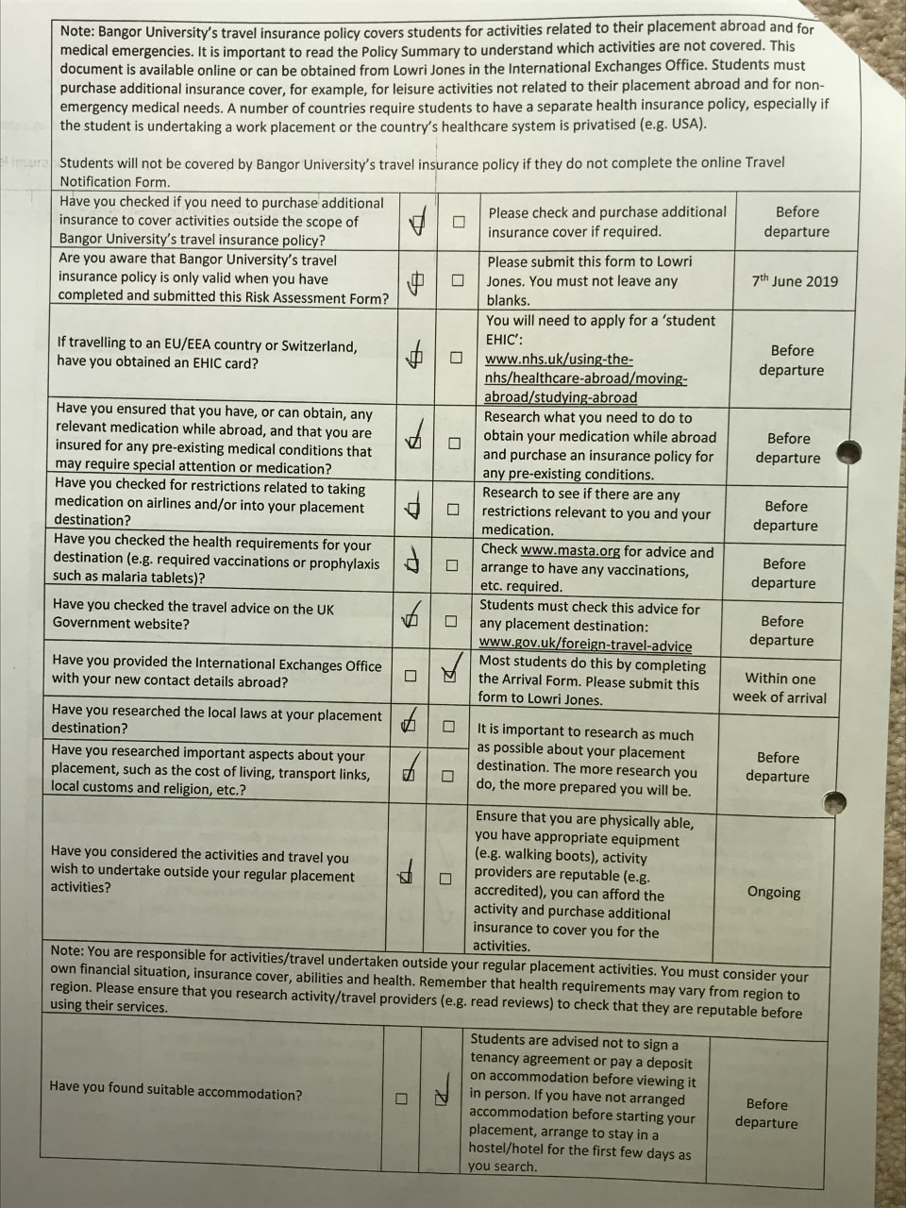
Appendix A: Risk assessment form

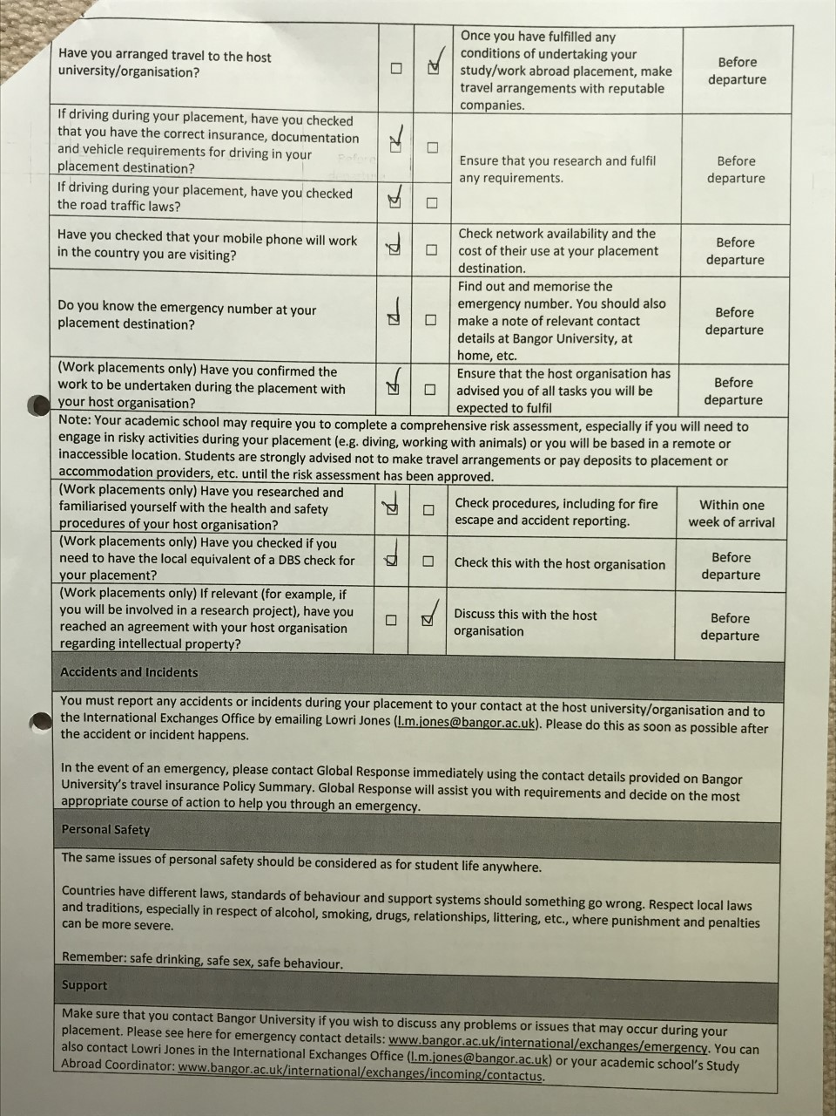
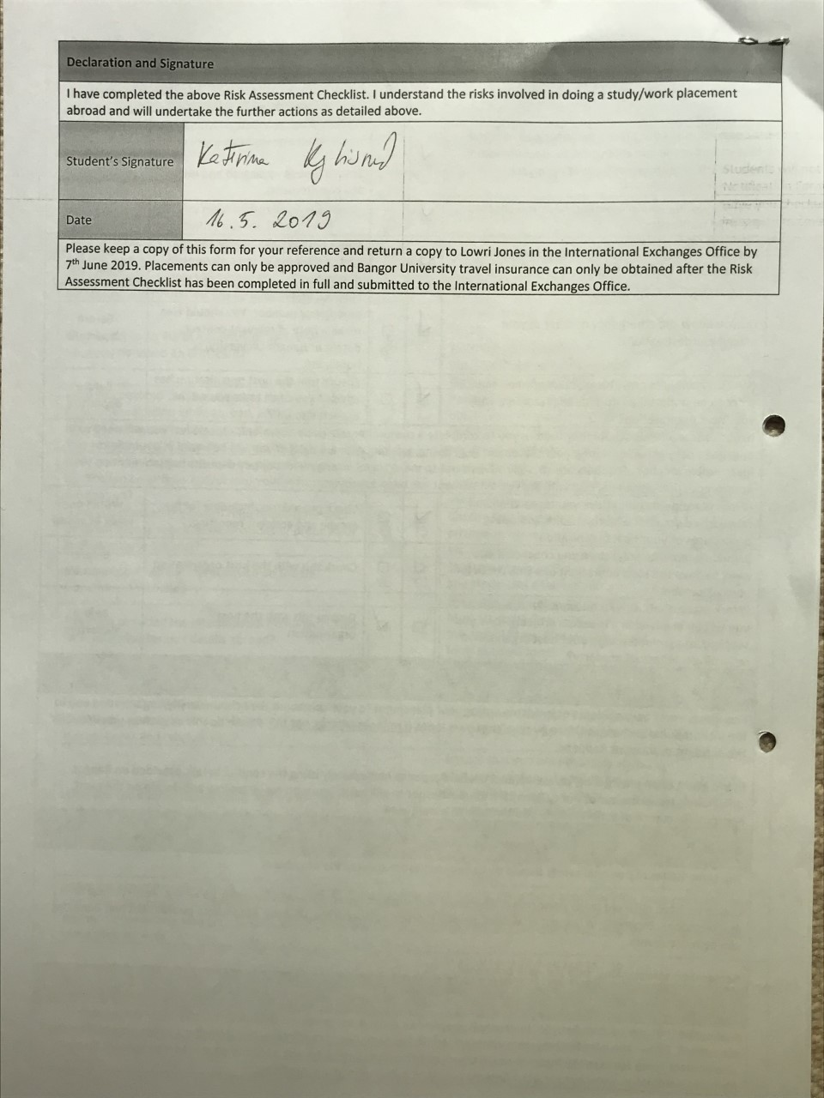
Appendix B: The High-Tech Campus Map
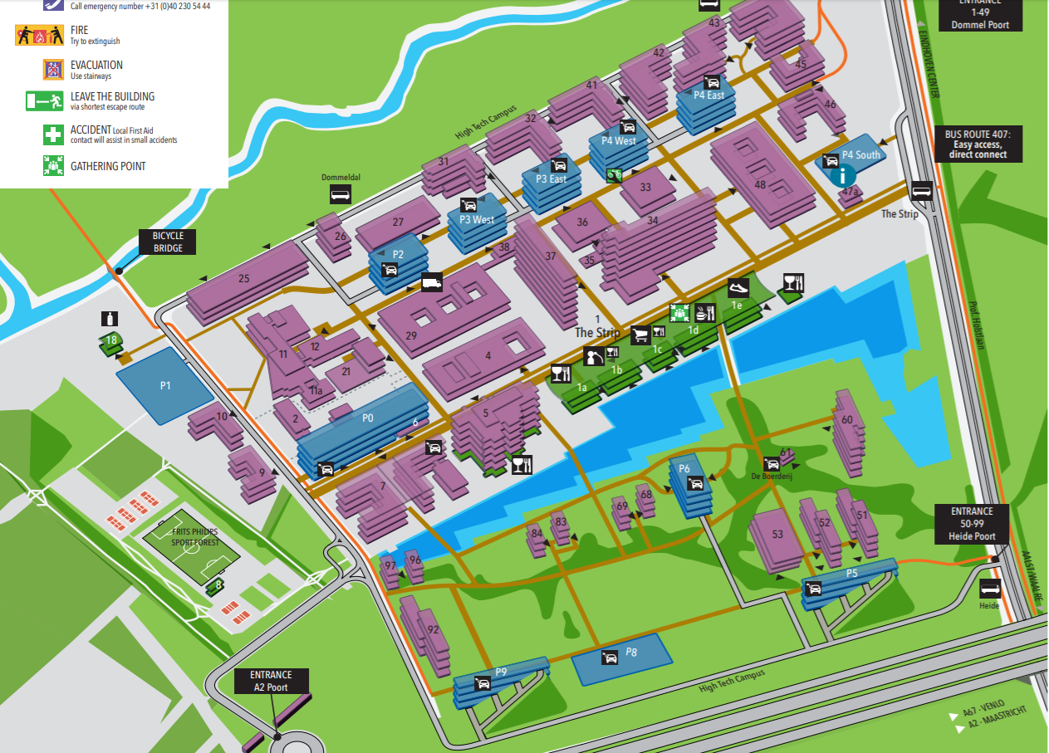

Appendix C: Privacy Compliance in Human Studies Course Certificate
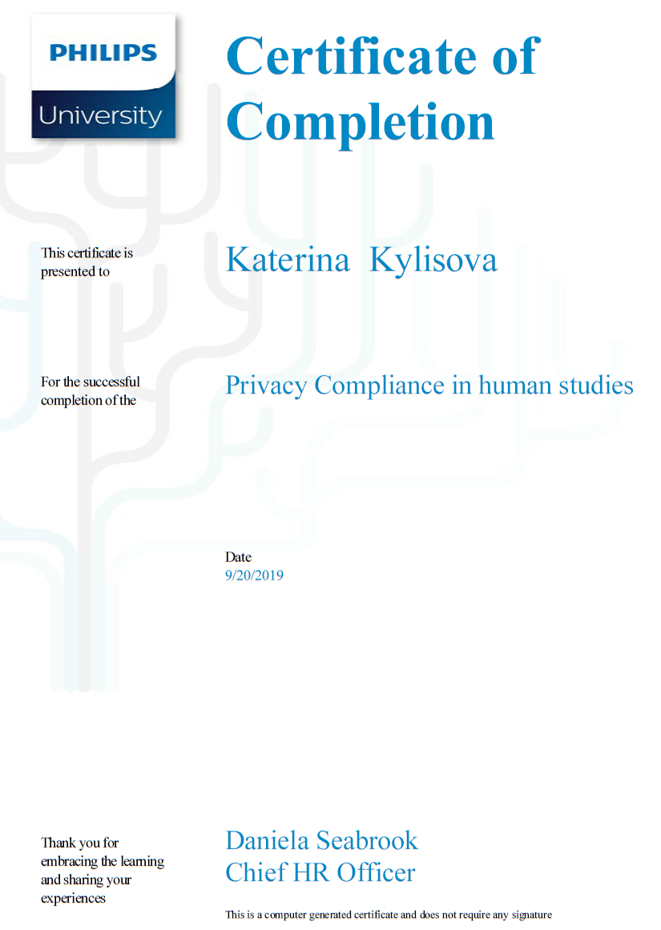

Appendix D: The welcome screen of the Body&Mind for better sleep intervention
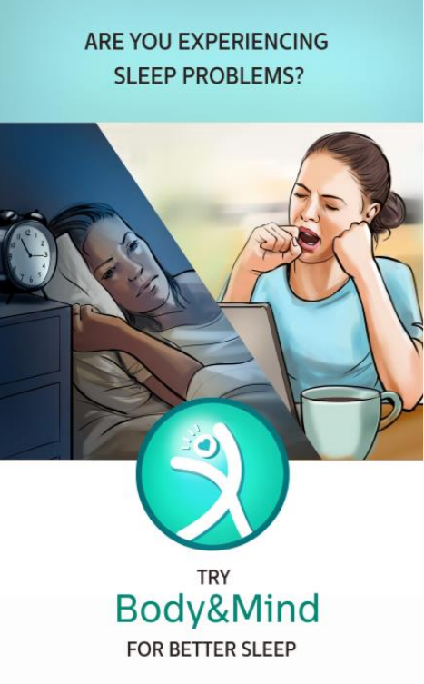

Appendix E: MTurk advertisement

Body&Mind for Better Sleep MTurk Advertisement
Description:
For a concept evaluation around Physical Activity, Relaxation, and Sleep, we are looking for participants between 30 and 65 who are experiencing problems falling asleep or staying asleep at night and who are willing to complete a survey.
For this:
- You’ll be asked social-demographic questions about yourself
- You’ll be asked questions about your sleep problem and general health
- You’ll be presented with our concept and will be asked to provide a feedback about it
Key words:
Sleep problems, Insomnia, Intervention
Reward:
8$ per hour, the survey will take 20 to 30 minutes to complete, therefore the compensation will be around 4$ for the survey.
The data will be analysed by Philips Healthcare and kept strictly confidential.

