

WHISTLEBLOWING
(PUBLIC INTEREST DISCLOSURE)
POLICY AND PROCEDURES

Date | Purpose of Issue/Description of Change | Equality Impact Assessment Completed
8 June 2015 | Amendment and reissue – Version 2 | 28th July, 2015
16 July 2018 | Review and re-approval – version 3
16 October 2020 | Review and re-approval – version 4
September 2023 | Review and re-approval – version 5
19 March 2026 | Full Review following Temperature Check Report
3 July 2026 | Minor amendment approved through Compliance Committee Chair’s Action

Policy Officer | Senior Responsible Officer | Approved By | Date
Head of Legal Services | University Secretary | Compliance Committee | 19 March 2026

This Policy will be reviewed at least every two years

1. Introduction

  - Bangor University is committed to the highest possible standards of openness, integrity and accountability and seeks to conduct its business in a responsible manner, taking into account the requirements of its funding bodies and the expectations of the Ethics & Integrity Commission (formerly Committee on Standards of Public Life). In line with that commitment, we encourage staff, students and other members of the University who have serious concerns about any aspect of our work to come forward and voice those concerns.

  - The Public Interest Disclosure Act 1998 gives legal protection to workers who make certain disclosures of information in the public interest. It is expected that an employee will faithfully serve his or her employer and not disclose confidential information about the employer’s affairs. However, this policy permits members of the University to speak freely, and to raise at a high level any serious concerns which they might have about apparent malpractice within the University without fear of adverse repercussions or reprisals provided that they act lawfully, without malice, and in the public interest.

  - Protection under the Act does not extend to students and other non-employees. However, Bangor University is committed to the protection of all those who raise concerns in the public interest. In addition to staff, this policy and procedure may also be used by other members of the University (as defined in the Ordinances), including members of the Council, members of the Court, and students.

  - The University considers it reasonable to expect those who have such concerns to use this procedure rather than air their complaints outside the institution.

2. Definition of Whistleblowing

The definition of whistleblowing adopted by Bangor University:

Whistleblowing is the disclosure of information by an individual about suspected wrongdoing or risks within the organisation that are in the public interest and fall outside normal line-management reporting procedures.

3. Aims and Scope of this Policy

3.1 This policy aims to provide avenues for members of the University to raise serious concerns, disclose information in circumstances which the individual believes shows malpractice, and receive feedback on any action taken. It also creates mechanisms so that the matter can be taken further if there is dissatisfaction with the University's response.

3.2 In addition to this policy, a number of other policies and procedures are already in place within the University including grievance, dignity at work and study (bullying), complaints, harassment and disciplinary procedures which should be followed in relation to such matters.

3.3 This Policy is not intended to preclude matters of concern being raised by the recognised Trade Unions through the agreed joint consultation procedures.

3.4 This ’whistleblowing’ policy is intended to cover concerns which are in the public interest and may (at least initially) be investigated separately, although the invocation of the procedures outlined in 3.2 above might be a consequence of the investigation of the concern which is disclosed.

3.5 The University will treat all disclosures made under this Policy in a consistent and fair manner. All disclosures will be acknowledged, recorded and reviewed.

3.6 The types of concerns which the Act is intended to cover include:

- criminal offences – this may include financial malpractice or fraud.
- criminal activity in supply chains – this may include modern slavery or human trafficking.
- failure to comply with legal obligations; including breaches of the University's Charter, Charity Law or other regulations.
- miscarriages of justice.
- allegations of sexual harassment.
- endangering the health and safety of University members or the local community.
- damage to the environment; and
- any attempt to conceal any of the above.

This list is not intended to be exhaustive, and members of the University are encouraged to use this policy on occasions where they believe they have discovered any malpractice or impropriety.

3.7 In relation to section 3.4 above it is immaterial where the reported concern occurred (whether it occurred in the UK or in any other country or territory) as long as it relates to the business of the University.

3.8 A disclosure of information is not a qualifying disclosure if the individual making the disclosure commits an offence by making it, however the University may still choose to investigate the allegation made.

3.9 This document does not establish a mechanism for questioning academic, business or financial decisions already taken by the University; nor does it provide a means for reconsideration of any matters already addressed under existing harassment, complaint or disciplinary procedures, or of matters which should properly be considered under those procedures; nor does it relate to the malpractice or wrongdoing of students.

3.10 In some cases, a concern may be more appropriately addressed under a different University policy or procedure.

The following policies are particularly relevant:
- Counter Fraud Policy and Fraud Response Process.
- Anti-Bribery Policy

4. Safeguards

4.1 Protection

This policy is designed to offer protection to members of the University who raise a concern in accordance with the procedure in section 5 below and who are acting both in good faith and in the reasonable belief that the disclosure tends to show malpractice.

4.2 Confidentiality

The University will treat all disclosures made in accordance with this policy in a confidential and sensitive manner. It will therefore endeavour to keep confidential the identity of the person who has raised the concern. However, it must be appreciated that the investigation process may reveal the source of the information and that a formal statement from the original complainant may be required as part of the investigative process.

The University will also take all reasonable steps to ensure that members of the University who have raised concerns under this procedure will not be victimised in any way by other members of the University. Victimisation or other detrimental treatment of an employee, student or other member of the University, as a result of that person raising concerns under this policy in good faith, will be treated as a serious disciplinary offence under the University’s disciplinary procedures.

4.3 Anonymous Allegations

This policy encourages members of the University to put their name to any disclosures they might make. Concerns expressed anonymously are much less powerful, but they will be considered at the discretion of the University.

The factors which the University will take into account when exercising this discretion include:

- the seriousness of the issues raised;
- the credibility of the concern; and
- the likelihood of confirming the allegation from attributable sources.

All anonymous allegations will be passed to the Whistleblowing Officer for consideration. The University may not be able to properly establish whether anonymous allegations are credible without being able to ask an individual for more details or for clarification, and this makes it more difficult to reach an informed decision.

4.4 Unfounded Allegations

If an allegation made in good faith is not confirmed by subsequent investigation, the University will take no action against the person who originally raised the matter. If, however, an individual makes malicious or vexatious allegations, and particularly if that person persists with making them, disciplinary action may follow.

PROCEDURES

5. Rules for Making a Disclosure

Under the Public Interest Disclosure Act 1998 an individual will be protected when making a disclosure as long as:

- The information disclosed is made in good faith.
- The person making the disclosure believes it to be substantially true.
- The person making the disclosure is not acting maliciously or making false allegations.; and
- The person making the allegation is not seeking any personal gain.

In addition, under the Employment Rights Act 2026 an individual raising a concern that sexual harassment has occurred, is occurring or is likely to occur, will be protected from detriment and dismissal under this Whistleblowing Policy.

6. Procedure for Making a Disclosure

6.1 STEP 1 - Initial Point of Contact

Any member of the University who wishes to use this policy to make a disclosure should report the concern to the Whistleblowing Officer. The Whistleblowing Officer for Bangor University is the University Secretary.

A disclosure can be made to the University’s dedicated email address:
whistleblowing@bangor.ac.uk

The mailbox will be monitored by the University Secretary, but also by the Head of Governance and Risk, and the Governance, Risk and Corporate Events Officer to enable effective triaging of matters in a timely manner. If the disclosure concerns any of these officers, then the disclosure should be made directly to the Vice-Chancellor’s mailbox: vice-chancellor@bangor.ac.uk.

Matters will be logged as either whistleblowing concerns, or the individual will be directed to other University processes and procedures where it is appropriate to do so (e.g. Grievance Policy and Procedure (Ordinance 27)).

If the person wishing to express concern considers it inappropriate to raise the matter with either the University Secretary or the Vice-Chancellor, the concern should be reported either to the Chair of the Audit and Risk Committee (if the issue falls within the remit of that Committee) or the Chair of Council. They will then become Designated Officers under this procedure. In addition, and in the event of an unforeseen extended absence of the Whistleblowing Officer, the matter will be passed to the Vice-Chancellor or a Designated Officer as appropriate. In the absence of the Vice-Chancellor the matter will be passed to a Designated Officer.

If a concern raises issues of financial malpractice, the Whistleblowing Officer (or, as outlined above, the Designated Officer) will be expected throughout to act in close consultation with the Vice-Chancellor (as the Accounting Officer of the University) and the Chief Financial Officer.

The Whistleblowing Officer can appoint a nominee to undertake Step 2 below where it is appropriate to do so.

All allegations received by the Whistleblowing Officer will be::

- treated confidentially, and only raised with other staff where absolutely necessary to take forward any investigation
- acknowledged within five working days;
- recorded;
- reviewed and assessed to determine the appropriate course of action, and
- where appropriate, investigated. Where an investigation is undertaken this should, normally be concluded within 30 working days. If this timescale proves difficult due to the complexity of the case the individual raising the concern must be kept fully informed.

6.2 STEP 2 - Action to be taken by the Whistleblowing Officer / Designated Officer

Following review of the disclosure, and where an investigation is the appropriate course of action, the Whistleblowing Officer / Designated Officer will acknowledge receipt of the concern and will note the likely timescale of any investigation. The Whistleblowing Officer / Designated Officer will consider the information which has been presented and determine the form of the investigation to be undertaken. This could result in a decision:

- to investigate the matter internally.
- to refer the matter to the police.
- to call for an independent inquiry where a level of independence is deemed necessary.
- to pursue the investigation by more than one of these or other means.

In exceptional cases, the Whistleblowing Officer / Designated Officer may decide not to investigate or take any further action. In which case, the complainant and the Audit and Risk Committee will be informed, in line with reporting procedures in 6.5 below.

If it is decided to investigate the matter internally, the Whistleblowing Officer / Designated Officer will then consider how to establish whether there is a prima facie case to answer. This consideration will include determining:

- who should undertake the investigation.
- the procedure to be followed.
- the scope of the concluding report.
- where the information relevant to the investigation may be held and securing the information (where relevant).

At all times, matters will be kept confidential and only discussed where absolutely necessary in order to take forward the investigation.

The Whistleblowing Officer / Designated Officer can raise the matter, informally, with the Chief People Officer in order to obtain further advice prior to undertaking the investigation. In addition, the Whistleblowing Officer / Designated Officer will seek advice from the Chief People Officer to ensure that the individual bringing forward the concern is provided with advice and support. In the event of the Chief People Officer being the subject of the concern, the Deputy Chief People Officer would be consulted.

6.3 STEP 3 - Internal Investigation

Investigations will not be undertaken by Whistleblowing Officer / Designated Officer. Normally, another independent officer (the “Investigating Officer”) within the University will be asked, by the Whistleblowing Officer / Designated Officer, to undertake the investigation.

The Investigating Officer will be required to undertake the investigation as sensitively and speedily as possible and to submit a written report to the Whistleblowing Officer / Designated Officer. The Investigating Officer will be provided with administrative assistance to aid the investigation.

The Investigating Officer will conduct interviews with relevant individuals and possible witnesses as is appropriate. This will include the individual who made the initial disclosure and will also include the individual whom the concern has been raised against. Any individual interviewed under this procedure will be provided with support and will be entitled to be accompanied at any meetings by a colleague or trade union representative. Written notes of all interviews will be prepared, and the interviewee shall be given an opportunity to review the notes for accuracy before they are finalised.

The Investigating Officer may recommend that evidence which becomes available as a result of investigations under this Policy may be referred for action as detailed below:

- Disclosures involving an allegation of misconduct, discrimination or harassment by a member of staff (Student Complaints Procedure / Grievance Policy and Procedure / Disciplinary Policy and Procedure)

- Disclosures involving an allegation of harassment, bullying, unfair treatment, victimisation or identity-based discrimination by a student (Dignity at Work and Study Policy, Student Complaints Procedure, General Regulations for all Students);

- Disclosures involving an allegation of misconduct by a student (General Regulations for all Students, Regulation for Student Discipline).

- Actual or suspected incidences of fraud (Counter-Fraud Policy and Fraud Response Process)

The Investigating Officer will also consider and make a recommendation on whether the report can be shared with the individual making the disclosure, and the individual(s) about whom the disclosure was made. This will be dependent on the content of the report, which may contain confidential, sensitive and / or personal data. If possible, consideration should be given to providing a redacted version of the report or a summary to the individual making the disclosure.

Upon receipt of this report the Whistleblowing Officer / Designated Officer will decide whether any further action is required by the University. This could include invoking other established internal processes including disciplinary or grievance procedures, undertaking a special investigation or deciding to refer the matter to an external authority (such as the police, regulatory authorities, or other bodies) for further investigation.

6.4 STEP 4 - Feedback

The Whistleblowing Officer / Designated Officer will inform the member of the University who expressed the concern (where known) at the earliest opportunity of what action, if any, is to be taken.

The Whistleblowing Officer / Designated Officer will also ensure that the person or persons against whom the initial allegation was made is informed of the allegation and the evidence supporting it and has the opportunity to comment before any investigation or further action is concluded.

The individual raising the concern will be invited to complete a short, anonymous survey, on their satisfaction with the process. The outcomes of which will feed into the Key Performance Indicators (KPIs) set out in Appendix 1.

6.5 STEP 5 - Review of Decision

If the Whistleblowing Officer / Designated Officer has decided that no further action should be taken, the individual concerned must be informed in writing of the reasons for this and given the opportunity to request a review of the decision to another appropriate person (the Designated Reviewer).

Designated Officer: Designated Reviewer:
University Secretary (Whistleblowing Officer) Any other Designated Officer
Vice-Chancellor Any other Designated Officer
Chair of Audit and Risk Committee Chair of Finance Committee or Deputy Chair of Council in the absence of the Chair of Finance Committee
Chair of Council Deputy Chair of Council or Chair of Finance Committee in the event of the Deputy Chair of Council’s absence

The Designated Reviewer will be required to consider all the information presented, the procedures followed after the initial disclosure was made and the reasons given for not taking any further action. The outcome of this consideration will be either to confirm that no further action by the University is required or that further investigation is called for in accordance with the procedures outlined in steps 2 and 3 above. If the earlier decision to take no action is upheld that will be the end of the matter.

6.6 STEP 6 – External Review

A person who remains dissatisfied after all internal mechanisms for dealing with a complaint or concerns have been exhausted may take their concern to the Chair of the Audit & Risk Committee. If the Chair of the Audit & Risk Committee was the original Designated Officer the individual can refer their concerns to prescribed people and bodies. These are mainly regulators and professional bodies but include other persons and bodies such as MPs. The relevant prescribed person depends on the matter of the disclosure and a complete list of prescribed persons can be found on the government website.

7. Reporting of Outcomes

Any Whistleblowing Officer / Designated Officer to whom a disclosure is made is required to prepare a report of the disclosure and the subsequent actions taken and to forward this to the University Secretary who will retain all such reports for a period of three years from the date of the initial disclosure. The University Secretary will ensure that in all cases a report of the outcomes of any investigation is submitted to the Audit and Risk Committee in order to allow the Committee to monitor the effectiveness of this disclosure procedure. In addition, an anonymised report outlining the concern raised, and the outcome of the investigation will be submitted to the People & Culture Committee in order that wider matters relating to University culture can be explored and assurance provided. Such reports will normally be in summary form, but in the event of a disclosure relating to matters within the purview of the Audit and Risk Committee, a full report must be submitted.

8. Misuse of Policy and Procedures

As outlined above, employees and other members of the University will be protected by the University against any victimisation as a result of proper use of the procedures laid out in this policy. However, frivolous, vexatious or malicious allegations may be dismissed and may result in appropriate disciplinary action being taken against the discloser.

Discouraging a member of staff from bringing forward a concern under this Policy will be considered a disciplinary offence and will be taken forward under the appropriate Human Resources procedures.

Disclosure to the media is not normally covered by this policy. According to guidance published by the Department for Business and Industry, “if a worker goes to the media, they can expect in most cases to lose their whistleblowing law rights.”

9. Awareness Raising

The University is committed to ensuring that this Policy is promoted to all members of staff and members of Council. Training on how to raise a concern will be provided, and a dedicated webpage has been developed to provide further guidance on whistleblowing procedures.

REPORTING

The University Council, through the Audit & Risk Committee, will receive an annual report related to whistleblowing, which will include how incidents have been managed and what lessons have been learnt.

In addition, the Audit & Risk Committee, and the People & Culture Committee will receive anonymous reports following the conclusion of each whistleblowing investigation.

Appendix 1

WHISTLEBLOWING KEY PERFORMANCE INDICATORS (KPIs)

These KPIs will be reported as part of the Annual Report on Whistleblowing to the Audit & Risk Committee.

KPI 1: Reporting and Awareness

These KPIs measure whether staff understand and use the whistleblowing process.

- Number of whistleblowing concerns raised per year
- Percentage of concerns raised through the dedicated email address

KPI 2: Responsiveness and Timeliness

These KPIs monitor how effectively the organisation receives, acknowledges, and investigates disclosures.

- Percentage of whistleblowing reports acknowledged within the policy’s stated timeframe
- Average time taken to complete investigations compared to the policy benchmark.
- Percentage of cases concluded within the agreed timescale.

KPI 3: Quality and Outcomes of Investigations

These KPIs assess whether concerns are dealt with properly, consistently, and with integrity.

- Percentage of upheld disclosures
- Percentage of investigations resulting in corrective or preventative action
- Number and type of systemic issues identified

KPI 4: Protection and Trust

These KPIs ensure that whistleblowers feel safe and that the organisation meets its legal obligations under PIDA.

- Number of allegations of detriment or retaliation following a disclosure
- Percentage of whistleblowers who report they felt safe raising concerns
- Percentage of disclosures made anonymously.

KPI 5: Governance and Assurance

These KPIs help the Council and the Audit & Risk Committee monitor the effectiveness of the system.

- Annual Whistleblowing Report completed and submitted to the Audit & Risk Committee on time.
- Compliance rate with internal policy requirements.
- Yearly reminder of the whistleblowing procedures in the Bulletin.
- Internal audit assurance rating for the whistleblowing process (e.g., substantial / reasonable / limited assurance).

KPI 6: Continuous Improvement

These KPIs measure how Bangor University learns from whistleblowing activity.

- Number of policy or process improvements implemented as a result of whistleblowing findings.
- Bi-annual review of policy completed and approved within schedule.
- Percentage of recommendations from investigations successfully implemented within the set timeframe.
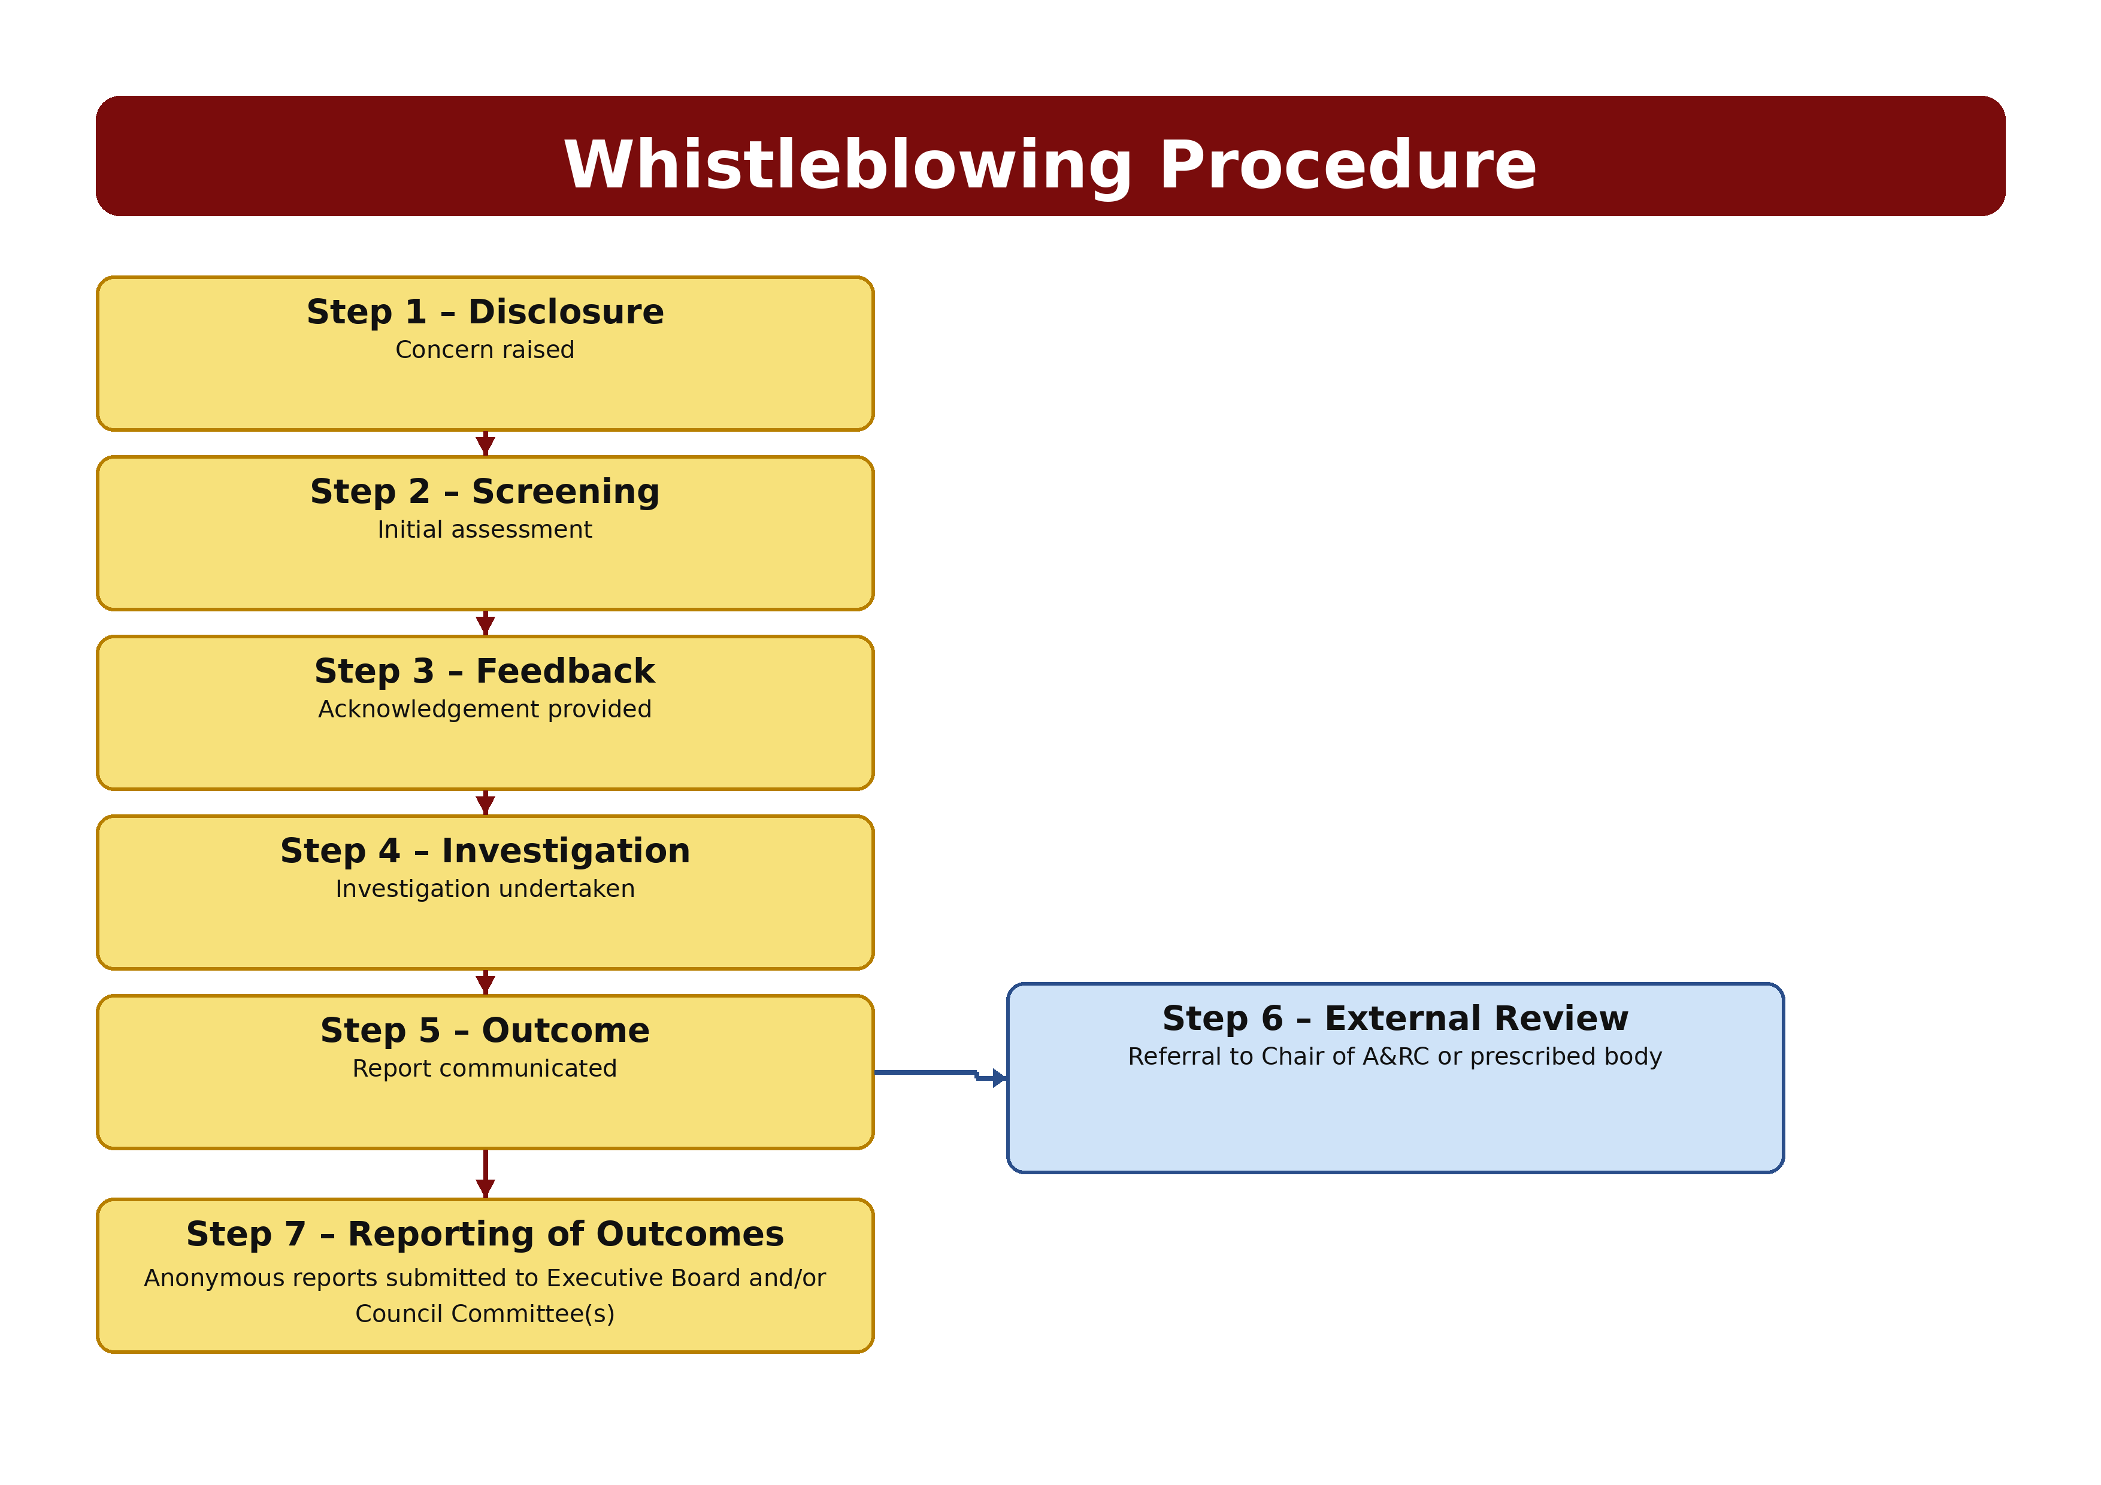

https://eic.independent-commission.uk
GOV.UK – Information for Whistleblowers. Defines whistleblowing as when an employee or former employee reports suspected wrongdoing at work, officially described as “making a disclosure in the public interest.” ACAS – Whistleblowing at Work: The Law. Describes whistleblowing as the action taken to report wrongdoing at work that affects others, legally known as “making a disclosure in the public interest.” Public Interest Disclosure Act (PIDA) 1998 – Interpreted through FCA Regulatory Guidance. Sets out the statutory definition of a “qualifying disclosure”, covering criminal offences, breaches of legal obligations, miscarriages of justice, serious health and safety risks, environmental damage, and the concealment of such matters.
https://www.gov.uk/government/publications/blowing-the-whistle-list-of-prescribed-people-and-bodies--2
https://www.gov.uk/government/publications/whistleblowing-guidance-and-code-of-practice-for-employers

