Helpful DECISION TOOLS, to establish if your study is research,
And is NHS Ethics or CAG approval required?
http://www.hra-decisiontools.org.uk/research/
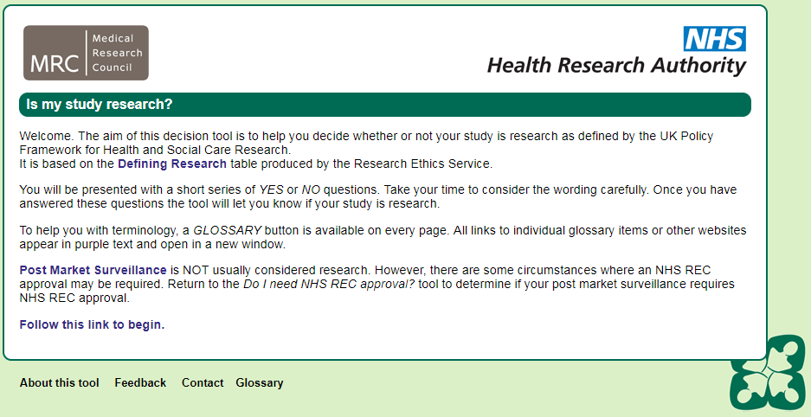
http://www.hra-decisiontools.org.uk/ethics/
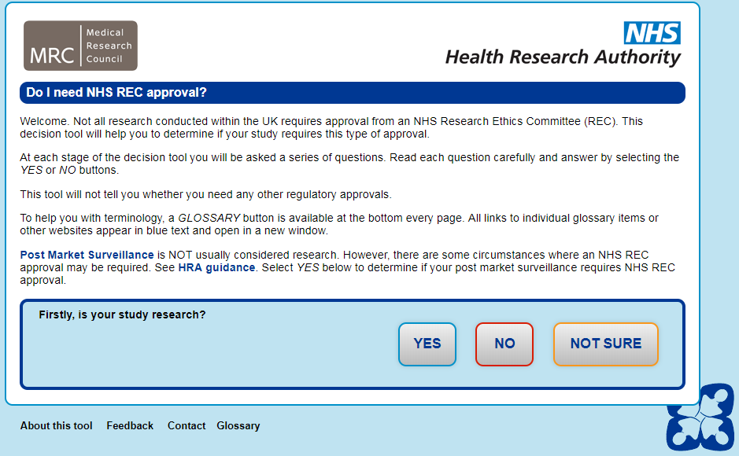
http://www.hra-decisiontools.org.uk/CAG/
