 |  |  | SAMPLE  Monthly Vehicle Inspection / Maintenance Checklist |  |  |  |  |  |  |  | ENGINE FLUIDS
 |  |  |  |  |  |  |  |  |  |  |  | Oil Level
Vehicle: |  |  |  |  |  |  |  |  |  |  |  | Brake Fluid
Registration: |  |  |  |  |  | Mileage: |  |  |  |  |  | Coolant
 |  |  |  |  |  |  |  |  |  |  |  | Power Steering Fluid
Mark each item to side with:
 | Satisfactory |  |  |  | Defective |  | N/A |  | Not Applicable |  |  | Screen Wash
 |  |  |  |  |  |  |  |  |  |  | INTERNAL / SYSTEMS
Include any relevant comments: |  |  |  |  |  |  |  |  |  |  |  | Wheel  (spare / jack available)
EXTERNAL
 | Bodywork  (dents / scrapes / rust) |  |  |  |  |  |  |  |  |  |  | Vehicle Manual / Handbook  (available)
 | Windscreen / Windows  (clean / undamaged) |  |  |  |  |  |  |  |  |  |  | Seat Belts  (available / working)
 | Mirrors  (present / undamaged) |  |  |  |  |  |  |  |  |  |  | Warning Triangle  (available)
 | Lights (reversing / head / brake / side / indicators)  (working / undamaged) |  |  |  |  |  |  |  |  |  |  | First Aid Kit  (available)
 | Fuel Cap  (present / working) |  |  |  |  |  |  |  |  |  |  | Horn  (sound briefly to check working)
 | Tyre Pressure (incl. spare wheel)  (correct as per guidance) |  |  |  |  |  |  |  |  |  |  | Cleanliness  (good / poor)
 | Tyre Wear (incl. spare wheel)  (minimum 1.6mm tread depth) |  |  |  |  |  |  |  |  |  |  | Brakes  (working)
 | General Cleanliness  (good / poor) |  |  |  |  |  |  |  |  |  |  | Power Steering  (working)
 | Number Plates  (visible) |  |  |  |  |  |  |  |  |  |  | Internal Lights  (working)
 | Racks / Tow Bars  (good order / fixed securely) |  |  |  |  |  |  |  |  |  | Check Completed By:
Windscreen Wipers
(good order / working)
 | Electric Vehicles: Charging Cable / Connection Point (vehicle & charging point)  (good order / clean) |  |  |  |  |  |  |  |  |  | Date: |  | Time:

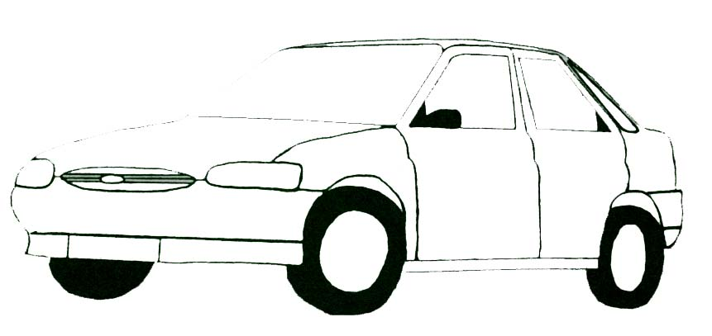  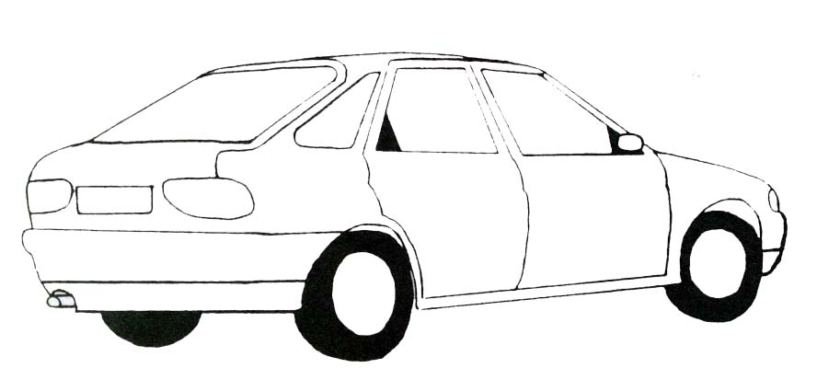  Condition of vehicle-detail. Make a note of areas of damage: | General Remarks / Further Action:

