
This Information Sheet provides guidance on the how to ensure the safety of all members of staff, students and others who may have to drive on University related business. This document forms one of a series of Information Sheets, supporting the Driver and Vehicle Safety Policy Standard.
INFORMATION SHEET: DV3 – JOURNEY PLANNING
Further, useful guidance can also be found in the Driver and Passenger Safety Handbook.

Journey Planning
Driving is probably one of the most hazardous activities we carry out regularly, but, because we do it so often, in and out of work, it is a hazard we often forget. The phrase ‘hierarchy of control’ is often used in risk management. The first level of control within this structure is ‘elimination’ and the second is ‘reduction / substitution’ with the aim to firstly remove the hazard completely or to introduce measures to manage the hazard, reducing associated risk in the process.
The following outlines simple controls Colleges / Services and Drivers can take to make driving safer:

- Avoid the Journey / Frequency of Travel
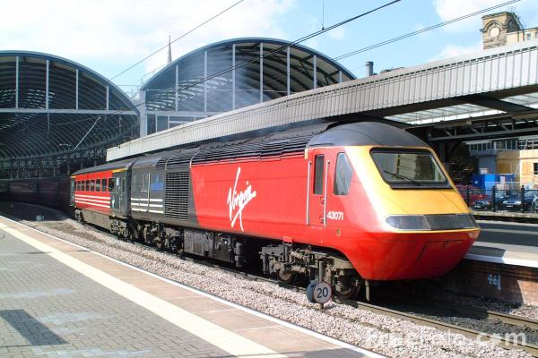
- If possible, Colleges / Services should promote the use of remote communications as a substitute for road travel eg telephone, email or video-conferencing.
- If personal attendance is unavoidable, consider public transport eg plane, train.
- If road travel is unavoidable, maximise car sharing to reduce the number of journeys.
- Arrange meetings less frequently.
- Reduce the number of people attending.

- Reduce Travel Distances / Times
The University recommends Colleges / Services set in-house limits on maximum daily driving distances. As a working rule, no Driver should be expected to drive continuously for more than 2 hours, without at least a 15 minute break, and no Driver should be expected to drive for more than 6 – 7 hours a day.
If people do need to drive to and from a location for work (including attend meetings), set reasonable maximum daily mileages which Drivers should not be expected to exceed. Support this with clear policies that allow overnight stops, or ensure the driving can be shared. This is especially important if the day is long ie a total of 6 hours driving to attend a 5 hour meeting.

- Control Drivers’ Hours
Crashes are often caused by tired Drivers, which is most likely to happen on long journeys between 2:00 am and 6:00 am and between 2:00 pm and 4 pm (especially after eating or drinking even one alcoholic drink). “Sleepiness” slows reaction time, alertness, concentration and decision making, all crucial driving skills.
4. Optimise Schedules
When planning long distance journeys, scheduling should give Drivers sufficient time to take account of weather and traffic conditions so they can keep to speed limits. Schedules and expectations should reduce night driving and avoid the times of day previously mentioned when falling asleep at the wheel is more likely.

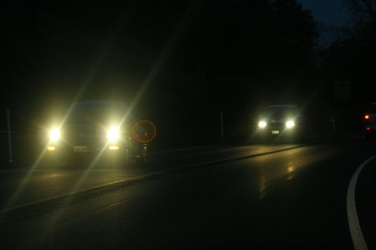
5. Overnight Stays
If Drivers have to travel long distances at the beginning of the day or the journey is likely to take more than four hours, Colleges / Services should ask Drivers to travel the day before and stay overnight. Similarly, at the end of a work period (an all-day Conference for example) at a remote location, provision to stay overnight should be made so Drivers do not have to drive when tired. Driving for more than six to seven hours a day should be discouraged and be the exception rather than the norm.

6. Promote Safe Driving
Colleges / Services are expected to encourage safe driving. This includes:
- Safe speeds to ensure speed limit compliance and personal performance schedules do not encourage speeding.
- Distraction – never expect Drivers to make or take phone calls, send messages or transact business whilst driving. Stipulate these activities must only be done when safely parked.
- Impairment – drink and drug driving (including prescription and over-the-counter medicines), and medical fitness to drive (eyesight, illness) should be considered. If a member of staff is required to drive University vehicles under their contract of employment a regular medical assessment, through the Health and Safety Office may be required.
- Vehicle checks should be undertaken before each journey to make sure everything’s working properly and is safe; especially tyres, lights, windscreen wipers and all fluid levels.
- Journey planning – give Drivers a copy of the ‘Driver and Passenger Safety Handbook’ which provides a range of useful information and hints and tips on safe driving.
7. Incident and Accident Procedures
Any person driving on University business who travels alone or for long distances should be provided with advice on what to do and whom to contact in the event of an incident / emergency. They should have access to a mobile phone, but be advised on its safe use, and have appropriate College / Service emergency contact numbers.
The Main Arts Security Lodge: 01248 382795 is a useful number to have, especially if travelling outside of normal working hours, and if driving hired vehicles, the number of the hire company and the contact details generated by the on-line Vehicle Insurance Submission, which should be completed for all vehicle hires should be taken.
Vehicles owned by the University (Colleges / Services) and used for long-distance travel should have ‘breakdown’ cover to ensure its safe retrieval and the return of the Driver to base following an incident.
Any accident or incident whilst driving on University related business must be reported to the Health and Safety Office using the standard Accident / Incident Report Form. In-line with University procedures the College / Service must also investigate any driving related accident / incident.

8. Adverse Weather Conditions

Long distance driving at night and in adverse weather conditions; particularly fog, high winds, ice, snow, flooding or where there is a danger of a Driver becoming stranded in a remote location should be discouraged.
During adverse weather periods eg middle of winter, long distance driving should be avoided; especially when the use of less major roads will take place. This would include journeys to and from Swansea and Cardiff.
If Drivers are ‘caught-up’ in bad weather, overnight stays should be recommended with no pressure placed on them to return to base – even if a colleague must ‘cover’.

9. Specify ‘Safer’ Routes
Colleges and Services should require those responsible for journey planning (Supervisors, Line Managers or Drivers themselves) to take account of:
- Road type (accident rates are lowest for example on motorways and dual carriageways), although thought must always be given to the driver’s personal preference and experience.
- Hazards (weather reports, road works, accident ‘black spots’ and internet reports).
- Traffic densities (avoid peak traffic hours).
- High-risk features such as busy shopping centres, festivals.

10. Monitor Driver Tiredness
There are a number of ways to monitor Driver tiredness. Managers can discuss the issue with their Drivers during performance appraisals or as part of a general ‘catch up’ when the Driver returns.
In order for lessons to be learned, Drivers should be encouraged to share their experiences of sleepiness whilst driving with their colleagues and Line Manager.

11. Keep a Record of Use of Vehicles
Where College / Service vehicles are used a record should be kept of their use, for example Driver and journey details. The keeping of such records is essential if any incident were to occur, especially if a speeding offence is committed which needs to be investigated further.

RoSPA statistics.
See such sites as: www.highways.gov.uk/traffic/.

