
This Information Sheet provides guidance on the steps Colleges and Services should take to ensure the safety of staff and students when towing and using trailers on University related business. It forms one of the Information Sheets within the Driver and Vehicle Safety Policy Standard.
INFORMATION SHEET: DV4 – TRAILERS AND TOWING VEHICLES

Background
Towing trailers requires competence, experience, skill and a good understanding of the dangers, requirements and limitations on what can be towed and how. This document provides practical advice on how to meet the requirements to ensure towing activities are undertaken safely.

Vehicle Weights Explained

Unladen Weight: The unladen weight of any vehicle is the weight of the vehicle when it’s not carrying any passengers, goods or other items. It includes the body and all parts normally used with the vehicle or trailer when it’s used on a road. It doesn’t include the weight of the fuel or, if it’s an electric vehicle, the batteries.

Maximum Authorised Mass (MAM): Is the weight of a vehicle or trailer including the maximum load that can be carried safely when it’s being used on the road. This is also known as gross vehicle weight (GVW) or permissible maximum weight. It will be listed in the Owner’s Handbook and is normally shown on a plate or sticker fitted to the vehicle. The plate or sticker may also show a gross train weight (GTW), also sometimes called gross combination weight (GCW). This is the total weight of the tractor unit plus trailer plus load.

Down-plating: If a vehicle is unlikely to be used at its potential maximum weight, it may be ‘down-plated’. This means a lower weight is shown on the plate / sticker attached to the vehicle.

The Driver
It is the responsibility of each College / Service to ensure the competence of Drivers who tow trailers whilst driving on University business. Each College / Service must approve each Driver who will tow or use a trailer - see Information Sheet DV1 Approving the Driver. This process includes checking the Driver has the required driving licence categories, which as explained below can be difficult.

Driving Licence Categories
Specific driving licence requirements apply when towing vehicles. However, trying to identify what is needed is extremely complex as it can vary dependent on the driver’s age, the date when their driving licence was originally obtained, the vehicle that is to be used to tow the trailer, the size of the trailer and the weight of the load to be towed. It should be noted that in some circumstances additional, specific training will be required before a driver is allowed to tow.
The Driving and Vehicle Licensing Agency who oversee driving licences have recognized the difficulties associated with working out what is needed and have developed a useful on-line ‘Step by Step’ Tool to ascertain what driving licence requirements apply.
It is imperative Colleges / Services check this link before authorising drivers to tow.

https://www.gov.uk/towing-rules

The Towing Vehicle
It is important that the vehicle used to pull a trailer is adequate for the job:
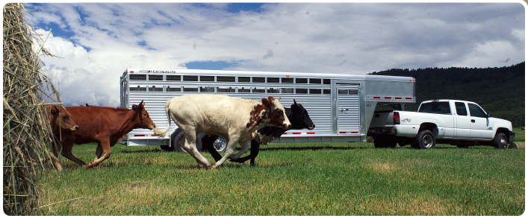
- Check that the engine is large enough to tow the trailer and load.
- Check the vehicle’s brakes are powerful enough to stop the vehicle and trailer safely.
- Check that the Trailer’s Gross Weight does not exceed the Towing Capacity of the towing vehicle.
Adding a loaded trailer to a vehicle will impact on the vehicle's performance. Starting, especially on hills, can be more laboured; stopping can take longer and cornering and negotiating bends requires extra care - all these must be carefully considered when choosing and loading (and towing) a trailer.
The most important check is the manufacturer's recommended towing limit, which should be included in the Handbook and on the chassis VIN plate. For example: a Ford (LWB) Transit may have a towing capacity of 2500kg for a ‘braked’ trailer and 750kg for ‘un-braked’ trailer.

Trailer Safety
To ensure the safe operation of trailers Colleges / Services must undertake the following checks:
- Is the gross weight being towed within the trailer’s official payload and the total vehicle manufacturer's recommended maximum towing limit (braked or unbraked)?
- Is the load correctly secured?
- If the trailer is laden, is the load correctly distributed ie not too much or too little nose weight?
- Are all the lights undamaged and working correctly?
- Is the 7-core cable and plug undamaged?
- Is the correct number plate fitted? (registration number and style)?
- Is the breakaway cable or secondary coupling undamaged and correctly connected, to a suitable point on the tow bar or towing vehicle?
- Are the tyre pressures correct and all tyres free from cuts, bulges and with adequate tread of at least 1.6mm, (includes the spare)?
- Are wheel nuts / bolts tightened to the correct torque?
- If required, are the mudguards in satisfactory condition and secure?
- Is the trailer correctly coupled to the tow-ball or pin?
- Is the coupling height correct, ie not excessively nose down or nose up?

Pre-Tow Checks
- Check the trailer is level when coupled to the towing vehicle.
- Make sure the nose weight is between 50 and 100kg (unless trailer is very light).
- Make sure the tyre pressures are correct with at least 1.6mm tread depth.
- Check the jockey wheel, corner steadies / prop stands are fully wound up and secure.
- Do a final check to make sure loads, straps etc are secure and will not come loose.

Frequency of Inspections & Servicing
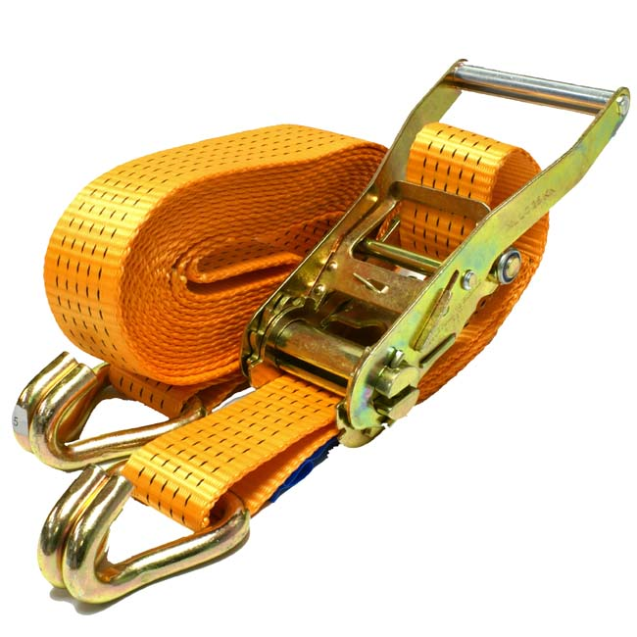
This will depend on the type and frequency of usage and advice provided by the manufacturer. As part of this process it is essential that straps or any other equipment that is used to secure loads eg bungee cords are included. An outline guide could be:
- A visual in-house inspection carried out before each journey.
- Formal inspections / servicing carried out by a competent garage:
  - After the first 600 miles (1000 km) - essential for new trailers or if new brake linings or bowden cables are fitted.
  - Every 3000 miles (5000 km) – three monthly for heavily used commercial / industrial trailers, either by mileage towed or type of application. Includes boat trailers.
  - Every 6000 miles (10,000 km) - annually for caravans and leisure trailers. Six monthly for commercial / industrial trailers - based on "average" use.
- Keep records of all inspections and formal servicing.

Boat Trailers: Additional Advice
It is recommended hubs and brakes are not immersed in water, particularly salt water. If this is not possible the following advice should be followed:
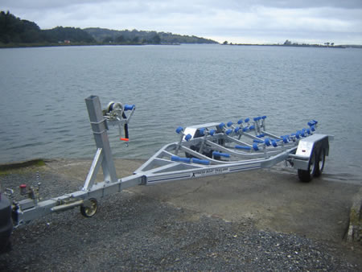
- DO NOT immerse when the hub is hot ie straight after a long journey. Wait until the assembly has cooled, otherwise a vacuum will form, increasing water ingress.
- Keep immersion times to a minimum and DO NOT leave the trailer standing in the water after the boat has been launched.
- After immersion in salt water, the hub assembly and trailer should be hosed down with fresh water.
- Do not park the trailer for long periods with the handbrake fully on, particularly if the hub is wet. If necessary, chock the wheels.
- It is recommended trailers are serviced more regularly and certainly at least every three months irrespective of mileage. This includes a brake strip down and re grease of bearings.
- Hubs with unitised bearings cannot be greased and whilst they are more resistant to water ingress, particularly if allowed to cool before immersion, are NOT waterproof. Repeated immersion in water will eventually lead to their failure.
- Bowden cables are generally not provided with lubrication ie a grease nipple, as introducing grease inhibits the movement of the inner cable within the specially designed and coated outer-casing. Excess grease could also contaminate the brake linings making them ineffective. Experience shows a periodic soaking in thin oil e.g. WD 40, especially over the winter, helps.

Record Keeping
Colleges / Services must keep records of all the trailers they use. This includes insurance details and records of inspections and servicing.

