
This Information Sheet provides guidance on how to ensure the safe use of vehicles and is one of a series of Information Sheets which supports the Driver and Vehicle Safety Policy Standard.
INFORMATION SHEET: DV2 – VEHICLE SAFETY GUIDE

As driving is possibly the most hazardous task staff and students will ever do whilst at the University it is essential Colleges / Services provide and operate safe and suitable vehicles.
Each College / Service has a duty to not only provide a suitable vehicle but also a roadworthy one, and as such are required to put in place suitable management arrangements to achieve this. This Information Sheet provides advice on what is expected with regards to vehicle safety and to make sure the law and University standards are complied with.


Risk Assessment
Each College / Service must prepare a suitable and sufficient risk assessment for vehicles used and / or driving undertaken as part of their activities. In addition, Colleges / Services must make sure all vehicles are:
- Fit for purpose.
- Roadworthy and road legal eg MOT, Tax, Insurance.
- Regularly maintained and inspected.

Vehicle Supervisor
If a number of vehicles are operated and owned or (long) leased by a College / Service it is suggested a member of staff is designated as the College / Service Vehicle Supervisor. This person must ensure agreed inspection, maintenance and testing regimes are undertaken for each vehicle so they remain roadworthy with associated records kept. They can also instruct new Drivers about the vehicles.

Vehicle Selection: Purchasing / Long-Term Lease
Before purchasing or leasing a vehicle each College / Service must assess its needs and the intended use of the vehicle. Vehicles must be suitable for all the activities envisaged with consideration given to the following issues before deciding which vehicle to lease or buy:
- The terrain where the vehicle is to be used.
- The number of passengers to be carried.
- Where applicable, type of equipment and materials to be carried.
- Safety features of the vehicle and its European Safety rating (E-NCAP rating).
- Segregation of driver / passenger(s) from any stored items (cargo, equipment etc).
- Driver comfort and general ease of driving and parking.
- The vehicle’s green rating for the environment.

All vehicles purchased or leased on a long term basis must be entered onto the University Insurance Schedule via the Finance Office. Note: The on-line Vehicle Insurance Submission Form must be completed for other general vehicle hires eg a week long car / minibus hire to attend a conference.
Suitable for Purpose
All vehicles should be fit for purpose. For example:
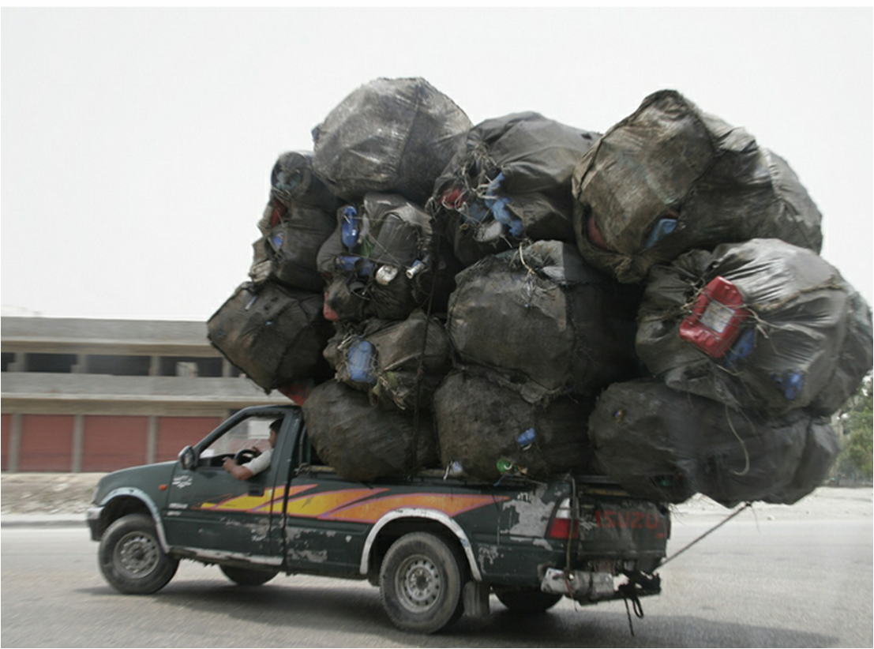
- Vehicles used to access the coastline and carry equipment should have suitable storage areas and be robust enough to cope with rough terrain. Four-wheel-drive should also be a requirement if ‘boggy’ or rough terrain work is anticipated (Note: drivers of four wheel drive vehicles may require specific training in its safe operation and maintenance).
- Vehicles used to move equipment and materials should, if possible have a separate bulkhead and have sufficient load capacity (axle / load weight).
- If a vehicle is to be used for towing its towing capacity should exceed the anticipated ‘towed’ weight. Drivers may also require specific training before being allowed to tow (see Info Sheet DV4: Trailers and Towing Vehicles Safely).
- Vehicles such as cars and minibuses should not be used for carrying equipment and materials unless the load can be ‘strapped / secured’ to stop them breaking loose. The load carrying capacity of a car derived vehicle may be limited and its drivability when fully laden may be seriously affected by the load being carried.

Vehicle Safety Rating
Most vehicles sold in the European Union (EU) undergo tests to assess its safety and performance in a road traffic accident which incorporates the safety of pedestrians who may come into contact with the vehicle. Before purchasing or leasing a vehicle the E-NCAP (European New Car Assessment Programme) rating of vehicles should be assessed with consideration given to purchasing / leasing the vehicle with the highest safety rating. On-line car assessment results can be obtained from: www.euroncap.com
If no E-NCAP rating is available all effort should be made to ascertain the design and performance safety rating of the vehicle, including its safety performance during an accident.
Other useful sources of information when selecting a vehicle are the Department for Transport (DfT) statistical information on driver injury statistics of vehicles involved in two-car accidents and the RoSPA / DfT guidance ‘Choosing Safer Vehicles’.

Basic Driver Checks
Each Driver should carry out a basic Driver Check on a vehicle before starting a journey; this includes College / Service owned / leased vehicles, hire cars and own cars. Checks should include:
- Tyres and wheels.
- Lights (indicators, brakes, etc.).
- Warning Lights (on the dash).
- Seat belts.
- Windscreen wipers and water.
- Condition of windscreen (chips, cracks).
Weekly Vehicle Inspections / Maintenance
Colleges / Services must undertake recorded Weekly Inspections / Maintenance of any owned / leased vehicles. Checks can be undertaken by the Vehicle Supervisor (if appointed) or another competent person with some basic servicing skill. Training and instruction on how to undertake Weekly Checks can be obtained from the Health and Safety Office.
As a minimum Weekly Checks should assess the following:
- Tyre pressure.
- Tyre tread depth and condition.
- Oil and brake fluid levels.
- Water coolant and washer levels.
- Windscreen wipers.
- Windscreen, window and mirrors.
- Lights and warning lights.
- Seat belts and operation.
- Drivability, including steering and brakes.
- The vehicle’s general condition, interior and exterior.

SEE HSS WEBSITE FOR WEEKLY AND MONTHLY VEHICLE INSPECTION FORMS.

Formal Servicing and Maintenance of Vehicles
As with all potentially hazardous equipment it is essential vehicles are inspected, maintained and serviced regularly to ensure their safety and roadworthiness.
College / Service ‘owned / leased vehicles’ should be checked weekly. Additional servicing and maintenance (including those on long-term lease) should then be undertaken in accordance with the recommendations detailed in the Manufacturer’s and Owner’s Handbook, and / or at the very least annually, by a registered garage and MOT Test Centre.
Records of servicing and MOT Test Certificates must be kept centrally by the College / Service. A member of staff, possibly the Vehicle Supervisor or an Administrator, should be appointed to make sure all vehicles are serviced and tested in accordance with the manufacturer’s requirements.

Road Tax
Each College / Service with road going vehicles should nominate a member of staff to administer the purchase of road excise (Tax Disc).
Where practicable, Tax Disc purchase should be undertaken on-line in order to reduce the possibility of important paperwork (MOT Certificate, Log Book etc.) being mislaid. If on-line registration is not possible, the original MOT Certificate and Tax Renewal Reminder form (or log book) must be received.
If a vehicle is no longer to be taxed and is not driven on a public road the SORN (statutory off road notification) must be completed and returned to the DVLA.

Short Term Rental Vehicles
Where members of staff rent a vehicle on a short-term hire arrangement the amount of control the College / Service has on the vehicle is limited. Before hiring any vehicle the member of staff authorising hire should ensure, as far as is reasonable:
- The hire vehicle is suitable for the task.
- The driver of the vehicle is authorised to do (see Info Sheet DV1: Approving the Driver).
- The Finance Office’s on-line Vehicle Insurance Submission is completed.

Where possible, vehicle hire should be through University approved suppliers, a list of which is available from the Finance Office.
It is appreciated that occasionally Services / Colleges hire specialized vehicles which are not available from approved suppliers. In such instances, every reasonable effort should be expended to ensure the supplier is competent and professional and the hire vehicle is safe, legal and roadworthy.
As with all road going vehicles, the Driver should undertake simple Driver Checks before setting off.

Privately Owned Vehicles
Private vehicles are not classed as work equipment; however, each College / Service must satisfy itself, as best as it can, that private cars used in the course of University business are suitable for purpose and, as far as is reasonable, roadworthy, and road legal.
Members of staff (and others) using their own cars on University business must possess a valid and appropriate driving licence, be insured (Business Use included on personal vehicle insurance) and must fulfil their other general, legal driver obligations eg MOT, Tax.
The Driver and Passenger Safety Handbook provides further information on these requirements as well as offering some useful advice on general driver and vehicle safety, for example, journey planning, basic vehicle checks, what to do in an emergency.

This information is available via the Office of National Statistics and the DfT Website www.dft.gov.uk and search on: Cars, Make and Model.

