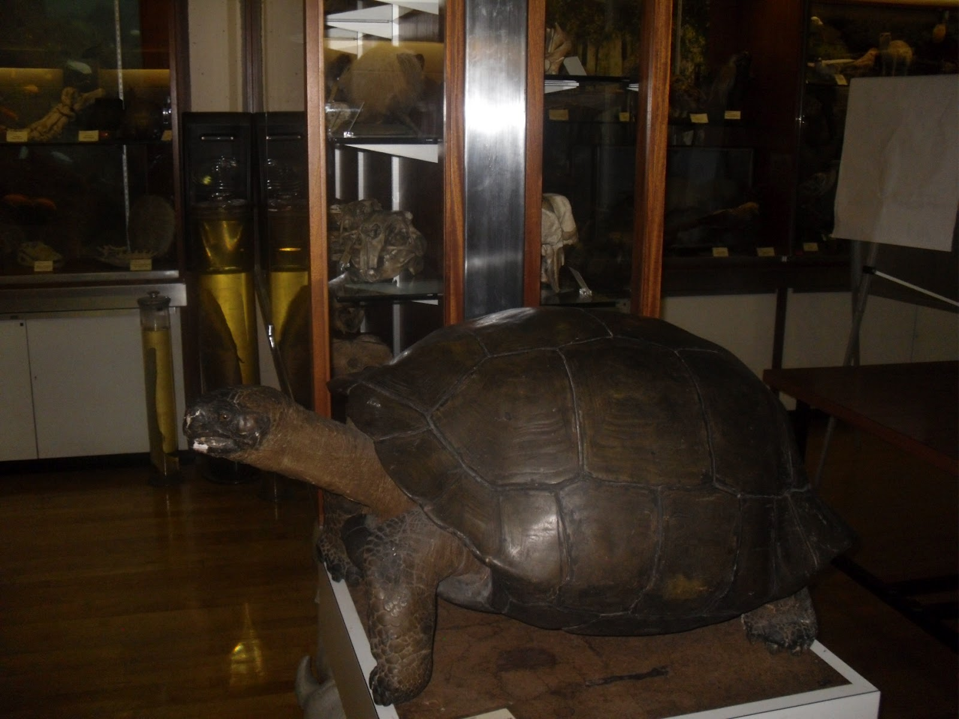

CONSULTATION VERSION: OCTOBER 2014

a guide to assist   
staff planning   
general day trips & visits

Fieldwork Handbook:

‘General Day Trips & Visits’

A guide for staff   
on what to consider when planning   
general day trips and visits   
away from the University

|  |
| --- |
| **Purpose and Background** |

This Handbook provides guidance to staff planning general, low risk day trips and visits. For example, visit to a Museum, trip to an Adventure Centre.

We all carry out such trips outside of work, so why when planning a similar activity as part of teaching should the ‘risk’ increase? The only difference usually is that more people are involved, making it a bit more difficult to get them to the venue and ultimately make sure they all return back to base (eg Bangor) at the same time, safely.

The information in this Handbook should help you meet the requirements of the *University’s Fieldwork Policy Standard (*incorporates the key principles of the *UCEA Guidance on Health and Safety in Fieldwork)* and should highlight that planning such trips isn’t complicated.

An example *Risk Assessment* and an example *Trip Registration Form* are also included, which staff can, where appropriate, customise to make the planning process simpler.

|  |
| --- |
| **Definitions** |

For the purpose of this Handbook, the following definitions, as per the Fieldwork Policy apply:

|  |  |  |
| --- | --- | --- |
| **general day trip & VisitS:** | *Trip (group and lone) away from the University to undertake an activity that poses a risk that is generally no greater than everyday life.* | |
| **Authorisations** | | |

Due to the nature of this fieldwork, it is expected Deans of College, normally through Heads of School will have given overarching authorisation to relevant staff to allow them to plan such trips; provided the necessary financial, academic and health and safety controls (including a risk assessment) are in place.

|  |
| --- |
| **Responsibilities** |

We plan most things in life, often automatically without much thought, for example if going to the zoo, we check opening times and general facilities, plan the route, ‘fill’ the car and leave the house with money and a mobile phone.

Participant health, safety and well-being is always paramount and as with any University activity a risk assessment which documents foreseeable risks and the controls needed to manage these must be in place. For example, provision of adequate supervision and appropriate pre-trip information. But be practical. For low risk trips, general good organisation, with trip preparations made in a timely manner should be sufficient to ensure the trip is both successful and safe.

**RISK ASSESSMENT:** A generic risk assessment is attached and will, unless there is something significantly different about your trip be sufficient. Do remember to review it before each trip though, to make sure it remains pertinent.

**COMMUNICATION:** Provide relevant trip details, including health and safety information in plenty of time pre- trip, especially if participants need to make their own arrangements. This does not mean printing off numerous documents – use email, Blackboard or provide a pre-trip briefing with links to useful material.

**REVIEW:** From time to time review systems and controls so you can check they are suitable and working. Talk to staff and students about their experiences to see what they thought about the trip organisation and if they had any concerns or problems. This will help identify where controls can be improved or even simplified. Keep details of any reviews.

|  |
| --- |
| **Planning – Risk Assessment** |

If possible, participants should be included in the planning process to help develop their organisational and health and safety skills.

As a general rule, the following key areas should be considered. Breaking the trip down in this way will also help when deciding what to include in the trip risk assessment.

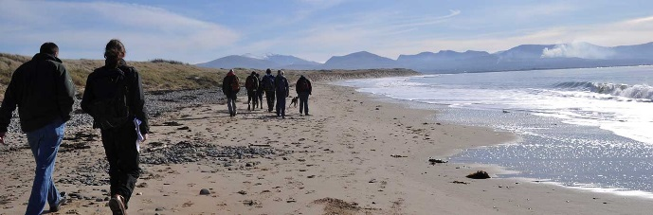

**DESTINATION / TRANSPORT**

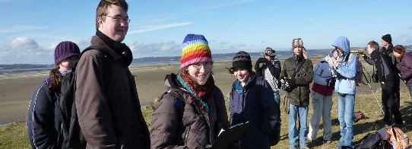

**PEOPLE / ACTIVITY**



**EMERGENCIES**

The Table on the next page will give you some ideas on what to think about during the planning stage.

|  |  |
| --- | --- |
| **POINTS TO CONSIDER** | |
| **DESTINATION – ‘Controlled’:** *Venues usually open to the public. Will have Public Liability Insurance and other controls in place to manage risks arising from their activities*  *Example: Zoo, Adventure Centre, Museum, Theatre, Religious Site* | * **Opening Times:** Check, especially ‘out of season’ – will you have time to travel and carry out the planned activity in a day * **Welfare:** Are toilets, café etc available * **Accessibility:** Is it suitable for all participants eg level access, parking or drop off point nearby, lifts, accessible facilities * **Drop Off / Pick Up Point:** If some distance away how will you get to the venue * **3rd Party Providers:** * Clarify responsibilities of those providing an unusual, higher risk service eg High Ropes Centre * Confirm they have Public Liability Insurance * Check risk assessments / accreditations to Governing Bodies * Check what participants need to supply eg trainers, water proofs |
| **DESTINATION – ‘Uncontrolled’:** *No one is directly in charge, or the site can be more remote or difficult to get help if needed*  *Example: Beach, City Centre, National Park* | * **Welfare:** Are facilities available eg toilets, a place to get food and drink. If not can you stop off on the way * **Accessibility:** Can all participants attend, irrespective of fitness and mobility issues * **Drop Off / Pick Up Point:** If some distance away how will you travel between the two sites * **Site:** Is it remote, steep, unsafe. Does it have uneven paths, lots of steps, no phone reception * **Environmental:** Is the trip weather dependent or restricted eg, tide times, certain times of the day so you return in daylight |
| **Transport:** | * Plan the journey - calculate travel time, take into account hidden extras eg weekend / holiday traffic, road works * Try to travel by public transport or licensed providers eg taxi, coach * If not possible, confirm numbers so enough vehicles are hired * If participants are driving themselves provide driving instructions and refer them to the *Driver & Passenger Safety Handbook* * Book coaches with a reputable company and agree the pick-up / drop off points * If using minibuses refer to the *Minibus Safety Policy*. Book minibuses with a reputable supplier (listed on the Vehicle Insurance Submission Form on the Finance Website) * Complete the Vehicle Insurance Submission Form * Check drivers are at least 25 years of age * Check drivers have in-date MIDAS Training * Ensure a Small Bus Permit is displayed in each minibus |

|  |  |
| --- | --- |
| **POINTS TO CONSIDER** | |
| **PEOPLE / ACTIVITY:** | * **Inclusivity:** Should be inclusive.Identify those with specific needs so you can arrange support pre-trip - it may be too late once on site * **Activity:** Is a certain level of fitness or mobility needed * **Costs:** What do participants pay for eg train fare, entry fees * **Welfare:** Tell people if they need to take food and drink. If toilets aren’t available make people aware and plan a stop on route * **Clothing:** Are specific items needed eg, walking boots, waterproofs * **Culture:** Is a certain standard of behaviour / dress expected * **Equipment:** Do you need a torch, map, sun cream, antibacterial hand wipes, First Aid Kit, spares of kit etc * **Supervision:** It must meet teaching needs. Consider ‘helpers’ eg 2nd year students if participants are new or inexperienced * **Free Time:** Make it clear if there are activities the participants must not do in their free time * **Lone Trips / Visits:** Don’t worry if the trip is low risk. Check the person: * Knows exactly when and where they are going * If applicable knows who they are meeting * Has sufficient funds * Is provided with emergency contact details * Has a means to contact others |
| **EMERGENCIES:** For group trips fill in and take a copy of the *Trip Registration Form* (attached). Also give a copy to a ‘Home Contact’, eg School Office or if back out of hours Main Arts Security | * Remind participants to bring personal medical essentials eg insulin * **‘Controlled’**: Venues usually have First Aid cover with help in all cases, or for serious cases available via 999 * **‘Uncontrolled’**: Make your own First Aid arrangements for sites where it is hard to get help eg uncontrolled, remote, poor phone reception. But remember accidents on ‘low risk’ trips will probably involve minor injuries such as a cut or sprain - so be practical: * Taking a full First Aider is best but participants with some first aid knowledge may also be suitable * Have a small First Aid kit * Check you and others have an in-credit, charged mobile phone * Consider how you will raise help if there is no phone reception * Give ‘supervisors’ and ‘helpers’ emergency contact details and tell them where the Trip Registration Form is * Always tell participants what the emergency arrangements are * Always tell participants who to report concerns to |

|  |
| --- |
| **Remind participants they must report all accidents and incidents** |



|  |  |  |  |  |  |  |  |
| --- | --- | --- | --- | --- | --- | --- | --- |
| **Risk Assessment (RA) Title**  **Remember to complete Footer details** | **Complete** |  | **Date RA Created and/or Reviewed** | **Complete** |  | **Version No** | **Complete** |

|  |
| --- |
| **Summary of Activity RA Covers** |
| **Complete FOR EXAMPLE:** One day trip to a museum and if time permits, a ‘High Ropes’ Activity Centre. Sixty students and four members of staff will attend the trip. Liverpool can be easily travelled to / from in one day, transport is via coach, one minibus and one staff driving themselves in their own car. |

|  |  |  |  |
| --- | --- | --- | --- |
| **Location(s) RA Covers** | **Complete** | **Person(s) RA Covers** | Students and staff attending trip |
| **College / Service** | **Complete** | **School / Section** | **Complete** |
| **RA Assessor(s)** | **Complete** | **Contact Details** | **Complete** |

|  |  |  |  |  |
| --- | --- | --- | --- | --- |
| **Actions to be Reviewed By** | **Complete** |  | **Next RA Review Date** | Review before further similar trips |

**NOTE: Arrangements must be in place to communicate new and / or revised Risk Assessments to relevant persons with old versions filed**

| **Ref No** | **What are the  Hazards?** | **Who/What  is at Risk?** | **Existing  Controls** | **Further  Controls** | **Action  By** | **Action Complete** |
| --- | --- | --- | --- | --- | --- | --- |
|  | **Venue / Location** – injuries, ill health if venue is unsuitable or activities poorly managed | Students, staff | * Museum is a low risk ‘controlled’ public venue in a City Centre location with access to services * High Ropes Activity Centre is an established public facility and has relevant accreditations, public liability insurance in place * Sufficient number of staff to supervise | 1. Monitor weather. In event of adverse weather cancel trip, informing all relevant persons 2. Inform participants in a timely manner of specific trip information / arrangements eg predicted weather, long and steep walk from car park to Activity Centre, costs | Event Organiser |  |
|  | **Activity** – injuries, ill health if activities unsuitable or poorly managed |  | ***See Welfare below***   * Museum visit will consist of general walking around and looking at and possibly handling some exhibits * At High Ropes, Centre staff will supervise all ‘high ropes’ activities, adjusting activities according to participants ability * Centre will check participants are prepared (eg robust footwear) and supply specific activity equipment eg harnesses, hard hats * Staff will confirm arrangements pre-trip eg clothing / footwear at High Ropes Centre | ***See Welfare below*** |  |  |
|  | **Welfare** – injuries, ill health if unprepared for trip, facilities not available | Students, staff | * Museum and High Ropes Activity Centre have welfare facilities: toilets, café to purchase food and drink * Motorway Services available en-route for breaks if needed * Staff will, in confidence try to establish specific individual needs which may require consideration eg medical, disability | 1. Inform participants of arrangements they are responsible for eg cash, food / drink, remembering personal medication (eg insulin), wearing / taking suitable clothing for predicted weather and activity 2. If ‘declared’ establish and implement arrangements to support individual needs | Event Organiser |  |
|  | **Inclusivity** – distress if access / travel arrangements unsuitable and individual excluded | Students, staff | * Trips should be inclusive * Participants asked to inform organizer in confidence if they have specific needs which require consideration * Accessible coach and minibus requested * Confirmed museum and general public areas at High Ropes Centre are accessible with suitable facilities available | 1. Contact High Ropes Centre if participant declares individual needs to establish if High Ropes Centre can cater for this 2. If individual is unable to join in at High Ropes Centre but wishes to participate in an activity seek an inclusive alternative 3. On arrival (if required) confirm on-site arrangements such as Refuge Points and inform individual | Event Organiser  Staff on Trip |  |
|  | **Transport** – road traffic accident resulting in injuries / fatality | Students, staff, Driver, Road Users, Pedestrians | * Local companies used that regularly provide coach service and minibuses to the University * Minibus driven by MIDAS trained staff. Minibus Safety Policy to be complied with * Vehicle hirers checked for Liability Insurance * No alcoholic drinks allowed on vehicles * Passengers instructed to remain seated and wear seat belts (if available) whilst moving * Vehicle aisles and exits to be kept clear * Staff driving own vehicle must follow Vehicle & Driver Policy Standard and have business use on vehicle insurance if claiming mileage | 1. Arrange pick / up drop off time and location with coach / minibus company 2. Provide directions and parking details to minibus driver and staff driving themselves 3. Inform participants of details 4. Contact Health and Safety to arrange S19 Permit for display in the minibus | Event Organiser |  |
|  | **Emergencies** – dealing with ill health, injuries, accidents / incidents, person not making return trip | Students, staff | ***See Welfare above***   * As public venues, Museum and High Ropes Centre are required to have emergency arrangements eg First Aid, Fire in place * Coaches carry First Aid Box as standard * Both venues in areas with easy access to emergency support / services * Staff to ensure carry charged, mobile phones | ***See Welfare above***   1. Complete Trip Registration Form 2. Take copy of Form on Trip and leave a copy with appropriate person (eg Main Arts Security Lodge) in Bangor 3. Inform participants of emergency arrangements and contact details 4. Use Form as Register to confirm people arrived for return trip | Event Organiser  Staff on Trip |  |
|  | **Other**  - **include additional items eg if the students have spare time to explore area** |  |  |  |  |  |