MINIBUS INFORMATION HANDBOOK

This Handbook summarises the requirements placed on Colleges and Professional Services (Services) to ensure owned, leased and hired minibuses that are driven by staff, students and volunteer drivers on University related business are maintained and operated safely.
Information is also provided on the general duties and responsibilities placed on those that drive minibuses and / or travel in minibuses on University related activities.
The Handbook incorporates good practice as described by the Vehicle & Operator Services Agency, Royal Society for the Prevention of Accidents, the Health and Safety Executive and the Highway Code.
NOTE: This does not apply to minibuses driven abroad (including Ireland) or Students’ Union minibuses used on Students’ Union activities.

- lies to:

- Each College and Department who has members of staff using Display Screen Equipment through the course of their

Date of implementation: September 2008



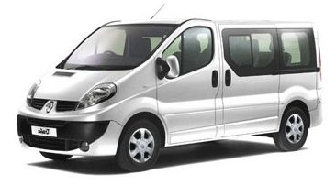

INTRODUCTION
A minibus is any vehicle which is adapted to carry more than 8 but no more than 16 passengers (excluding the driver). This Handbook outlines the procedures that Colleges and Services must follow to ensure owned, leased or hired minibuses driven by staff, students or volunteers on University related business in Wales, England and Scotland are operated and maintained safely. In addition, it provides specific information on the following:
- Section 19 Permits (in accordance with the requirements of the Transport Act)
- Driver Competence
- Driver Hours
- Driving Abroad (includes Ireland)
- Purchasing / Hiring a Minibus
- Responsibilities of the:
  - College and Service
  - Minibus driver
  - Passengers travelling in the minibus
- General information on vehicle, driver and minibus safety

2. SECTION 19 PERMITS
This section explains ‘permits’ as required by the Transport Act. All Colleges and Services that use minibuses must ensure they comply with these requirements at all times when operating a minibus on University related activities.
What are Permits? | Usually, any organisation operating in Great Britain that accepts any sort of payment for providing transport to passengers must hold either a Public Service Vehicle (PSV) operator’s licence issued by the Traffic Commissioner or a private hire vehicle licence issued by the Local Authority. In most cases, the driver of PSVs will also require a Passenger Carrying Vehicle (PCV) entitlement on their driving licence.
Exemptions | Under Section 19 and 22 of the Transport Act, organisations who operate in GB without a view to profit can obtain a permit exempting them from the need to hold a PSV operator’s licence, and under specific conditions, the drivers of certain vehicles are exempt from the need to have PCV entitlement on their driving licence.
Types of Permit | There are two types of permits issued under the Transport Act. Permits issued under Section 19 (permits in relation to use of vehicles by education and other bodies) apply to University activities.
Section 19 Permit | As the University is a non-commercial educational establishment that operates vehicles without profit to transport staff, students and others the University exist to help, it can operate under the ‘standard permit’. This is issued for vehicles that carry no more than 16 passengers (excluding the driver). The permit cannot be used to carry the public.

Where do I get a Permit? | Health and Safety (H&S) obtains Section 19 Permits from the Department for Transport and issues them to Colleges / Services when required. There is a fee for this. Permits also need to be replaced every 3 years.
What do I do with the Permit? | 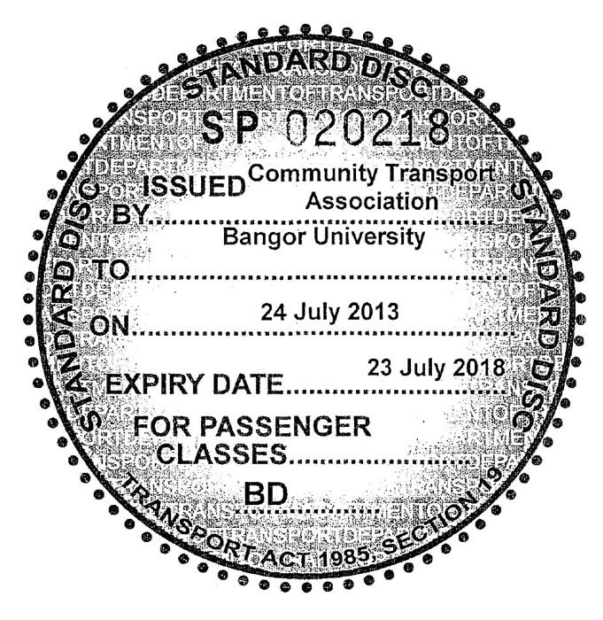  Calculate how many permits you need. Once purchased ensure drivers display the permit in the windscreen of any minibus, whether owned, leased or hired used on University business. The permit may be transferred between minibuses but it is time restricted so will need to be replaced every 3 years.

3a. DRIVER COMPETENCE REQUIREMENTS
General | Minibus drivers must 25 years of age or over, have held, as a minimum a full driving licence (Category B) for at least 2 years and be providing the service voluntarily for no payment other than out of pocket expenses.
Licensing  Requirements (Categories) | The categories displayed on a Driving Licence differs dependent on when the driver passed their test. NOTE: This impacts on: the laden weight of vehicle a driver can operate, possibly the number of passenger seats and whether the driver can also tow a trailer.  The table below should explain the differences:

Driving Licence Categories | Maximum Authorised Mass includes vehicle weight, driver, all passengers and any load | Minibus: 8 - 14 Passenger Seats | Minibus: 16  Passenger Seats | Tow  Trailers
B  (passed test from 1st Jan 1997 onwards) | 3,500kg  (4,250kg if specialist kit provided to aid disabled passengers) | YES  (MAM must not exceed 3,500kg  or 4,250kg if specialist kit provided to aid disabled passengers) | NO | NO
D1  (passed test pre 1st Jan 1997) | Minibus of any weight (vehicle must not exceed 8m in length) | YES | YES  (16 passenger seats maximum) | YES  (up to 750kg)

Training | Minibus drivers must have successfully passed a Minibus Driver Awareness Scheme (MIDAS) available through the Students’ Union or other approved driving test.  NOTE: Refresher training is required every 4 years.
Authorisation | The College / Service must authorise all minibus drivers to drive (includes volunteer drivers). This includes presenting driving licences for the initial approval and then annually thereafter. NOTE: Any ‘point’s, medical conditions, endorsements etc must be notified by the driver to their College / Service immediately.
Operating | A Section 19 Permit must be displayed in any minibus used on University led, non-commercial activities in the UK (excludes Ireland).
Endorsements / Medical Conditions  (see Authorisation) | Any driver has a legal obligation to notify the Driver and Vehicle Licensing Agency (DVLA) of certain medical conditions. Extra rules apply to minibus drivers (between 9 and 16 seats). See DVLA - www.dft.gov.uk/dvla).  NOTE: Medical conditions, points etc must be reported to the Minibus Coordinator immediately. Failure to do so may result in insurance being invalidated.

3b. DRIVER COMPETENCE REQUIREMENTS IF TOWING
The following requirements apply if a driver wishes to tow a trailer whilst operating a minibus.
In addition, drivers must attend a course on how to tow a trailer with a minibus:
Date of Driving Test | Driving Licence Cat. / Test required | Trailer Weight
Pre 1st January 1997 | D1 – no test required | Trailers up to 750kg
Pre 1st January 1997 | D1E – no test required | Trailers over 750kg
Pre 1st January 1997  but licence has expired | Must pass (as appropriate) medical to retain D1 or D1E | Depends on Category obtained: D1, D1E
1st January 1997 onwards | Not permitted to tow unless the driver takes a D1 test (before moving onto D1E category if required)  AND a new MIDAS test that includes driving towing a trailer | D1 = Trailer up to 750kg  D1E = Trailer over 750kg
NOTE: Driving Licence Categories changed in 2013. Check by visiting New & Old Licences

4. DRIVER HOURS
The University recommends that each College / Service sets in-house limits on maximum driving distances per day. As a working rule, no driver should be:
- Required to drive continuously for more than 2 hours, without at least a 15 minute break.
- Expected to drive for more than 6 – 7 hours a day.

5. DRIVING ABROAD
Additional, often complex requirements will be placed when driving abroad, including Ireland. Please contact the Insurance Officer for further advice if planning to operate a minibus abroad.

6. HIRING / LEASING A MINIBUS
All minibuses must be hired / leased from a University approved supplier.
It is recommended that minibuses are fitted with forward facing seats, with high backs and diagonal seat belts. Where they are not considered suitable, a risk assessment must be completed that reflects the decision not to use such minibuses. Every effort must also be made to ensure minibuses are accessible for all.
When hiring a minibus checks should be made to ensure it is taxed and MOT’d. Although it is usually felt that the vehicle will have already undergone a safety inspection prior to receipt, drivers must still carry out the pre-use check.
Al minibuses must be insured for University business. If hiring minibuses this is carried out through completion of the Finance Office’s on-line Vehicle Hire Insurance Form. Before leasing minibuses please inform the University Insurance Officer.

7. USEFUL CONTACTS
- Health and Safety – 01248 383847
- University Insurance Officer – 01248 382199
8a. COLLEGE / SERVICE RESPONSIBILITIES
Colleges / Services should ensure the following processes are followed:
DRIVER checks (includes non-University staff / student volunteer drivers)
MINIBUSES ‘hired’ / ‘leased’

Maintain a register of leased minibuses

Check drivers meet the relevant competence requirements (see Driver above)

Calculate Section 19 Permit needs and purchase from H&S. Monitor & replace as required

Arrange MIDAS (or equivalent) tests for
drivers if necessary

Arrange breakdown cover for minibuses ensuring details are held in the vehicle

Notify Insurance Officer of minibus drivers. Ensure On-Line Vehicle Hire Insurance Form is completed prior to use of a hired minibus

Notify leased vehicles to the University Insurance Officer

‘Authorise’ the driver (in writing with Driver Authorisation Form) to drive a minibus
Check leased vehicles are MOT’d (annually from 1st anniversary of its registration date), taxed, insured and maintained at intervals recommended by the manufacturer and servicing garage

Issue a copy of Minibus Information Handbook to each driver ensuring they understand their roles and responsibilities

Set up systems to ‘book out’ and ‘book in’ minibuses. Include details of trip, Section 19 Permit issue, driver, fault reporting and need to complete a Driver Vehicle Inspection Checklist (leased minibuses)

Maintain a Register of ‘Authorised Drivers’ and associated records securely (consider data protection) eg copy of driving licence, MIDAS test details, points on licence

Ensure Trip Registration Form completed for trip with a copy held in an accessible location
Arrange MIDAS Refresher Training every 4 years
Re-inspect ‘Authorised’ Drivers licences annually, maintaining records as required

Maintain general records for vehicles – tax, MOT, insurance, service records, Driver Vehicle Inspection Checklists

Contact the Insurance Officer immediately if drivers notify penalty points, endorsements, stipulations or medical restrictions


NOTE: Overseas Driving Licences may have different categories. Seek advice from Insurance Officer if necessary
8b. RECORD KEEPING
The College / Service must maintain the following records:
- A Register of leased minibuses (and associated documents provided by the Supplier) and Vehicle Insurance Forms (for hired and leased minibuses).
- Minibus Driver Authorisations (data held in accordance with the University’s Data Protection Policy).
- Details of minibus use i.e. date, driver, Section 19 Permit issued, faults reported.
- Copies of Trip Registration Forms (completed for all trips).

8c. MINIBUS DRIVER RESPONSIBILITIES
Any member of staff or student driving a minibus on University related activities must:
General: | - Familiarise themselves with the content of this Handbook
 | - Abide by the Highway Code eg wear seat belts, never use a phone if driving
 | - Pass MIDAS or other approved training
 | - Only drive vehicles / tow trailers they are trained and authorised to use
 | - Never exceed driver hours (see 4) and plan the journey ( Appendix 3)
 | - Never charge for their driving services
 | - Notify endorsements, medical restrictions etc to their College / Service
 | - Never smoke in, or allow others to smoke in the minibus
 | - Never be under the influence of alcohol or drugs or allow others to consume alcohol or drugs in a minibus
 | - Be mindful of over the counter / prescribed medication which could affect their ability to drive
 | - Never allow capacity numbers / load limits to be exceeded
The Trip: | - Book minibuses through an approved University Supplier
 | - Complete the Trip Registration Form (see Appendix 1), keeping a copy on the vehicle, in addition to handing a copy to a suitable College / Service contact
 | - Check they hold their Driving Licence
 | - Display the Section 19 Permit in the vehicle
 | - Check Breakdown Service details are available
 | - Carry out a general check of the minibus before departing (see Appendix 2)
 | - Never drive if faults are found which make the minibus un-roadworthy
 | - Ensure passengers understand their responsibilities
 | - Check trailers, loads, doors are secure with walkways, exits kept clear
 | - Ensure the vehicle is returned in a clean and tidy state
 | - Report damage, faults, accidents to their College / Service

8d. PASSENGER RESPONSIBILITIES
Passengers travelling in a minibus on University related business must:
  - Never distract the driver, and comply with driver instructions at all times
  - Wear seat belts at all times whilst the vehicle is moving
  - Never smoke, drink alcohol or take drugs, other than over the counter / prescribed medication in a minibus
  - Be punctual and not board a vehicle until their name is on the Trip Registration Form
  - Be aware that if their actions endanger anyone they may face disciplinary action

GENERAL VEHICLE ARRANGEMENTS

ANCILLARY EQUIPMENT
The following equipment should be available in a minibus First Aid kit, fire extinguisher, reflective triangle, serviceable spare tyre and changing equipment.
The fuel cut-off switch (diesel), Emergency Exit, vehicle carrying capacity and vehicle height (including roof rack if applicable) should also be clearly marked.
VEHICLE CHECKS
Before each trip drivers should carry out a general check of the minibus (see Appendix 2). This includes:
- Lights / Indicators: Are working and clean
- Number Plates: Are clean
- Tyres: A spare is available and tyres are inflated and not excessively worn
- Windows: Are clean and free from dirt
- Windscreen / Washers: Are clean and the windscreen washer is working
- Seat / Seat Belts / Head Restraint: Are adjusted to the driver’s needs
- Mirrors: Are adjusted correctly
- Controls: Familiarise themselves
- Breakdown Cover: Details in the minibus
- Loads / Trailers: Are secured with loads inside the vehicle kept away from walkways, exits
- Fire Extinguisher / First Aid Kit: Are available

VEHICLE SECURITY
Even if only leaving the vehicle for a short time, drivers should remove the ignition key and engage the steering-lock (if available). In addition, contents should be removed or concealed if possible.

BREAKDOWN COVER
Colleges /Services should arrange breakdown cover, with details displayed in the vehicle.

PUNCTURE
Never change a minibus tyre. Contact the Breakdown Service.
BREAKDOWNS
If a vehicle breaks down, think first of other road users then:
- Get the vehicle off the road if possible
- Use hazard warning lights to warn other traffic
- Keep sidelights on if it is dark / visibility is poor
- All persons should alight and proceed to a safe point, well away from the vehicle and traffic
- Display a warning triangle on the road at least 45 metres (147 feet) behind the vehicle on the same side of the road. Take great care when placing them - never use on motorways
- Never let anybody stand between the vehicle and oncoming traffic at night / in poor visibility or stand where they will prevent other road users seeing lights

BREAKDOWNS ON MOTORWAYS
If the vehicle develops a problem:
- Leave the motorway at the next exit or pull into a service area. Only pull on to the hard shoulder as a last resort, stopping as far to the left as possible, with wheels turned to the left
- Try to stop near an emergency telephone
- Leave the vehicle by the left-hand door and ensure passengers do the same
- Do not attempt even simple repairs
- Keep passengers away from the carriageway and hard shoulder. Ensure children are kept under control
- Walk to an emergency telephone on the same side of the carriageway (follow the arrows on the posts). The phone is free of charge and connects directly to the Police. Use in preference to a mobile phone
- Give full details to the Police
- Return and wait near the vehicle (well away from the carriageway and hard shoulder)
- Only if at risk from a person, return to the vehicle by a left-hand door and lock all doors. Only leave when the danger has passed



EMERGENCY PROCEDURES

FIRST AID
As a rule you should never:
- Move casualties unless further danger is threatened
- Remove a motorcyclist's helmet unless it is essential
- Give casualties anything to eat or drink
Even with no training you can help in an accident by:
- Stopping others smoking
- Keeping casualties comfortable and warm
- Assessing all casualties
- Treating casualties in priority order - generally:
  - Not Breathing: Remove blockages in mouth and apply CPR if trained
  - Unconscious: Ensure a supply of air by loosening clothing at neck, chest and waist
  - Difficulty Breathing: As above
  - Severe Bleeding: Apply pressure using clean material if possible, without pressing on any foreign body in the wound. Raise unbroken limbs to slow down bleeding
  - Burns: If possible cool the burn with cold water. Never remove clothing stuck to a burn
  - Broken Bones: Keep it in the position found but try to immobilise with padding if possible


NOTE: First Aid training can be arranged through your College / Department

IF YOU ARE INVOLVED IN AN ACCIDENT
- Stop in a safe place and switch off the engine
- Switch on hazard warning lights
- Impose a no smoking ban
- Call the Emergency Services with full details of the accident location and any casualties
- If safe to do so, move uninjured people away from the vehicle to safety. On a motorway this should, be well away from the traffic, the hard shoulder and the central reservation
- Do not move injured people from their vehicles unless at risk from fire or explosion
- Apply First Aid within limits of ability
- Obtain details of any other driver, providing your own details as necessary

ACCIDENT AND INCIDENT REPORTING
All accidents should be reported to the College / Service immediately (office hours) or University Security on 01248 382795 (outside office hours). In addition an Insurance Accident Form and a University Accident and Incident Form should be completed within 48 hours of the event and handed to the College / Service.
It is important to obtain the following information:
- Time, date, location
- Vehicle type, Registration
- Insurance and Driver details of other vehicles involved
- Summary of injuries, vehicle damage
- Witness details
- Police details
- Incident Number if known

General DRIVING SAFELY – HINTS & TIPS

MODE OF TRAVEL
If possible, make long journeys by train, bus, coach or air. If this is not possible, make sure the minibus is suitable for your needs and is not only roadworthy but is easy and comfortable to drive.

SPEED
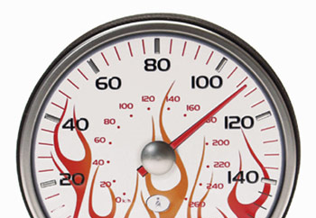
Inappropriate speed – exceeding the limit and driving within the limit but too fast for the road conditions is one of the most significant driving risks. At higher speeds, there is less time to spot problems and react, it takes longer to stop and impacts are more severe, causing more serious injuries to vehicle occupants and others.
All drivers are expected to drive safely and at reasonable speeds at all times. They must also take into account how the speed limit changes dependent on the vehicle:

Speed Limits (UK)
Vehicle | Built Up Area | Single C.way | Dual C.way | M.way
Minibuses | 30 | 50 | 60 | 70

PLAN YOUR ROUTE
Write out an easy to read Route Plan. Check for road works, likely traffic jams, and if possible, plan for regular rest breaks (every two hours, or sooner if feeling tired, for at least 15 to 20 minutes).
For latest traffic information visit: www.rac.co.uk/travelservices/traffic

WEATHER
Always remember to check the weather conditions for the outward and return journey. Never feel pressurized to drive, if you are not happy to drive in the conditions please say so.

DURATION OF JOURNEY
Avoid starting a long journey after a full day’s work / study / activity, starting a drive early morning, when you have had less sleep, or mid afternoon after eating a large meal.

DRIVER HOURS
The University recommends no driver should drive continuously for more than 2 hours, without at least a 15 minute break, and no driver should be expected to drive for more than 6 – 7 hours a day. Try to use two drivers if possible, but check they are insured and authorised to drive the minibus.

SLEEP
Try not to stay up late or reduce your normal sleep before a long journey and consider breaking long journeys with an overnight stop.

ALCOHOL

Remember alcohol must not be consumed or carried in any moving / stationary minibus.
Alcohol stays in the body for several hours and will make you sleepier, so avoid having even one alcoholic drink. Finally, remember the ‘morning after’ you may not be legal to drive!

MEDICINES / DRUGS
You may only take prescribed / over the counter drugs in a minibus. However, if you are taking medication, check whether it causes drowsiness. If it does, ask for an alternative that will not affect your ability to drive.

If you begin to feel tired
If you start to feel sleepy driving:
- Do not try to complete the journey
- Find somewhere safe to stop (not the hard shoulder)
- Take a nap of about 15 minutes
- Drink one or two cups of strong coffee or other high caffeine drinks
But remember, sleep is the only cure for tiredness. So, if necessary, find somewhere safe to stay overnight and inform others of your change of plan.
DRIVING MINIBUSES SAFELY – HINTS & TIPS

Staff and students must have passed their MIDAS or other approved test before driving a minibus on University related business. As minibuses are very different to cars minibus drivers should:
- Familarise themselves with the controls
- Adjust mirrors to suit their needs and ensure the rear mirror is not obstructed
- Remember to Mirror Signal Manoeuvre:
  - Course: Where are you on the road in relation to what you need to do
  - Mirror: Before changing course check all round, including mirrors
  - Signal: In plenty of time
  - Speed: Reduce gently / progressively
  - Gear: Select correct one for the speed
  - Mirror & Signals: Re-check mirrors and that your signal is correct
- Remember driving characteristics change between a loaded and empty vehicle
- Practise defensive driving, remaining alert to what others are doing
- Take extra care when negotiating bends and turning left to ensure others are not trapped on the nearside eg cyclists

STEERING
Drivers should:
- Keep both hands on the top half of the wheel – don’t cross them
- Tighten grip when cornering, braking, driving through standing water
- Steer gently and carefully on slippery surfaces
- Don’t ‘steer and gear’ or allow the wheel to spin back of its own accord

REVERSING
Drivers should reverse at low speeds, making the maximum use of all mirrors. If visibility is impaired or children are on the bus, drivers should appoint someone to guide them, making sure the signaller can be seen at all times and is not placed at risk.
BRAKING
Minibuses have a higher centre of gravity, so will have a much greater stopping distance than cars. In addition, the following steps should be taken when braking in a minibus:
- Brake with ample time, using the brakes gently
- Avoid applying brakes when cornering. If this cannot be avoided brake gently and carefully
- Have both hands firmly on the wheel during hard braking
- On long descents select appropriate speed and gear, applying the brakes intermittently to check the speed
- Applying brakes will warn other drivers you are slowing as the brake lights will come on

FOLLOWING / STOPPING DISTANCES
In good weather conditions as a minimum allow two seconds between your vehicle and that in front. But remember, stopping distances increase considerably dependent on the weather conditions, the weight of the vehicle and load being carried.

CARRYING GOODS / ROOF RACKS
Always check items stored in a minibus are secure with aisles and exits kept clear.
NOTE: A risk assessment should be carried out before using a roof rack.

TOWING TRAILERS
Never over load trailers and check any items stored in them; including covers are secure before driving.
In addition, remember drivers with a DVLA Licence obtained after January 1997 may not tow unless extra training is undertaken (see 3b). Drivers must also be authorised to tow by the Minibus Coordinator.

CHILDREN ON MINIBUSES
If children are involved on the trip check the seats and seatbelts are suitable for their age and size. Members of staff and / or students must also sit amongst the children to ensure the children do not try to un-belt, stand up and move around whilst the vehicle is moving.

APPENDIX 1: Completed before all Trips with a copy handed to a suitable College / Service contact

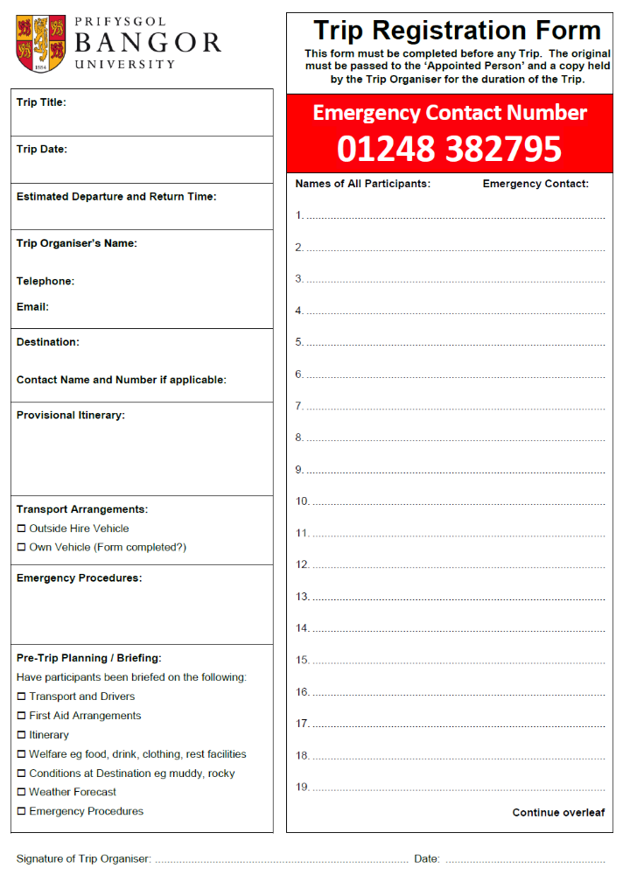

APPENDIX 2: Completed by the Driver before each Trip and handed to the relevant College / Service contact on return

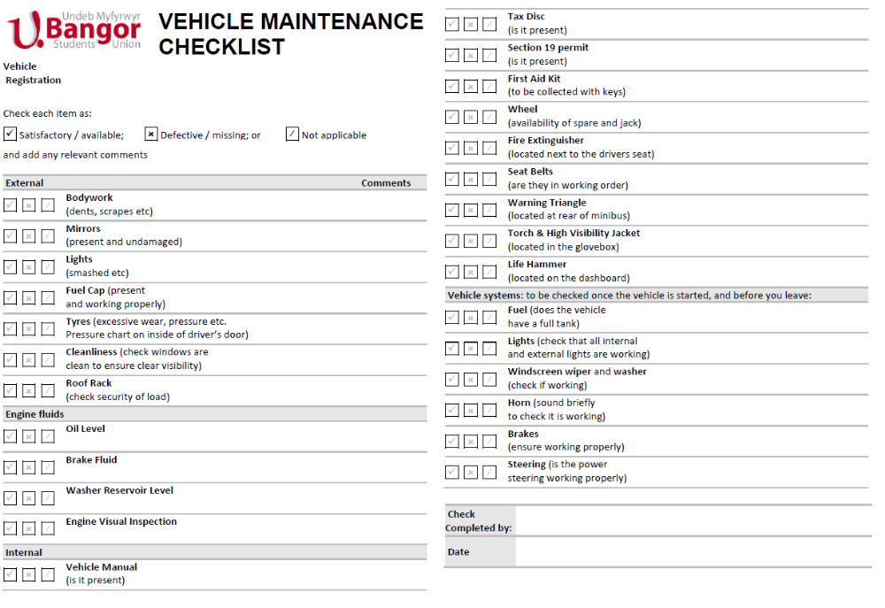


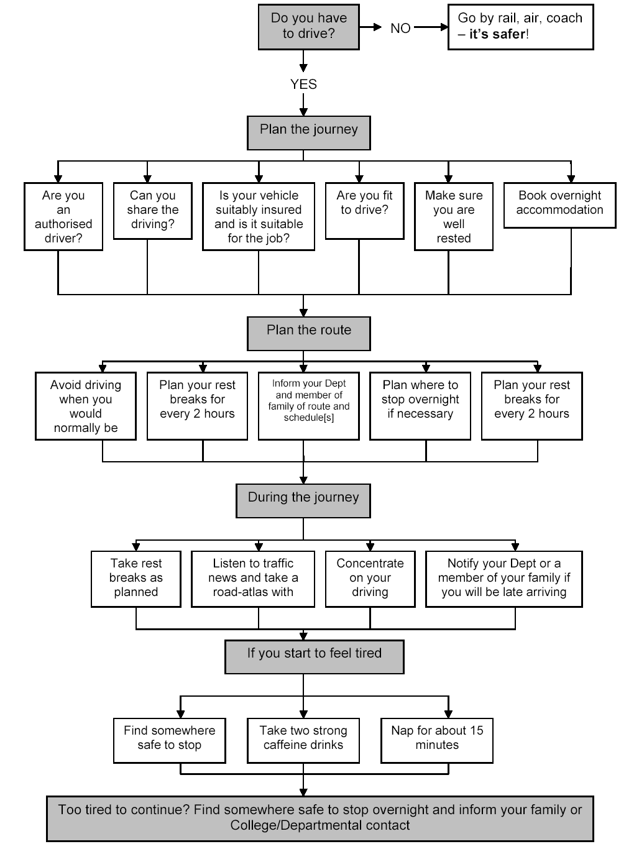
APPENDIX 3: Journey Planner

The University Insurance Officer must give specific authorisation for any minibus driver under the age of 25 and / or who have held their licence for less than two years.
Category B Drivers may only drive a 16 passenger seat minibus if the MAM (vehicle, driver, all passengers, and any load) weighs 3,500kg or less.
Drivers who passed their test before 1st January 1997 will usually have category D1 displayed on their licence. Technically they can drive minibuses up to 16 passenger seats and tow a trailer up to 750kg. Colleges / Services approving such drivers must confirm the driver has the ability to drive larger vehicles and tow. Additional training must also be provided on request eg minibus plus trailer driving course.

