Remote Approvals of Buying Annual Leave Applications
With the current working arrangements, line managers will need to follow the below steps to review and approve applications for the purchase of annual leave electronically.
Step 1.
Once the individual has created and submitted their application on the Sodexo portal, you will receive a email from Sodexo (no-reply@salarydeductplatform.com) with a link to register and access the application - as below:-

Dear Name of Line Manager
You have a new annual leave request to approve.
Please click on the following link, login and approve/reject the application.
https://linemanager.salarydeductplatform.com/
Warm regards
Salary Deduct admin team

Step 2
Clicking on the link will take you to the below page, please enter your bangor.ac.uk email address (using your name version not the username version) as this must match what staff have entered as your known email address. Create a password to register for the first time.
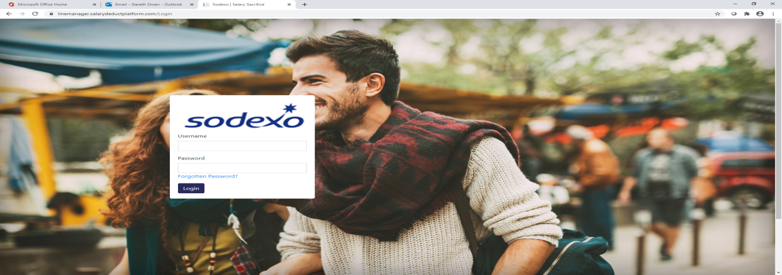
Step 3
You’ll receive an email as per below asking you to click on the link and change your password - entering the key code noted as well when prompted

Step 4
After changing your password you’ll then need to log in again into the line manager portal through the address https://linemanager.salarydeductplatform.com/
Once logged in you’ll see a screen like the one below, and by selecting electronically signed in the drop down you’ll see any applications shared with you by your team members for review and electronic approval
