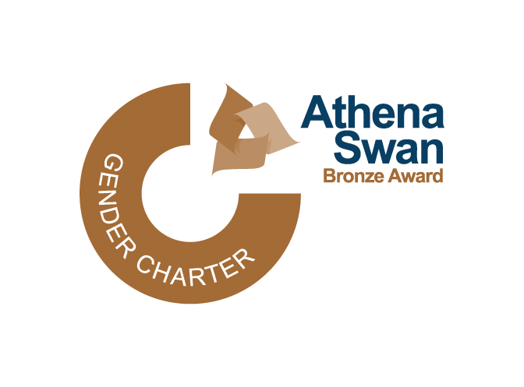

INCLUSIVE BANGOR SCHOLARSHIPS 23/24

To apply for an Inclusive Bangor Scholarship please complete this form and attach your CV and e-mail to athenaswan@bangor.ac.uk by 28 July 2023.

Surname/Family Name

Other names (in full)

Date of birth

Nationality

Correspondence address
E-mail

Telephone

UG course, year of graduation and final degree classification.
MSc/MA course you have applied for/been accepted on (incl. School affiliation)
Please provide details (name and contact details) of one academic referee. The referee will be asked to provide a reference if you are invited for interview.

Please check the scholarship criteria before completing this section.

Please give your reasons for applying for the Inclusive Bangor Scholarship, highlighting in particular your future career aspirations and how the scholarship would help you achieve these.(Maximum of 250 words)

What in your view are the main EDI (equality, diversity and inclusivity) issues in your field of study? What would you like to see your School/University do to address these and how have you contributed and/or will you contribute to this agenda? (Maximum of 250 words)

I hereby confirm that the information given on this form is true, complete and accurate and no information requested has been omitted.

Signed
Date

