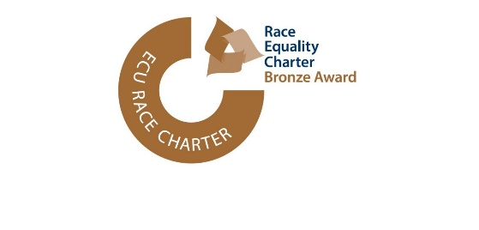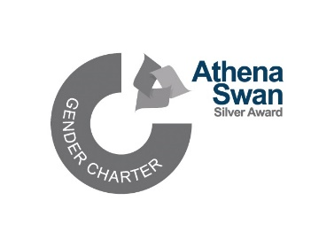

**INCLUSIVE BANGOR SCHOLARSHIPS 25/26**

To apply for an Inclusive Bangor Scholarship please complete this form and attach your CV and e-mail to athenaswan@bangor.ac.uk by **30 June 2025**

|  |  |
| --- | --- |
| Surname/Family Name |  |
| Other names (in full) |  |
| Correspondence address |  |
| E-mail |  |
| Telephone |  |
| UG course, year of graduation and final degree classification. |  |
| MSc/MA course you plan to apply for (incl. School affiliation) |  |
| Please provide details (name and contact details) of one academic referee. The referee will be asked to provide a reference if you are invited for interview. |  |
| You will recive a link to an online Equality Monitoring form once we have received your application. | |

**Please check the scholarship criteria before completing this section.**

1. Please give your reasons for applying for a Masters course. Please outline what your future career aspirations are and how the scholarship will help you achieve these?
2. Please outline what barriers you have faced and how you have overcome inequality in your life.
3. What opportunities or initiatives would you like to see your School and/or the University offer to promote equality, diversity and inclusion and address inequalities?

Please submit a written personal statement (max 750 words) or a video (max. 5min) addressing the above questions.

**I hereby confirm that the information given on this form is true, complete and accurate and no information requested has been omitted.**

**Signed**

**Date**