**Languages for all Guidance notes 2020/21**

Please see link to register:

<https://apps.bangor.ac.uk/applicant/account/login/?next=/applicant/menu>

If you do not have an account please create.

Please complete all sections below starting with Personal Details.

Please save each section as they are completed. You may return to your application at any time.

* You do not have to upload any documents in the last section ‘**documents’** please upload a blank document to continue.

When all sections have been completed you may submit your application.

1. Under ‘Programmes’ choose ‘**Non-graduating Undergraduate**…’

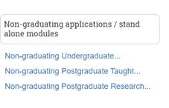

1. Then  from the course lookup, choose **‘Languages for All (NGU/LFA R50U)**’ from the drop down menu – helpfully its the first one
2. Then, select **‘part-time’**

Enter the module code and/or name into **‘Non-graduating / standalone** module(s) applications’ box (Community staff only)

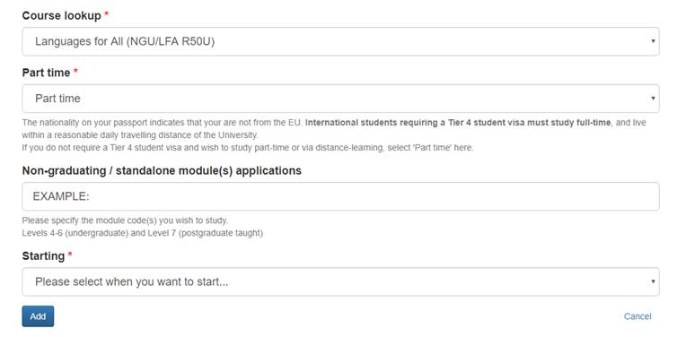Select Starting **2020.**

Click **continue** and enter additional information.

You will receive an e-mail invite to the Microsoft TEAMS Module channel.