REQUEST TO RENAME  A TAUGHT PROGRAMME |  | 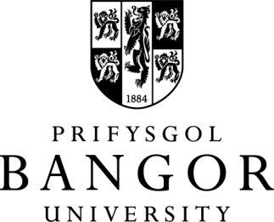
Any request to permanently withdraw programme
requires the approval of the Pro-Vice Chancellor (Education).
This form must be completed and submitted to the Quality Enhancement Unit which will then process the request. For full procedural information, please see: https://www.bangor.ac.uk/quality/course/valid.php.en
If the programme involves two or more schools (e.g. a joint or combined honours undergraduate degree) then the form must be signed by both Heads of Schools.
Note: Please consider the impact on ‘with foundation year’ and BUIC versions of the programme
PART ONE - Approval in principle
- Title of Programmes  Please include ‘with Foundation Year’ and BUIC versions of the programme | In English:  In Welsh:
- Level of award: | E.g. BA, MSc, Cert HE, PG Dip
- Programme Code:
- UCAS Code (if appropriate):
- From which academic year will the programme be renamed? | (Please take into consideration the recruitment cycle)
- Proposed New Title:
- Rationale:
- Does this change involve a change in curriculum? | YES NO (mark as appropriate)
 | If YES, please detail the changes required:
- Admissions  Are there any holding offers, or any applications been received for which decisions have not yet been made? | List current applicant numbers at different stages of the admissions process  UF  CF  UI  CI  Awaiting decision
- Prospectus/Marketing material: | (Please indicate prospectus/marketing material in which the old title has been included)
The School is responsible for dealing with all applicants within the system referenced in 9. above, as detailed in the procedure: https://www.bangor.ac.uk/quality/course/valid.php.en
- Name of School:
Head of School Signature:
Date:
- Have other Schools/Colleges been consulted? | Name of School:  Head of School Signature:
PART TWO – Approval by PVC (Education)
- Confirmation by Marketing, Communications and Recruitment that all live applicants have been dealt with. | Signed:  Date:
- Approval of rename by PVC (Education) | Signed:  Date:

