How to set up a payment plan for hall fees

Go to <https://apps.bangor.ac.uk/student/tp_payment/>

1. Complete the 3 sections below and press Log in

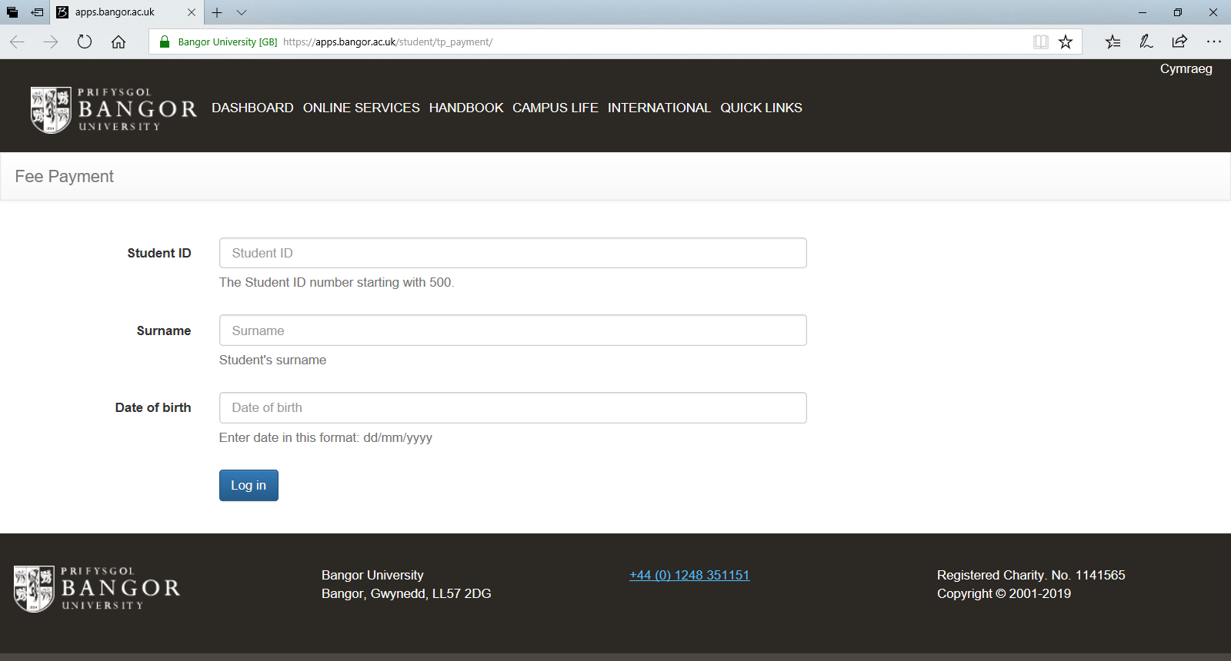

1. Select Hall Fees

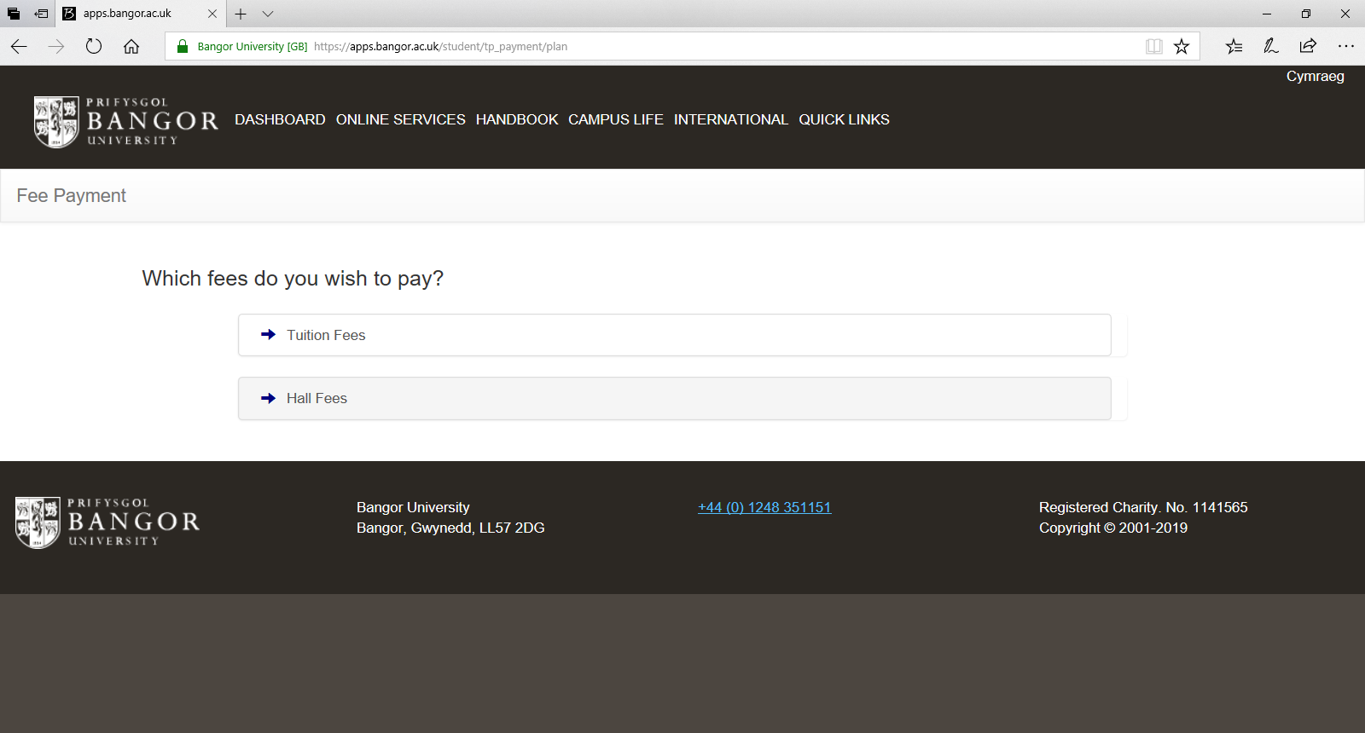

1. ***Please note if you are receiving a student loan we***

***recommend you select the 3 instalments as this is when you will receive the student loan into your account (Oct, Jan and Apr).***

Select which instalment plan you want to choose, press save and continue. If you would like to pay in full please follow step 9 onwards – Pay in full / one off payment

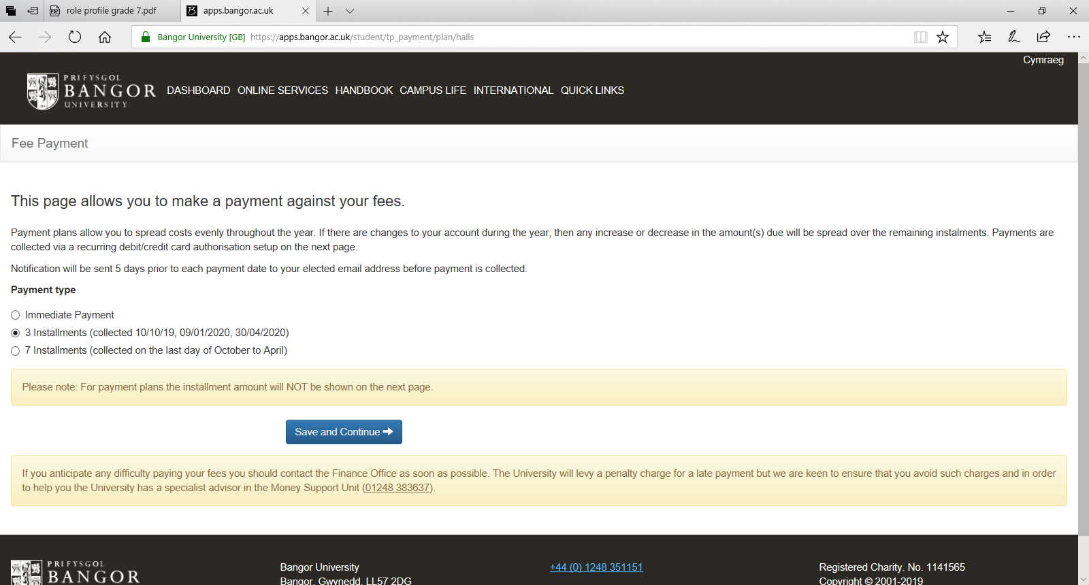

1. Please note as stated above this total cost is meant to be blank,

press continue

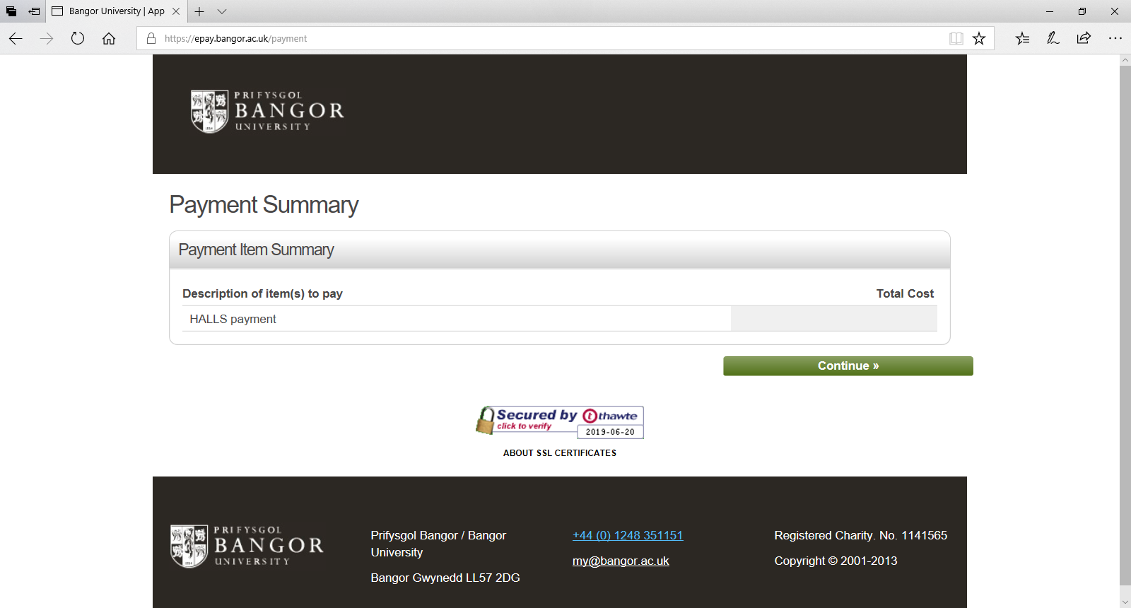

1. Please enter the details of the person paying for the hall fees i.e. parent or student etc.

Please note that the email address you enter in this section is the email that will receive the payment reminders a few days prior to the collection date.

The chosen bank account must be valid with at least £1.00 in the account. This is required as a soft credit check and the plan will not authorise without this amount. No payments will be taken when

setting up the plan.

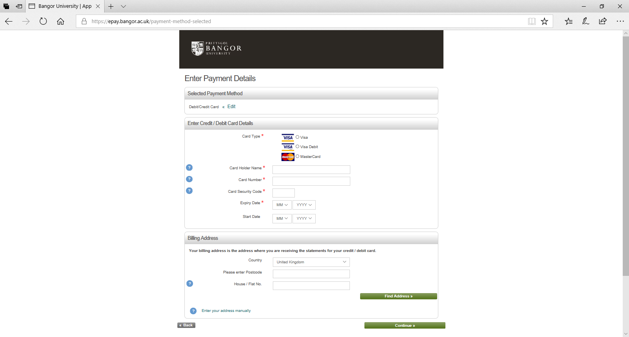

1. Please ensure the details entered are correct and press confirm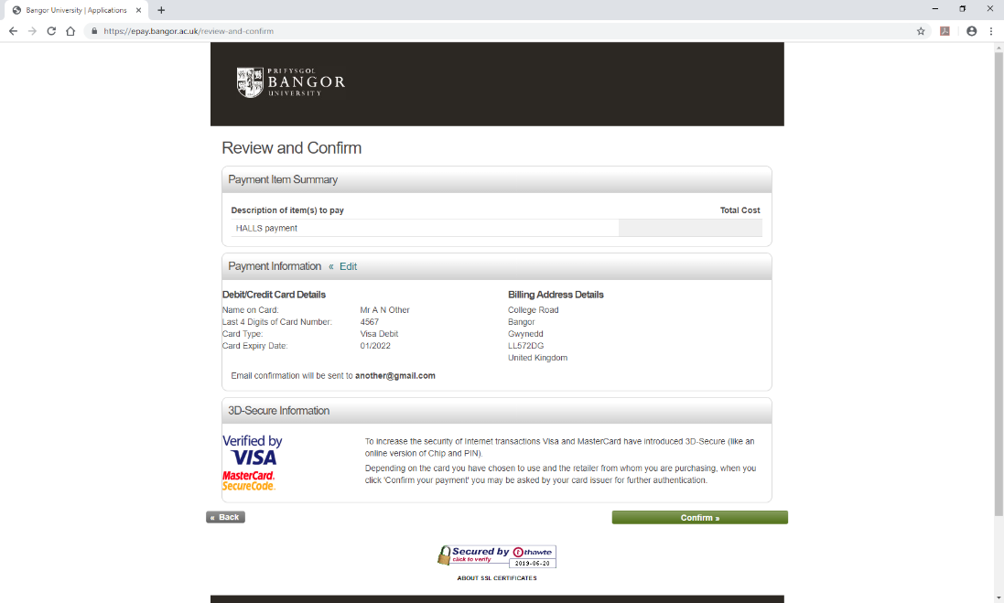
2. You will now either get a successful/unsuccessful message
3. Payment in full / one off payment

If you would rather pay in full, you need to select immediate

payment and enter the amount as shown below and press save

and continue

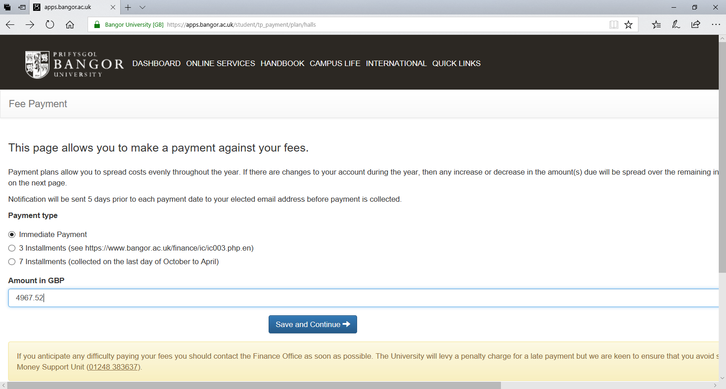

1. If you can’t recall how much your total Hall Fees are, please log on to [www.bangor.ac.uk/myroom](http://www.bangor.ac.uk/myroom) and select ‘review my offer’ the Hall Fees are at the bottom of the offer and on the right hand side next to Rent. ***Please remember to deduct the £300 pre-payment you may have already paid***

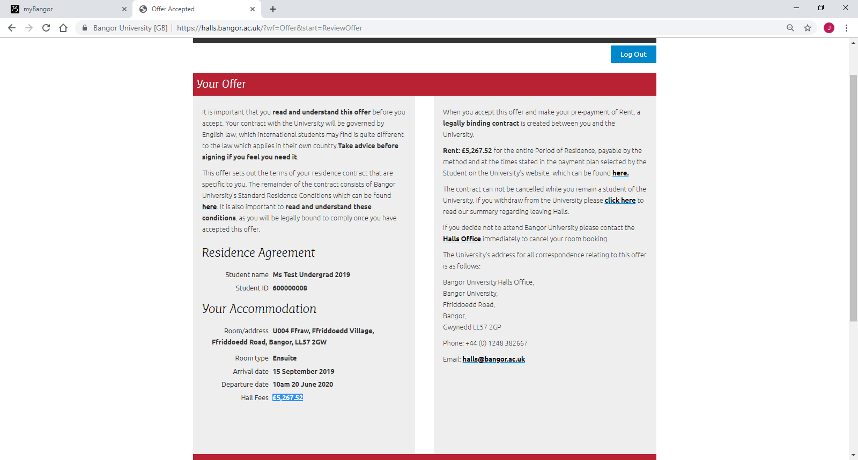

1. Please ensure the amount is correct and press continue

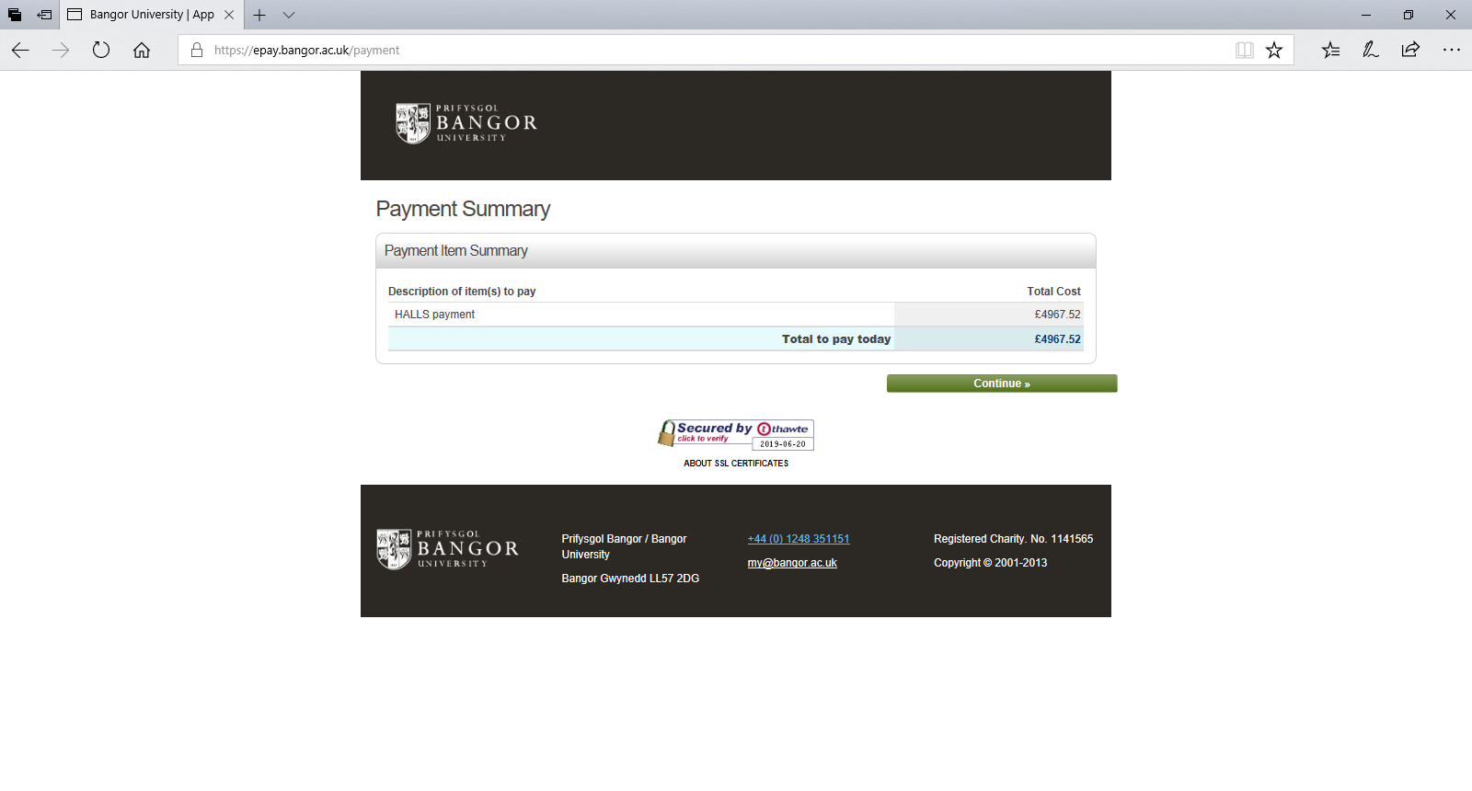

1. Please enter the details of the person paying for the hall fees i.e. parent or student etc.



1. Please ensure the details are correct and press confirm

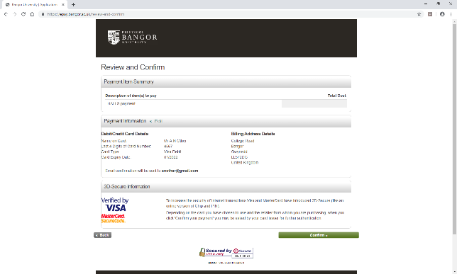

1. You will now either get a successful/unsuccessful message