5th Annual Wales Ecology and Evolution Network (WEEN)
The Bangor Fund was pleased to make a grant of £500 to fund the Bangor University Postgraduate Natural Sciences Conference, WEEN (Wales Ecology and Evolution Network).
Here is a report on the Conference by organiser and postgraduate student William Perry:
A huge thank you to the alumni donors to The Bangor Fund who made the 5th Annual Ecology and Evolution Network (WEEN) Conference such a success! It provides a fantastic opportunity to the postgrad students. Thank you.

After another year of the Wales Ecology and Evolution Network (WEEN), the connections made between postgraduate researchers among Wales’ largest natural sciences departments is going from strength to strength; with WEEN taking another step closer to becoming a well-established conference, as it celebrates its 5th birthday. Hosted by the Centre for Alternative Technology (CAT) on the weekend of 23rd – 25th November 2018, postgraduate researchers from all corners of Wales (Aberystwyth University, Bangor University, Cardiff university and Swansea university), in the form of Master’s students, PhD students and postdoctoral researchers, all gathered to talk about their research.
The weekend’s talks were split into 4 themes: Genetics and Evolution, Conservation, Environment, and Ecology, with delegates giving a myriad of stimulating talks in a relaxed, collegial environment. The talks given by delegates from Bangor University were to an excellent standard and ranged from research on new minION DNA sequencing of aerial environmental DNA (Anna Egerton, SNS Master’s student) to forecasting roe deer expansion in Wales (Owain Barton, SNS PhD student). On top of the traditional talks, the conference also featured a poster session and speed talks, whereby delegates had to summarise their research in a breath-taking 3 minutes.
In addition to the flow of ideas that was facilitated by the sessions’ talks, there was also a very social element to the conference. The keynote speaker, Dr. Niall McCann (known best for his ‘Biggest and Baddest’ series on Animal Planet), kicked off the events on Friday evening, bringing all the charisma and enthusiasm that he has shown throughout his career - telling exhilarating conservation stories, and positive case studies that show conservation can, and does, work. Following the keynote, everyone took part in a very biological themed mixed-university quiz to round off the evening, including a whole picture round dedicated to identifying animal dung! Saturday evening also hosted another social event where there was further networking amongst delegates.
Following a jam-packed morning of talks, the awards for best presentations (oral & poster) were handed out on Sunday afternoon, and the conference came to an end. On reflection, as everyone filtered out of the conference centre, saying their goodbyes to newfound colleagues and future collaborators, three things were abundantly clear. The first was the huge variety of research being conducted in Wales, which was clearly both novel and timely. The second being the sheer quality of talks, both in terms of the science, but also how it was communicated. Third, and possibly most important, was comprehension of the importance of communication and collaboration in science. Not only within, but between, Welsh universities. Without which, creating a vibrant research environment for the next wave of scientists being produced in Wales would not be possible.
With the thought of communication and collaboration in mind, I would like to thank all of those who attended WEEN 2018 for taking part, but also to our funders, which this year included all those universities taking part (Aberystwyth University, Bangor University, Cardiff University, Swansea University), in addition to the Institute of Biological, Environmental and Rural Sciences (IBERS) at Aberystwyth University, the Bangor Alumni fund, and the UK Genetics Society. Without this support the conference would not have been able to take place.
We now look forward to planning WEEN 2019, and the further cross-pollination between Welsh universities. To find out more about WEEN, please visit our website (https://weenwales.wordpress.com), twitter page (https://twitter.com/WEEN_Wales), or using the twitter hashtag #WEEN18.

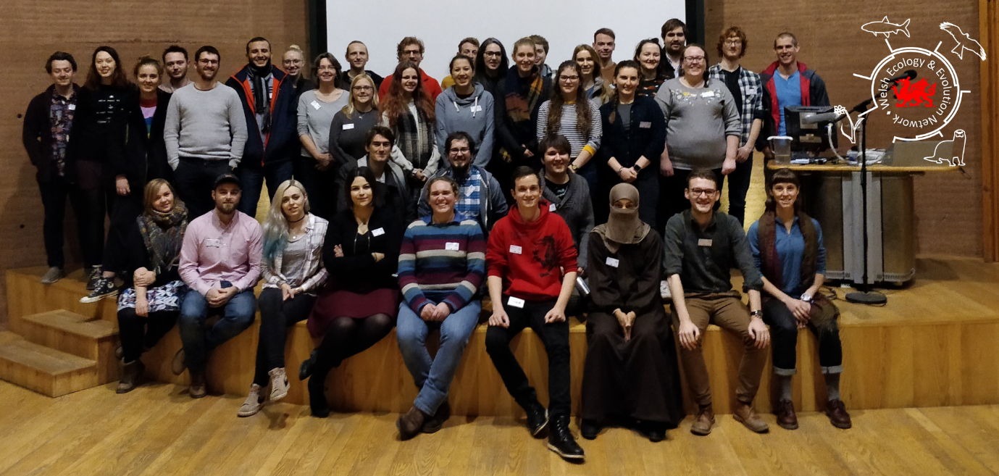
Group photo at WEEN 2018.
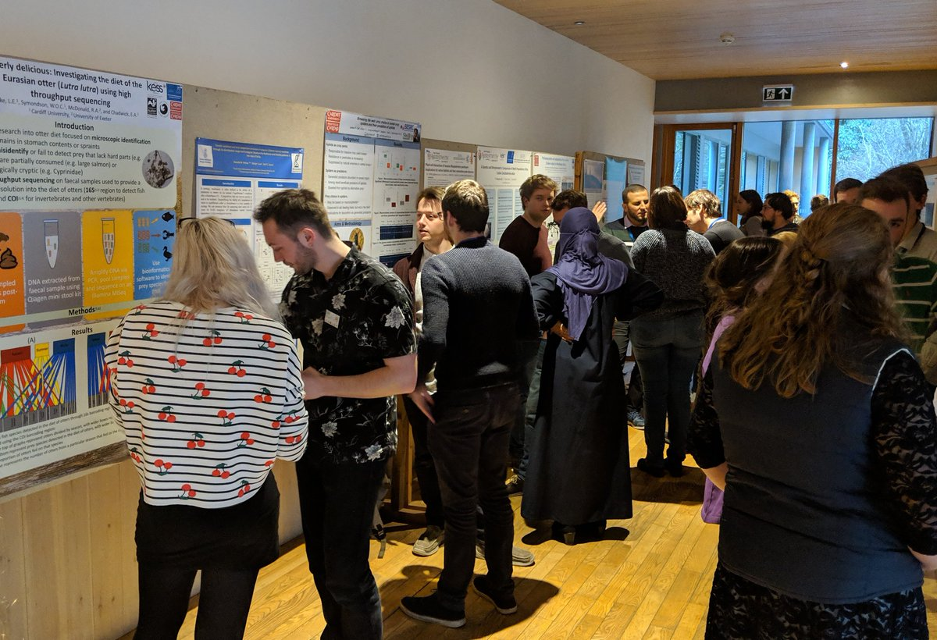
Poster session at WEEN 2018.
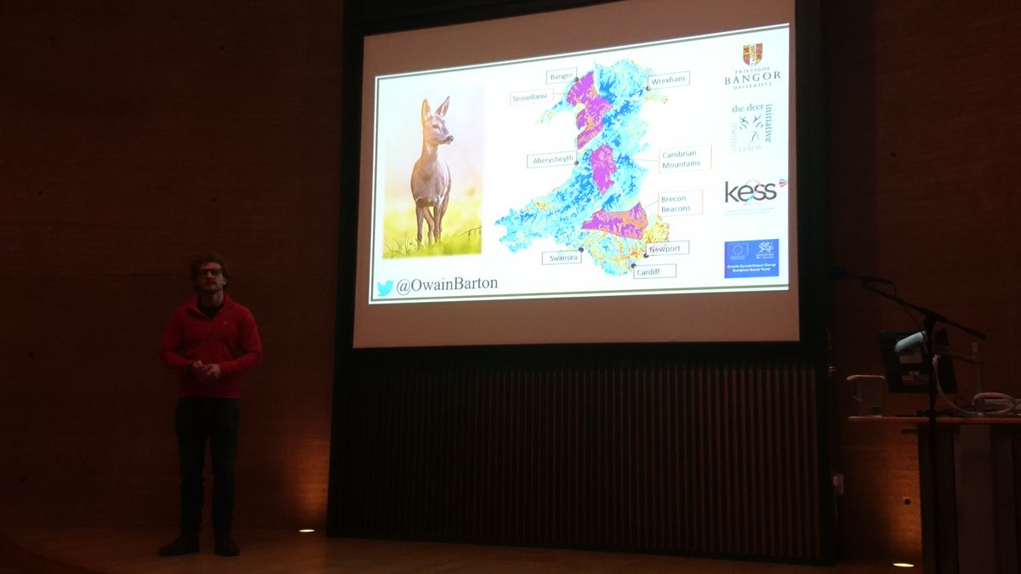
Owain Barton (SNS PhD student) giving a presentation on roe deer expansion in Wales.
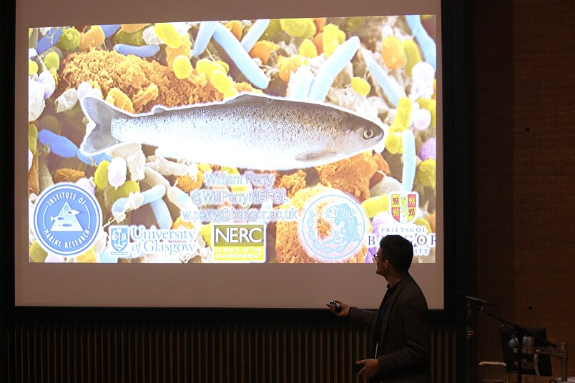
William Perry (SNS PhD student) giving a presentation on aquaculture salmon and their gut bacteria.
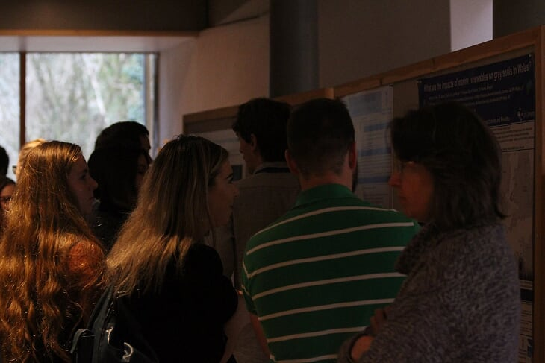
Poster session at WEEN 2018.
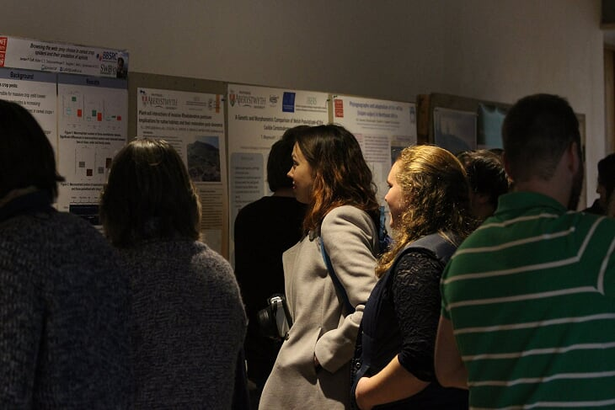
Poster session at WEEN 2018.

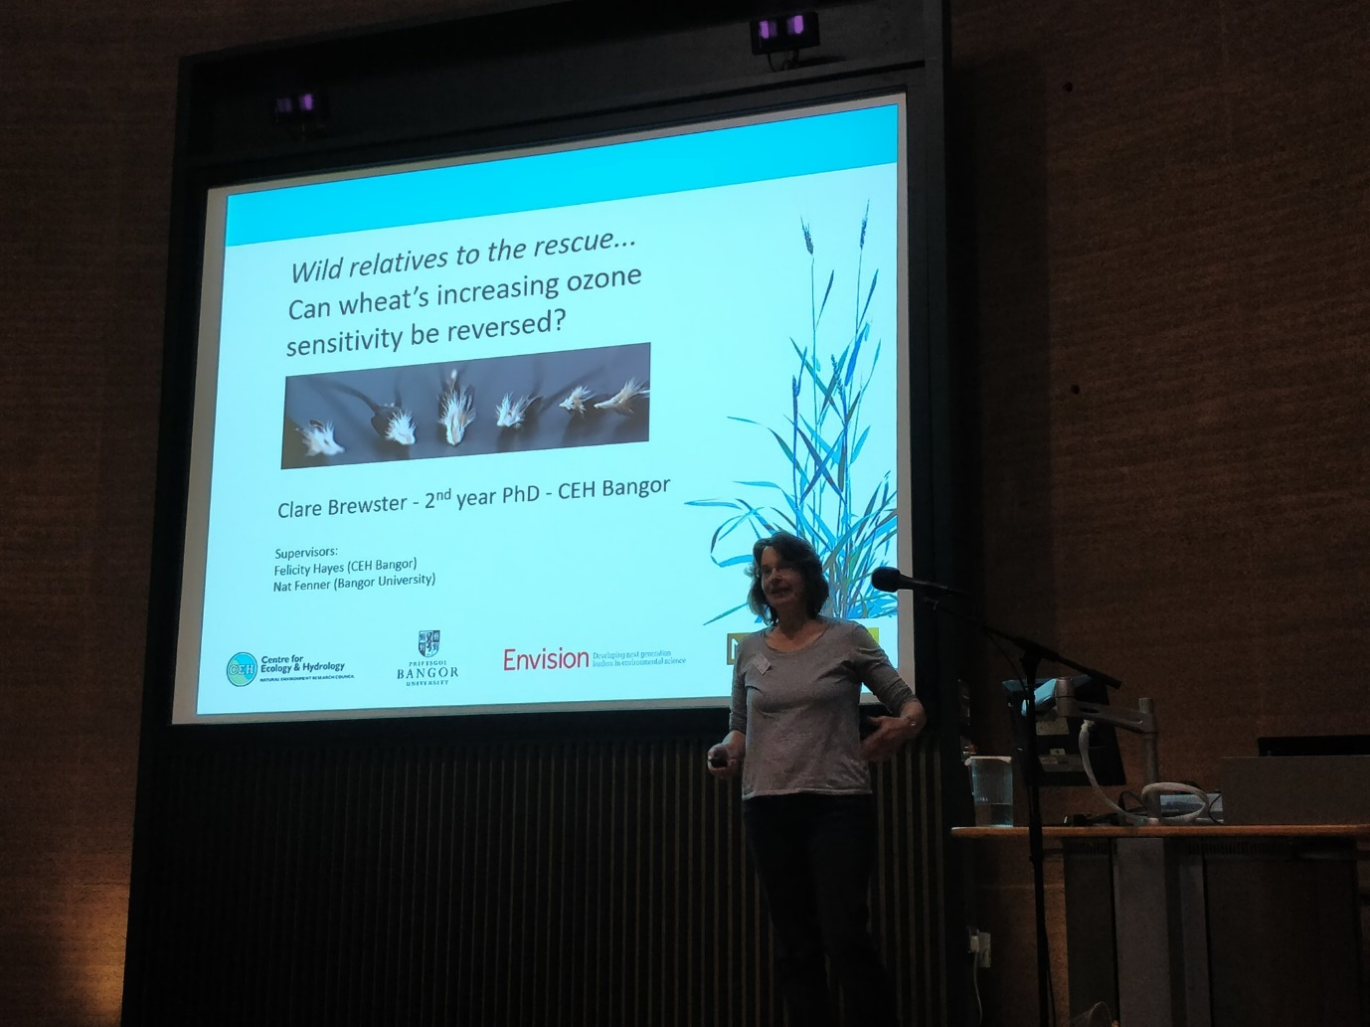
Clare Brewster (SNS PhD student) giving a presentation on ozone sensitivity in wheat.
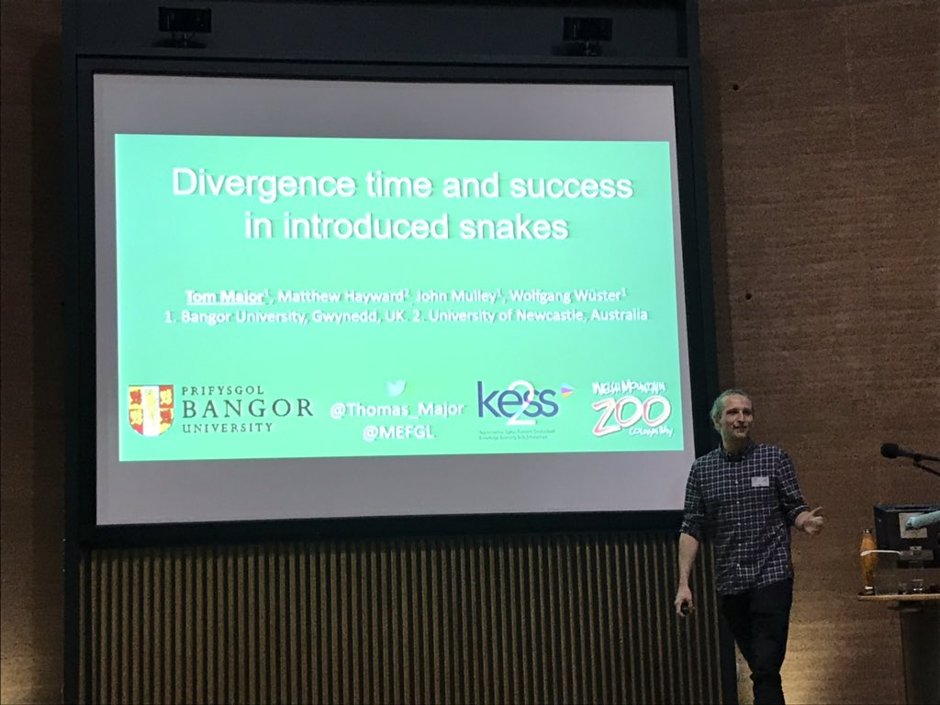
Tom Major (SNS PhD student) giving a presentation on factors controling success of introduced snakes.
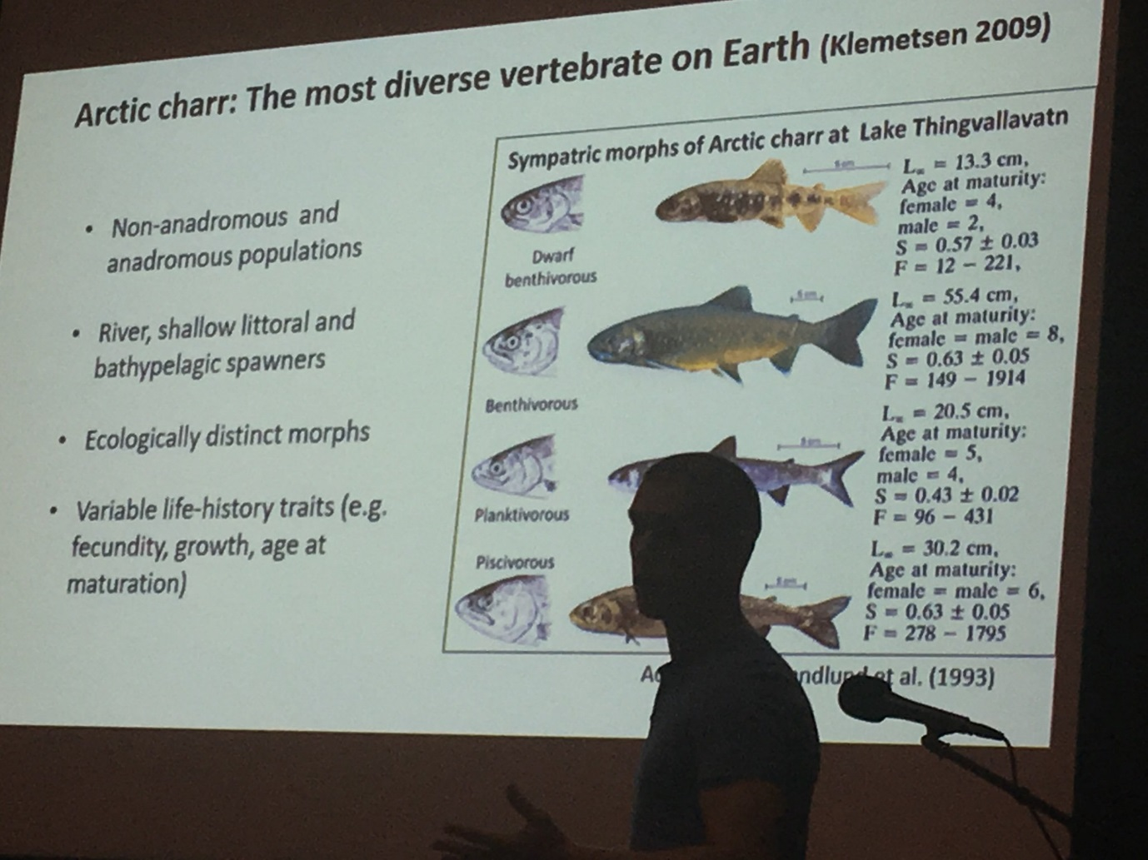
Antony Smith (SNS PhD student) giving a presentation on the conservation of Arctic charr in Llyn Padarn, North Wales.
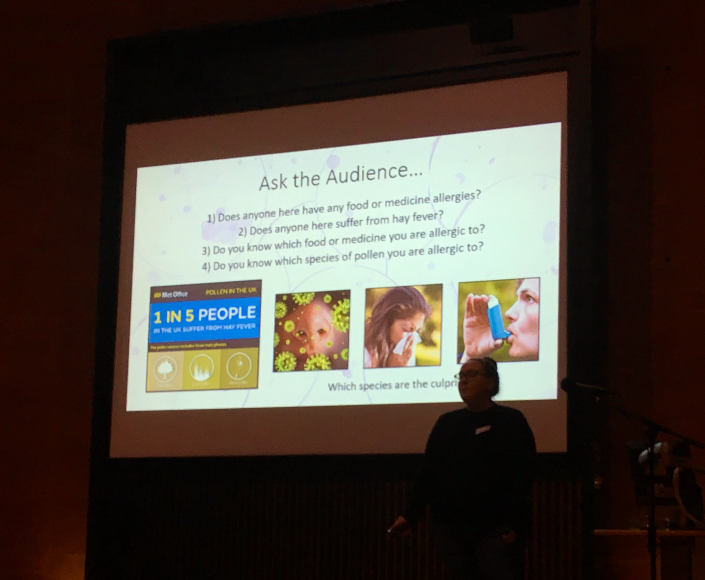
Anna Egerton (SNS PhD student) giving a presentation on minION DNA sequencing of aerial environmental DNA.
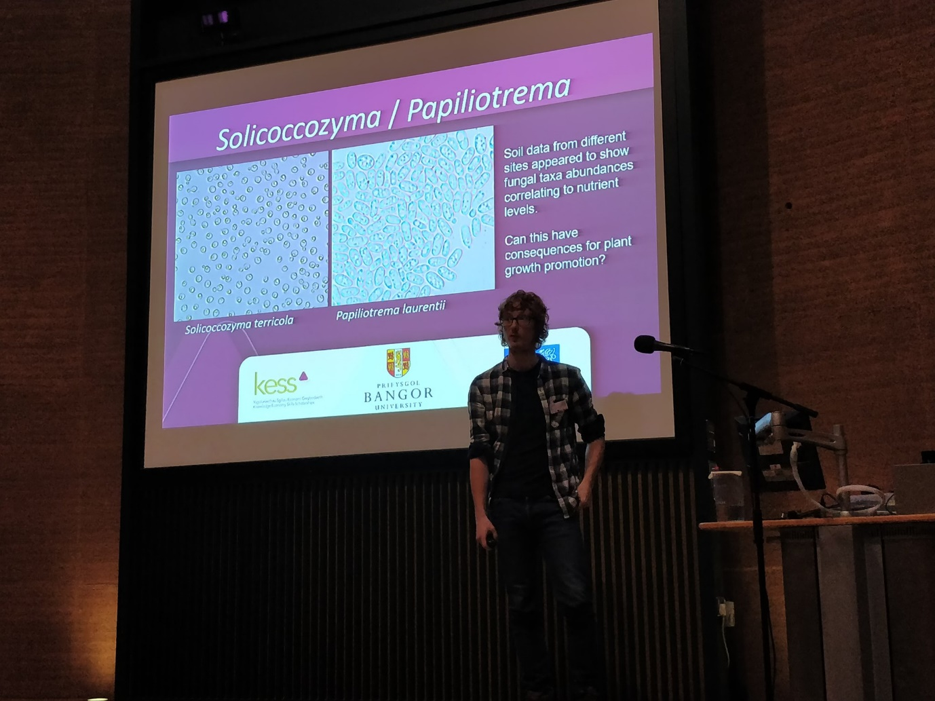
Luke Tyler (SNS PhD student) giving a presentation on plant phosphorus usage and the role of fungi.
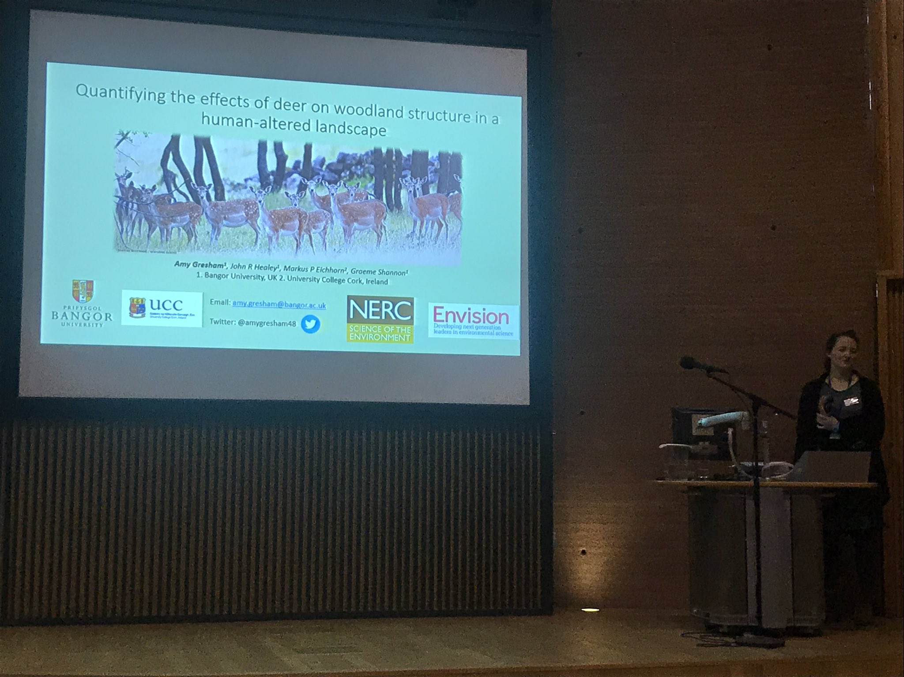
Amy Gresham (SNS PhD student) giving a presentation on the impact of fallow deer on UK woodlands.

