The Glacial Environments Exchange Programme (GEEPs): Final Report
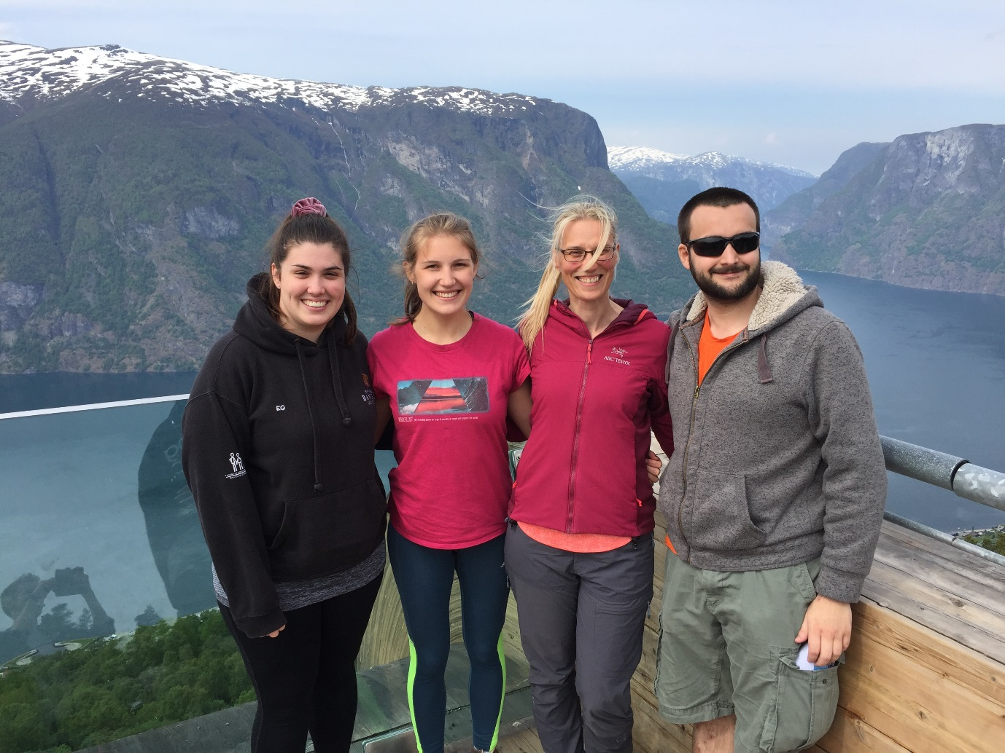

For the past three years I have been taking one or two students from Bangor’s Geography programme to participate in an international field course (GEO291) run by the University of Bergen. The chance to spend a short-term study abroad is a unique opportunity for our students, and only exists because of an agreement between myself and Professor Svein Olaf Dahl at the department of Geography in Bergen. Students who have participated in the past have funded themselves, but this year I was able to secure funding from The Bangor Fund to provide three travel bursaries of £500 for Bangor students to participate in the field course. The travel bursary was designed to cover the costs of flights from the UK to Bergen, and to cover the cost of attending the field course (~£162). It was a contribution to costs as the students still needed to cover their accommodation and food costs, whilst in Bergen. Students on the Year two module, Ice and Oceans, taking a degree in Geography, Geological Oceanography or Physical Oceanography were able to apply to participate in this extra-curricular opportunity via an application form that required them to outline the benefits of participating and why they should be selected. Three students were chosen after myself and Dr Tom Rippeth (SOS) reviewed the applications. They were Ellie Gawne (Geography), Theo White (Geological Oceanography) and Paige Farrington (Geological Oceanography).
The trip affords the students the opportunity to participate in the University of Bergen field course, followed by a two week stay in Bergen. The trip began with orientation in Bergen, two days before the field course departed. The students were met by myself upon arrival in Bergen city centre for a gentle introduction to the city and its surroundings. This is important so that the students got a real feel for the city they would call home following the field course.
The field course involved spending six-days in the field in the area, mostly based on the edge of Jostedalen National Park. The course is as intellectually challenging as the scenery is spectacular. This year’s course participants made for a very multi-national cohort, with students from Norway, Sweden, Germany and the UK. This immediately meant our Bangor students were exposed to an international community, albeit northern Europe centric. The course itself involved the students working in small groups on projects to investigate the development of the area over the course of 4 days, and includes specific stops on the outbound and homeward journey to develop skills and contextualise understanding. The course involves a drive through the western fjords, and provided the students with a fabulous introduction to the geography of SW Norway as well as developing some skills in terms of landscape observation and interpretation. Our Bangor students each worked with either one or two other students on the course, determined on the preference (and preparatory work they had undertaken) for a particular research topic. Here the students were able to develop their group work skills including negotiation and compromise, alongside practical field techniques and, data gathering and analyses. The trip requires the student groups to work independently, save for staff visits, during the day on their data collection followed by evening working on their analyses. This made for long days, however, the students really rose to the challenge and develop some new skills in both data collection and analyses using programmes such as ‘R’. The trip was very intensive, with students working long into the evening (light nights in Norway at this time of year) following long days in the field. The week in the field culminates with student-led talks at each group’s field area, where students share their research findings, a real peer-to-peer learning exercise. The reward for all this hard work was a hike to an outlet glacier of the Jostedal Ice Cap, Nigardsbreen.
As well as the week in the field, the course requires the students to produce a collaborate report about their research and participate in individual oral exams. This means students spend an additional two weeks in Bergen undertaking these assessments. Students not only benefit from partaking in fieldwork in a dramatic and dynamic environment – we only see examples of palaeoglaciation in Wales, rather than the active glacial settings encountered in Norway – but they also got to work with a host of other international students during their visit to Bergen. The students had a week to produce a circa 8,000 word group report on their study area. This involved working together to write (and edit) the report based on their field data. Here the students were exposed to different approaches to working and having to manage their time effectively to meet the very short deadline. This was followed up by an individual oral exam (30 mins long) the following week, where our students were quizzed on both their group report and other aspects of the field course. This type of examination is not typical of Bangor assessments, but our students were a great example of hard work being its own reward. The challenge and opportunity this type of assessment allowed our students to perform to their best, with the opportunity to improve their grade based on individual ability. Our students successfully completed their studies in Bergen, with Theo being awarded the top grade for their work. The students were awarded 10 ETCs points.
Although this is a short-term study abroad, the participants really threw themselves into the work and the experiences of living and studying abroad. This year’s visit was blessed with continual dry weather, unheard of if you’ve ever visited Bergen before, and temperatures up to 30 degrees C. Our student participants were able to enjoy swims in the lakes around Bergen, a day-long walk up Ulriken (the highest hill in Bergen) and across to Floyen (one of the seven hills that surround Bergen), and even a mini-cruise in the fjords.
This experience was truly rewarding for our student participants. Ellie has used the field experience as a spring-board for her dissertation project in the UK, and Theo is considering applying for the Masters in Physical Geography at the University of Bergen next year – two previous attendees have already gone down this route. This trip would not have been possible for the students without the financial help awarded to me through the Bangor Fund.

Dr Lynda Yorke
Senior Lecturer in Physical Geography
School of Natural Sciences

