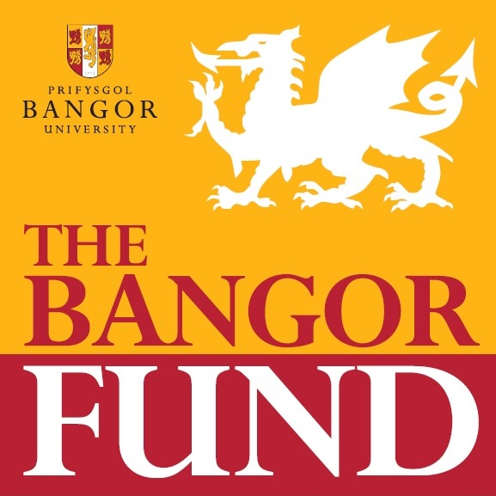

Overview

The Bangor Fund is the revenue generated by the Development & Alumni Relations Office (DARO) during the twice-annual telethons to alumni and friends. Donors to the Fund can select from three sub-funds or “pots” to guide their donations:

- Vice-Chancellor’s Fund - These are funds to support the University’s most important priorities as identified or supported within the University’s Strategic Plan.
- Student Support - This fund provides scholarships, bursaries, internships, travel grants and other direct student support, such as counselling services. It also supports initiatives that enhance the student experience and contribute significantly to campus life.
- Welsh Language and Culture - This fund reflects the mission to provide support for all Welsh language and cultural activities throughout the institution.
- A donor may choose to direct their donation to a specific School or Department, if they wish.

The primary purpose of the Fund is to enable the University to provide for “margin of excellence” projects, that is, non-budgeted expenses that substantially enhance the University’s student offering within the broad guidelines of the three designated sub-funds. Funds are not intended for operational expenses, currently budgeted costs, staff time, or, in general, baseline funding that the University could be reasonably expected to provide.

Guidance notes

The following points will govern the awards made:

- Typical grants range between £1000.00 and £5000.00, but occasionally can be more. For applications for more than £5000.00 or for more complex applications, please seek the advice and guidance of DARO prior to submission.

- Please do not submit for operational costs, such as staff time or fundamental services as they will not be considered.

- We do not support, except in exceptional circumstances, applications for multiple year’s funding for the same project or projects for individual students.

- We prioritise applications from Schools/Departments that have not received funding in the previous year.

- Partial funding may be given as a contribution towards the cost of a project if there is agreement by the School/College/Central Service that they will make up for the shortfall.

- We may decide to support only a selected area within a larger project, and not the entire application.

- Funding is meant to be spent in the academic year it’s awarded. There should be no carryover without approval from the Bangor Fund. This means that grants approved in Oct/Nov must be spent by July 31. It is the awardee’s responsibility to ensure the funds are spent down in the timeframe indicated. Unspent monies must be returned to the Fund.

- Projects must be of direct benefit to Bangor University and its students only and demonstrate a benefit to one of our areas of focus. The Bangor Fund does not award grants to projects whose primary beneficiary is external, to the community or to local schools, for example.

- All applications must be submitted through and with the approval of the Head of College/Central Service and individual approaches from staff or students will not be accepted.

- The Bangor Fund does not consider direct applications from students.

- Applications must be made on the form provided and submitted via email to the Bangor Fund (e.marshall@bangor.ac.uk).

- All payments will be made electronically by cost code.

- A stewardship report will be required following completion of the project to explain how this money has been applied and how it has benefitted a student(s)/project(s). In addition, please submit clear, print quality photographs for the DARO website and other publications.

APPLICATION FOR FUNDING

Name: Title:

Contact Details: Ext No: Email:

School/College: Date:

Please indicate which sub-fund the application is for:
- Vice-Chancellor’s Fund - These are unrestricted funds to support the University’s most important priorities at the discretion of the Bangor Fund Allocations Committee.

- Student Support - This fund provides scholarships, bursaries, internships, travel grants and other support, such as counselling services. It also supports initiatives that enhance the student experience and contribute significantly to campus life.

- Welsh Language and Culture - This fund reflects the mission to provide support for all Welsh language and cultural activities throughout the institution.

Name of Project & Timing (Please provide a title for your request, the dates the project will commence and the completion date):

Total Funding required including VAT and cost code: £
(Please ensure that project is accurately costed and clearly defined. Any areas which require external contracts should be supported by vendor estimates).

Date and amount of last award from the Bangor Fund:

Was a Stewardship Report submitted for your last award?

Have you applied to any other funding body? Please give details including outcomes or expected decisions.

Are there other sources of income available for this project if your application is not successful? Please provide details:

Please confirm that this funding is not already provided within the current departmental budget.

Project Description and Objectives:

How does the project conform to one of the three Pots available? What is the importance and urgency of the project?:

Please attach any further details of your application that you wish the Committee to consider:

Submitted by:
Approved by: (Head of College, School or Department)

