Women in Publishing Symposium
15 February 2020
Bangor University

Women from across the publishing world speaking on their experience of the industry in a one-day symposium

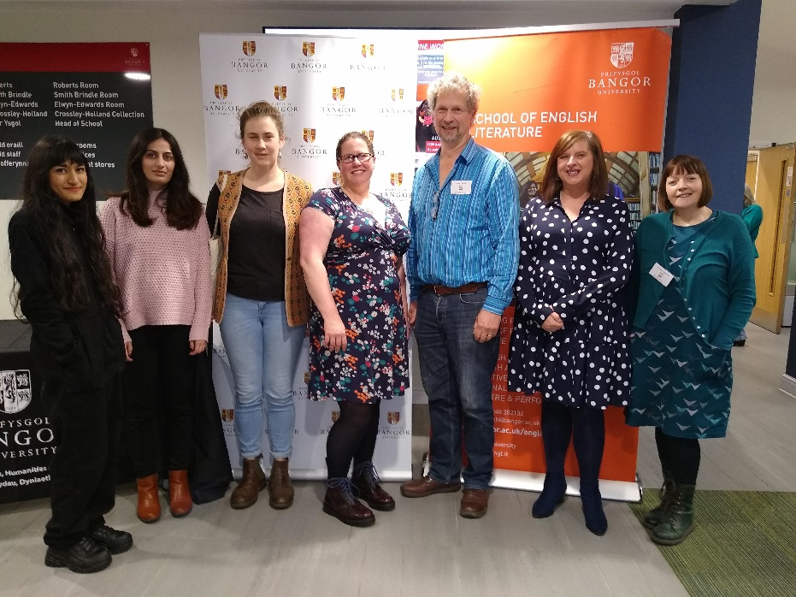
This free event was funded by Bangor University’s Bangor Alumni Fund and sponsored by The Stephen Colclough Centre for the History and Culture of the Book.
Speakers included Helgard Krause (CEO of the Books Council for Wales and one of the Booksellers’ 150 most influential people in publishing), two editors from Honno Press, Heather O’Connell from Bluebird Consulting, and three young publishing entrepreneurs who have founded and edit innovative magazine and journal formats such as Lumin and the Welsh language Y Stamp.
Despite Storm Dennis striking North Wales with strong winds and heavy rain, speakers and guests filled Matthias Hall at Bangor University for a full day of speakers and discussion, including fifteen women from the schools of Languages, Literatures and Linguistics and of Music and Media. Attendees gained insights into the publishing world (including which famous authors are among the worst spellers) and the opportunities that women have in publishing.
The publishing industry provides tremendous opportunities for women, but these are often balanced by obstacles and glass ceilings. According to a 2019 survey by Publishers Weekly in the United States, women hold approximately 80% of current publishing jobs while filling only 52% of management roles. While UK book publishing has similar proportion of women in the industry, the proportion of management jobs is significantly lower, with the gender pay gap as high as 40% in some companies.
Heather O’Connell, consultant/trainer and founder of Bluebird consulting, has more than twenty years’ experience in the publishing industry, working her way up from controller to senior management positions at Penguin and Harper Collins. She believes that people are the key to success:
“Publishing is a great industry with lots of incredible, dynamic and brilliant women despite that it suffers from many of the problems inherent in business, most of the top jobs are held by men, it’s more difficult for female entrepreneurs to get funding and we have not been untouched by (hashtag)Metoo. Events like this ensure that there is an ever increasing and inspiring pool of women entering the industry.”
Women find similar challenges in having their voices heard through publication. VIDA: Women in Literary Arts conducts “The VIDA Count”, an annual survey of content published in literary journals in the US and UK. According to their most recent report, only 20% of major literary publications achieve gender balance of 50% or more, while for some the percentage of work by women is regularly as low as 27%. Such statistics suggest the complex and evolving place of women within the publishing industry and indicate that, despite the prominence of women in the field overall, there remain significant challenges to gender equality.
This symposium highlights these challenges and engages Bangor University students and the Welsh literary community in seeking innovative approaches to publishing careers.
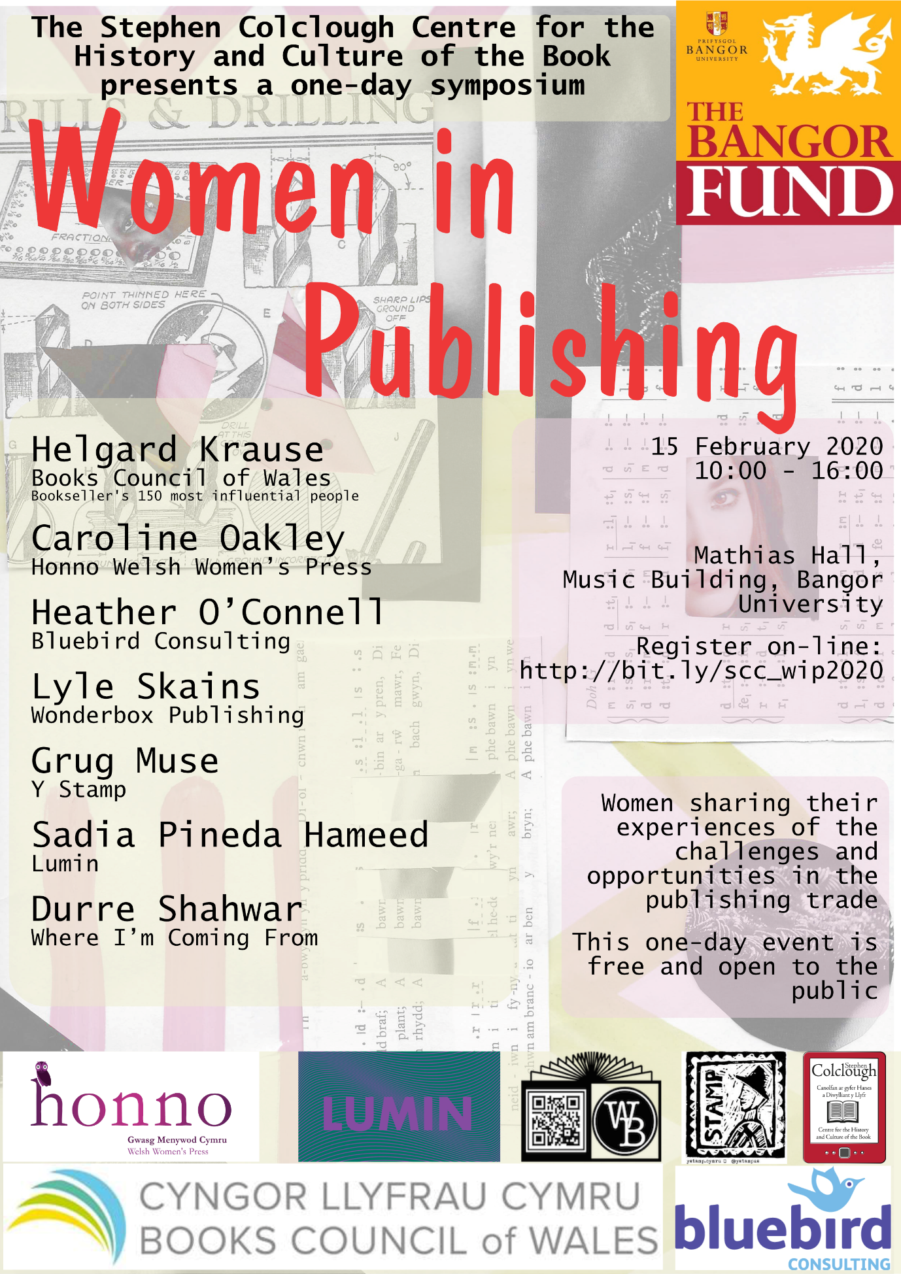

Milliot, J. (2019, November 15). The PW Publishing Industry Salary Survey, 2019. Publishers Weekly.
Page, B. (2018, March 29). Four more academic publishers reveal gender pay gaps. The Bookseller.
Garcia, S. F., & Kocher, R. E. (2019). The 2018 VIDA Count. VIDA: Women in Literary Arts.

