Undergraduate research with the Zanzibar Red Colobus Project (July – August 2019)
Report to the Bangor Fund
Dr Alexander Georgiev, Lecturer in Primatology, School of Natural Sciences

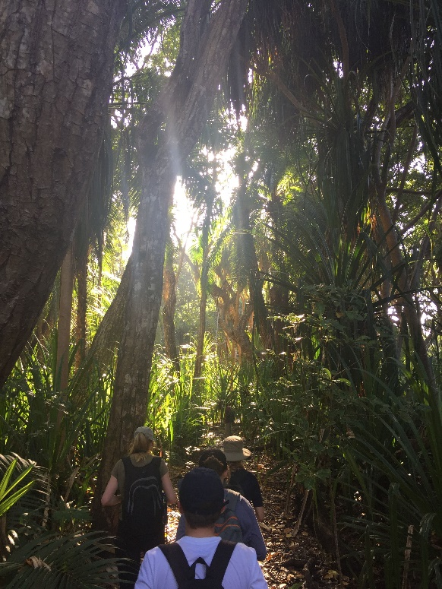

The support of the Bangor Fund provided valuable financial relief to three undergraduates who joined the Zanzibar Red Colobus Project (ZRCP) in the field last summer to collect data for their dissertation research. The £500 each of the three students received helped them offset the some of the costs of field work, that they had to cover from personal funds. Field research involves significant costs (from research permit fees, international flights, accommodation, payment of local salaries to field assistants, etc.) and the cumulative costs is well out of range for most undergraduates. With the help from the Bangor Fund, the opportunity to conduct original research in Zanzibar became a little more feasible for these students.

Students who received support: Kate Hampson (BSc Zoology with… ), Carys L’Estrange (BSc Zoology and Consevation) and Zoe Rule (Zoology).

Getting ready for Zanzibar:
In Feb – May 2019, I worked with the students here in Bangor to help them develop their dissertation research plans. Each of them identified a different question about the behavioural ecology and conservation of the endemic Zanzibar red colobus and produced a strong plan for data collection.

Fieldwork in Zanzibar:
In Zanzibar, they spent 2 months working in the field with me and two postgraduate students. They each hired a local field assistant to help them with following their monkey study groups and with data collection, provided training for them and worked alongside them in the field. They thus acquired valuable transferable skills in research planning, project management and supervision of research field assistants.

In the field, I provided training for the students in behavioural observation and sampling techniques, helped them refine their data collection protocols and advised on how to approach their evolving questions and methods. They all showed high degree of independence and enthusiasm in their data collection. They also got involved in a number of side projects that were part of the broader research agenda of the ZRCP. They received training in the use of GPS technology and used it themselves in the field, as part of data collection. They were also trained in non-invasive sampling of urine and faeces of primates (for analysis of physiological markers).

Working alongside Zanzibari assistants in the field also provided them with the opportunity to expand their understanding of how science and conservation in the tropics depends on building the capacity of local community members to allow an integrated approach to some of the most urgent problems of preserving wildlife. As our research team also worked in close collaboration with staff from the National Park where we were based, our undergraduates also learned about the complex issues of balancing the needs of people and wildlife from those who deal with these challenges on a daily basis – the national park wardens and guides that are in charge of protecting Jozani Chwaka-Bay National Park.

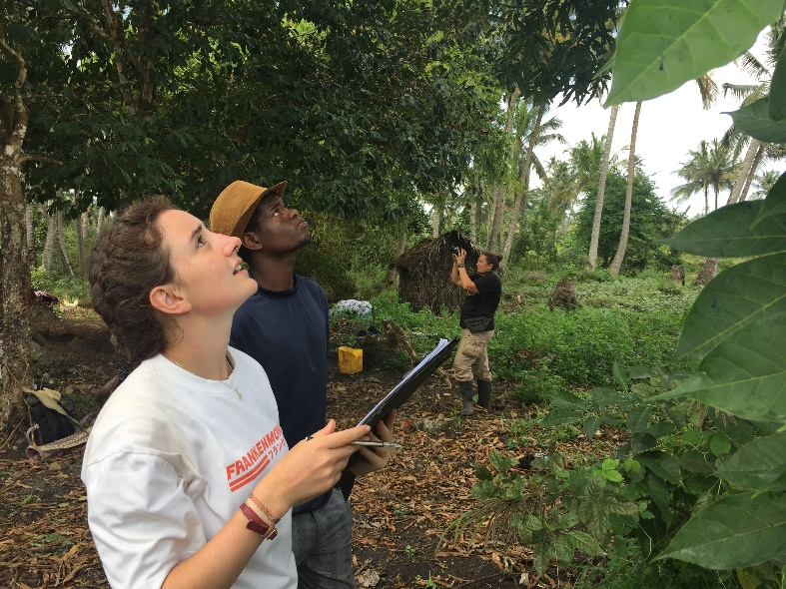

Back in Bangor:
Kate, Carys and Zoe are now in their final year of studies at Bangor. They returned here with rich and complex datasets that they personally produced by their dedicated work in Zanzibar. In the last few months they have all been organising and analysing these data. Now in their final semester they are beginning to draft their dissertations. The quality of the data and their analysis has been very impressive to see for me as a supervisor and I have high hopes for their finished dissertations later this semester.

The support from the Bangor Fund has been crucial in making the opportunity for these students to conduct their independent research in Zanzibar more affordable to them. Having three undergraduate researchers in the field for 2 months also provided me with a valuable opportunity to develop my own mentoring skills outside the classroom. I was able also to consider how supervising multiple short-term studies by undergraduates can feed into my broader research programme in Zanzibar. It certainly proved that with dedicated students even a short period of field work can yield some interesting and potentially publishable findings.

From conversations with the students, I believe they were all very inspired by their time in the field and all three are not considering pursuing postgraduate research opportunities to develop their passion for primate conservation. For me this is the most valuable outcome, achieved with the help of the Bangor Fund – to provide a real-world experience of research and conservation and leave the students eager to do more and make a difference after they graduate from Bangor University.

