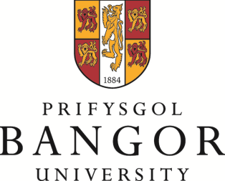

GWOBR GOFFA

LLEW REES

Dyfernir y wobr yn flynyddol i’r myfyriwr ym Mhrifysgol Bangor sydd wedi gwneud y cyfraniad mwyaf i godi proffil chwaraeon ym Mhrifysgol Bangor drwy ei g(ch)yraeddiadau personol ar lefel genedlaethol neu ryngwladol, ac sydd hefyd wedi cymryd rhan mewn cystadlaethau gan gynrychioli’r Brifysgol naill ai fel unigolyn neu aelod o dîm.

Gwerth y wobr fydd £750 yn achos un enillydd neu £400 yr un yn achos dau enillydd ar y cyd. Dylai’r arian gael ei ddefnyddio i hybu perfformiad yr enillwyr ymhellach a gallai gynnwys prynu offer, hyfforddiant ychwanegol, teithio etc.

Dylid gyflwyno ceisiadau erbyn Mawrth 31, 2020 a dylent gynnwys:

1. Ffurflen gais Gwobr Goffa Llew Rees wedi ei gwblhau.

2. Llythyrau cefnogaeth oddi wrth glwb, hyfforddwr neu Undeb Athletaidd.

Y pwyllgor fydd yn dewis yr enillydd/enillwyr.

Dylid anfon pob cais at Iona Williams,
Rheolwr Datblygu Chwaraeon,
Canolfan Chwaraeon Canolfan Brailsford.
Iona.williams@bangor.ac.uk

THE LLEW REES

MEMORIAL PRIZE

The prize will be awarded annually to the Bangor University student who has made the greatest contribution to raising the profile of Bangor University sport by his or her personal achievement at the national or international level and has also contributed and participated in competitions representing the University as an individual or as a team member.

The value of the prize will be £750 in the case of a single winner or £400 each in the case of two joint winners. The money should be used for further advancement of the winners’ performance and could include purchase of equipment, additional coaching, travel etc.

Applications should be received by March 31st, 2020 and should include:

- A completed Llew Rees Memorial Prize application form.

- Letters of support from club, coach or Athletic Union.

The award will be decided by the committee.

Please forward all applications to Iona Williams,
Sport Development Manager,
Canolfan Brailsford Sports Centre.
Iona.williams@bangor.ac.uk

