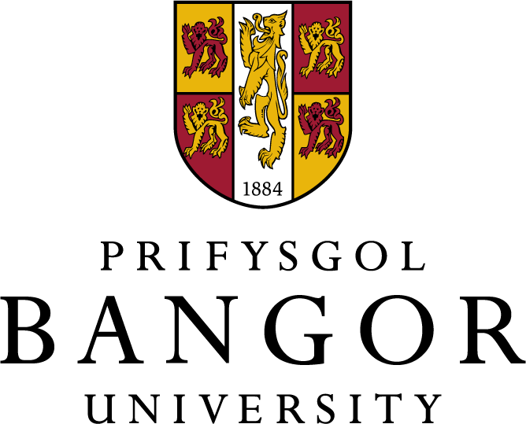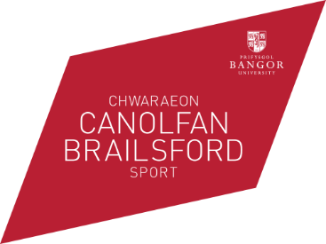

Volunteer programme

The Bangor Sports Volunteer programme (BSV) offers a host of sports related volunteering opportunities for students and staff to get involved in. You can volunteer at local schools, sports clubs, AU clubs and Canolfan Brailsford Sports Centre.

The BSV programme aims to increase:

- active participation in sport within the University and the local community
- the number of students volunteering in sports-related activities
- the coaching and participation opportunities for students in sport
- the experience and leadership skills of students and encouraging them into the sports sector.

The BSV programme is open to all students who wish to:

- learn new skills
- gain a sports coaching award
- work in the local community
- improve employability and diversify their CV

Benefits
- Gain valuable experience and increase your employability.
- Gain practical insight into working with young people.
- Opportunity to gain national governing body and first aid qualifications.
- Meet new people and make new friends.
- Enhance your student experience.
- Free DBS check (formerly CRB check).
- Sports kit provided.
- BEA points
For further information, please contact Iona Williams on iona.williams@bangor.ac.uk or 01248 382571.

