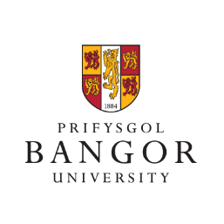
Bangor University Community Board Meeting (22nd March 2022)
Attendance: Representatives from the following bodies/institutions attended the meeting: Bangor University and Bangor Students Union; North Wales Police; Mantell Gwynedd; Cyngor Gwynedd Council; Bangor City Council; Ysgol Friars School; Adra; Betsi Cadwaladr University Health Board; Medrwn Môn; Grŵp Llandrillo Menai; Rhwydwaith Dolan Network.
Discussion matters: With Professor Andrew Edwards, Pro-Vice Chancellor for Civic Engagement, chairing, the following matters were discussed: Cases of spiking drinks amongst students and the work of the University/Police to prevent this; developments with the Parc y Coleg/College Park project; Graduation Ceremonies Summer 2022; the latest on the University and Health Board response to the Covid-19 pandemic; possible support to refugees from Ukraine; the latest on Pontio’s programme; developments with the University’s Civic Mission strategy; developments with the Cyngor Gwynedd Council ‘Clean and Tidy Communities’ project in Bangor city centre; the latest on the possible Health and Wellbeing Hub and Medical School in Bangor city centre; the latest on Adra projects in Bangor; the latest on Partneriaeth Ogwen Partnership projects in the Bethesda area; an update on Bangor City Council local elections in May 2022; developments with the flood prevention scheme in the Hirael area; the possibility of the University hosting a Community Day in 2023.

