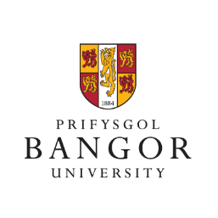
Bangor University Community Board Meeting (9th June 2022)
Attendance: Representatives from the following bodies/institutions attended the meeting: Bangor University and Bangor Students Union; Cyngor Gwynedd Council; Bangor City Council; Bangor Civic Society; North Wales Regional Equality Network; Rhwydwaith Dolan Network; Medrwn Môn; Adra; Grŵp Llandrillo Menai.
Discussion matters: With Professor Andrew Edwards, Pro-Vice Chancellor for Civic Engagement, chairing, the following matters were discussed: Support for refugees from Ukraine; the latest on appointing a new Vice-Chancellor; arrangements for staff and students on campus from September onwards; preparations for the Graduation Ceremonies Summer 2022; the latest on the Parc y Coleg/College Park project and facilities for skateboarders; the latest on the University’s Civic Mission strategy and webpage and the possibility of a Community Day in 2023; a summary of the University’s 2021 REF results; the latest on the work of Grŵp Llandrillo Menai and collaboration with the University; an update on the University’s Estates strategy; an update on Bangor City Council following the local elections in May 2022; a summary of the work of Bangor Students Union.

