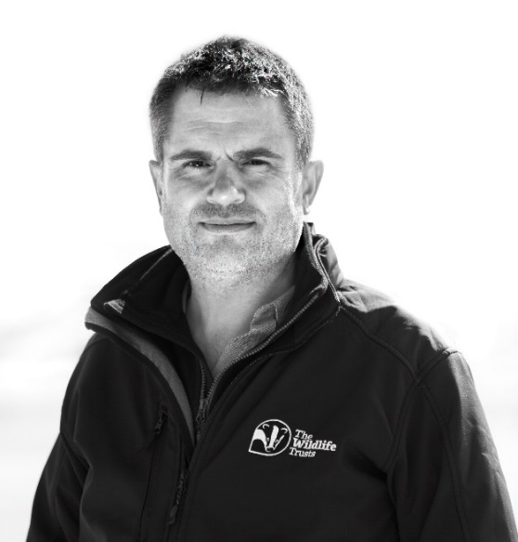
Craig Bennett
Chief Executive, The Wildlife Trusts
@craigbennett3

Craig is Chief Executive of The Wildlife Trusts. He has been described as “one of the country’s top environmental campaigners”, by The Guardian as “the very model of a modern eco-general” and, in 2021, was included in The Sunday Times Green Power List of the UK’s top 20 environmentalists.
The Wildlife Trusts are one of the largest landowners in the UK with more than 870,000 members and 35,000 volunteers. They are working in the heart of local communities to help nature recover and to ensure that is nature is part of everyone’s lives. Since becoming chief executive in 2020, Craig has spearheaded plans to protect 30% of UK land and sea for nature by 2030.
Craig was formerly CEO of Friends of the Earth where he refocussed the organisation to empower communities to take action on the climate and ecological crises, resulting in a step change in the scale and impact of the movement, with over 200 new Friends of the Earth community groups set up during his tenure. He also led the organisation to numerous campaign victories including on bees, fracking and against the expansion of Heathrow Airport.
Earlier in his career, Craig was Deputy Director at The University of Cambridge Institute for Sustainability Leadership (CISL), and Director of The Prince of Wales’s Corporate Leaders Group on Climate Change (from 2007 to 2010) which he transformed into one of the most progressive business voices on the international climate change agenda.
Craig has twenty years’ experience of designing and contributing to executive education and leadership programmes at numerous universities and business schools around the world including the Judge Business School, London Business School, Duke CE, and many others.
He also has a long history of providing advice and constructive challenge direct to CEOs and company boards. He is currently Chair of the Independent Challenge Group for Anglian Water, and a member of the Innovation Lab for Marks and Spencer plc. He was previously a member of the Net Positive Board for Kingfisher plc.
He is Honorary Professor of Sustainability and Innovation at Alliance Manchester Business School, an Associate Fellow of Homerton College (Cambridge), a Senior Associate of The Cambridge Institute for Sustainability Leadership, and a Policy Fellow of The Centre for Science and Policy at The University of Cambridge. He is also a Fellow of the Royal Geographical Society and a Fellow of the Royal Society of Arts.
He has a BSc (Hons) in Human and Physical Geography from The University of Reading and an MSc in Biodiversity Conservation from University College London, and Honorary Doctoral degrees from University College of Estate Management (UCEM), and Anglian Ruskin University (ARU).
He is also a judge on The Wainwright Book Prize, a Trustee of the think-tank Green Alliance. and an Honorary Fellow of the Chartered Institute of Water and Environmental Management (CIWEM). He regularly appears in the print and broadcast media.
@CraigBennett3 @ craigbennett3
www.linkedin.com/in/craig-bennett3
Craig Bennett
Prif Weithredwr, The Wildlife Trusts
@craigbennett3

Craig yw Prif Weithredwr The Wildlife Trusts. Cafodd ei ddisgrifio gan The Guardian fel “one of the country’s top environmental campaigners” a “the very model of a modern eco-general” ac, yn 2021, cafodd ei gynnwys yn yr 20 uchaf yn The Sunday Times Green Power List o amgylcheddwyr pennaf y Deyrnas Unedig.
The Wildlife Trusts yw un o dirfeddianwyr mwyaf y Deyrnas Unedig gyda mwy na 870,000 o aelodau a 35,000 o wirfoddolwyr. Maent yn gweithio gyda chymunedau lleol i helpu byd natur i ddod ato’i hun ac i sicrhau bod natur yn rhan o fywydau pawb. Ers dod yn brif weithredwr yn 2020, mae Craig wedi arwain ar gynlluniau i ddiogelu 30% o dir a môr y Deyrnas Unedig ar gyfer byd natur erbyn 2030.
Yn flaenorol Craig oedd Prif Swyddog Gweithredol Cyfeillion y Ddaear lle hoeliodd sylw’r sefydliad o’r newydd ar rymuso cymunedau i weithredu ynghylch yr argyfwng hinsawdd a’r argyfwng ecolegol, gan arwain at newid sylweddol ym maint ac effaith y mudiad, gyda dros 200 o grwpiau cymunedol newydd yn cael eu sefydlu fel rhan o Gyfeillion y Ddaear yn ystod ei gyfnod yn y swydd. Ef hefyd arweiniodd y sefydliad mewn sawl ymgyrch lwyddiannus gan gynnwys ymgyrchoedd gwenyn a ffracio ac ymgyrch yn erbyn ehangu Maes Awyr Heathrow.
Yn gynharach yn ei yrfa, roedd Craig yn Ddirprwy Gyfarwyddwr yn The University of Cambridge Institute for Sustainability Leadership (CISL), a Chyfarwyddwr The Prince of Wales’s Corporate Leaders Group on Climate Change (o 2007 i 2010) a drawsnewidiodd i fod yn un o'r lleisiau busnes mwyaf blaengar mewn perthynas â’r agenda newid hinsawdd ryngwladol.
Mae gan Craig ugain mlynedd o brofiad o ddylunio a chyfrannu at raglenni addysg weithredol ac arweinyddiaeth mewn nifer o brifysgolion ac ysgolion busnes ledled y byd gan gynnwys Judge Business School, London Business School, Duke CE, a llawer o rai eraill.
Mae ganddo hefyd hanes hir o ddarparu cyngor uniongyrchol a chynnig her adeiladol i Brif Weithredwyr a byrddau cwmnïau. Ar hyn o bryd ef yw cadeirydd grŵp herio annibynnol Anglian Water, ac mae’n aelod o labordy arloesi Marks and Spencer plc. Cyn hynny roedd yn aelod o fwrdd Net Positive Kingfisher plc.
Mae'n Athro Er Anrhydedd mewn Cynaliadwyedd ac Arloesedd yn Alliance Manchester Business School, yn Gymrawd Cyswllt Homerton College (Caergrawnt), yn Uwch Gydymaith The Cambridge Institute for Sustainability Leadership, ac yn Gymrawd Polisi The Centre for Science and Policy ym Mhrifysgol Caergrawnt. Mae hefyd yn Gymrawd Y Gymdeithas Ddaearyddol Frenhinol ac yn Gymrawd Cymdeithas Frenhinol y Celfyddydau.
Mae ganddo BSc (Anrh.) mewn Daearyddiaeth Ddynol a Ffisegol o Brifysgol Reading ac MSc mewn Cadwraeth Bioamrywiaeth o Goleg Prifysgol Llundain, a graddau Doethur er Anrhydedd gan yr University College of Estate Management (UCEM), a Phrifysgol Anglian Ruskin (ARU).
Mae hefyd yn un o feirniaid The Wainwright Book Prize, yn un o ymddiriedolwyr y felin drafod Green Alliance ac yn Gymrawd er Anrhydedd y Chartered Institute of Water and Environmental Management (CIWEM). Mae'n ymddangos yn gyson yn y cyfryngau print a darlledu.
@CraigBennett3 @ craigbennett3
www.linkedin.com/in/craig-bennett3

