Entrance Scholarship Examination - Economics

Answer 2 questions
Time allowed – 2 hours

- Why did the UK government’s policy of austerity between 2010 and 2019 fail to reduce government debt?

Figure 1: General government gross debt as a percentage of gross domestic product (GDP), UK, financial year ending 1995 to financial year ending 2020 (source: ONS).
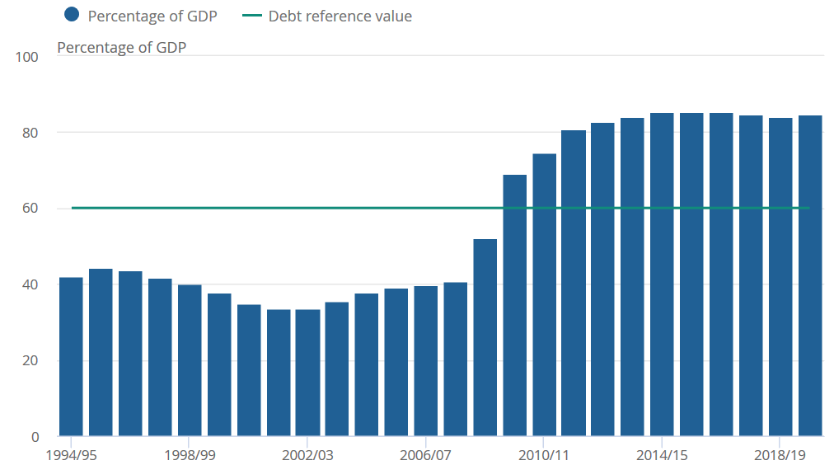

- Explain the Phillips Curve relationship between unemployment and inflation. According to the Bank of England’s November 2020 Monetary Policy Report, “the unemployment rate was projected to rise markedly [whilst] CPI inflation was expected to be around 2% in two years’ time”. Are these forecasts consistent with the Phillips Curve?

- The prohibition in the United States on the production, importation, transportation, and sale of alcoholic beverages from 1920 to 1933 proved to be highly lucrative for those criminals who defied the ban. Use demand and supply analysis to explain why this was the case.

- What do you believe will be the main long-term effects of Brexit on the economies of the UK and the EU? Support your reasoning with reference to economic theories.

- A popular argument in favour of the NHS is that good health care is essential for everyone, and so it must be provided by the state. However, nutritious food is just as essential, and yet we rarely hear arguments in favour of the state taking over the supply of food. Discuss why is it that state is expected to provide health care, but not food.

- Explain the difference between marginal and average costs. Which of these definitions of cost is more suitable as a basis for decision making, and why?

