**Bangor University**

**School of Sport, Health and Exercise Sciences**

**Entrance Scholarship Exam 2022**

**Time**: 2 hours.

**Instructions to Candidates**

Use black ink or black ball-point pen. Do not use pencil or gel pen.

Write your name and school/college on your answer booklet.

ANSWER ALL QUESTIONS.

Write your answers on the answer sheet provided. If you use more than one sheet of paper, fasten the sheets together.

**Information for Candidates**

The number of marks is given in brackets [ ] at the end of each part question. There are a maximum of 42 marks available.

You are reminded of the need for good English and clear presentation in your answers.

Diagrams, charts and graphs can be used to support answers when they are appropriate.

This examination paper consists of two printed pages.

1. **Identify the three main axes of rotation and provide a sporting example for each. [3]**
2. **Using examples, explain three social barriers that may account for the lower participation rate of women in competitive sport. [3]**
3. **The diagram below shows the S-shaped curve of performance for a gross motor skill.**



**(a) The part of the curve of performance labelled 3 is called: Tick one box only. [1]**

󠄀 A: Plateau

󠄀 B: Linear

󠄀 C: Positive acceleration

󠄀 D: Negative acceleration

󠄀 E: Associative

**(b) Identify one possible cause of a plateau and explain ways in which a coach can help a performer to combat the performance plateau effect. [6]**

1. **Evaluate the factors that determine the predominant energy system used when training to develop strength and muscular endurance. [6]**
2. **Using practical examples explain somatic anxiety and evaluate somatic anxiety management techniques that could be used prior to competition. [8]**
3. **Using the diagram below as a guide, discuss the methods a coach could use to improve the skill levels of a performer. Provide specific examples where appropriate. [15]**

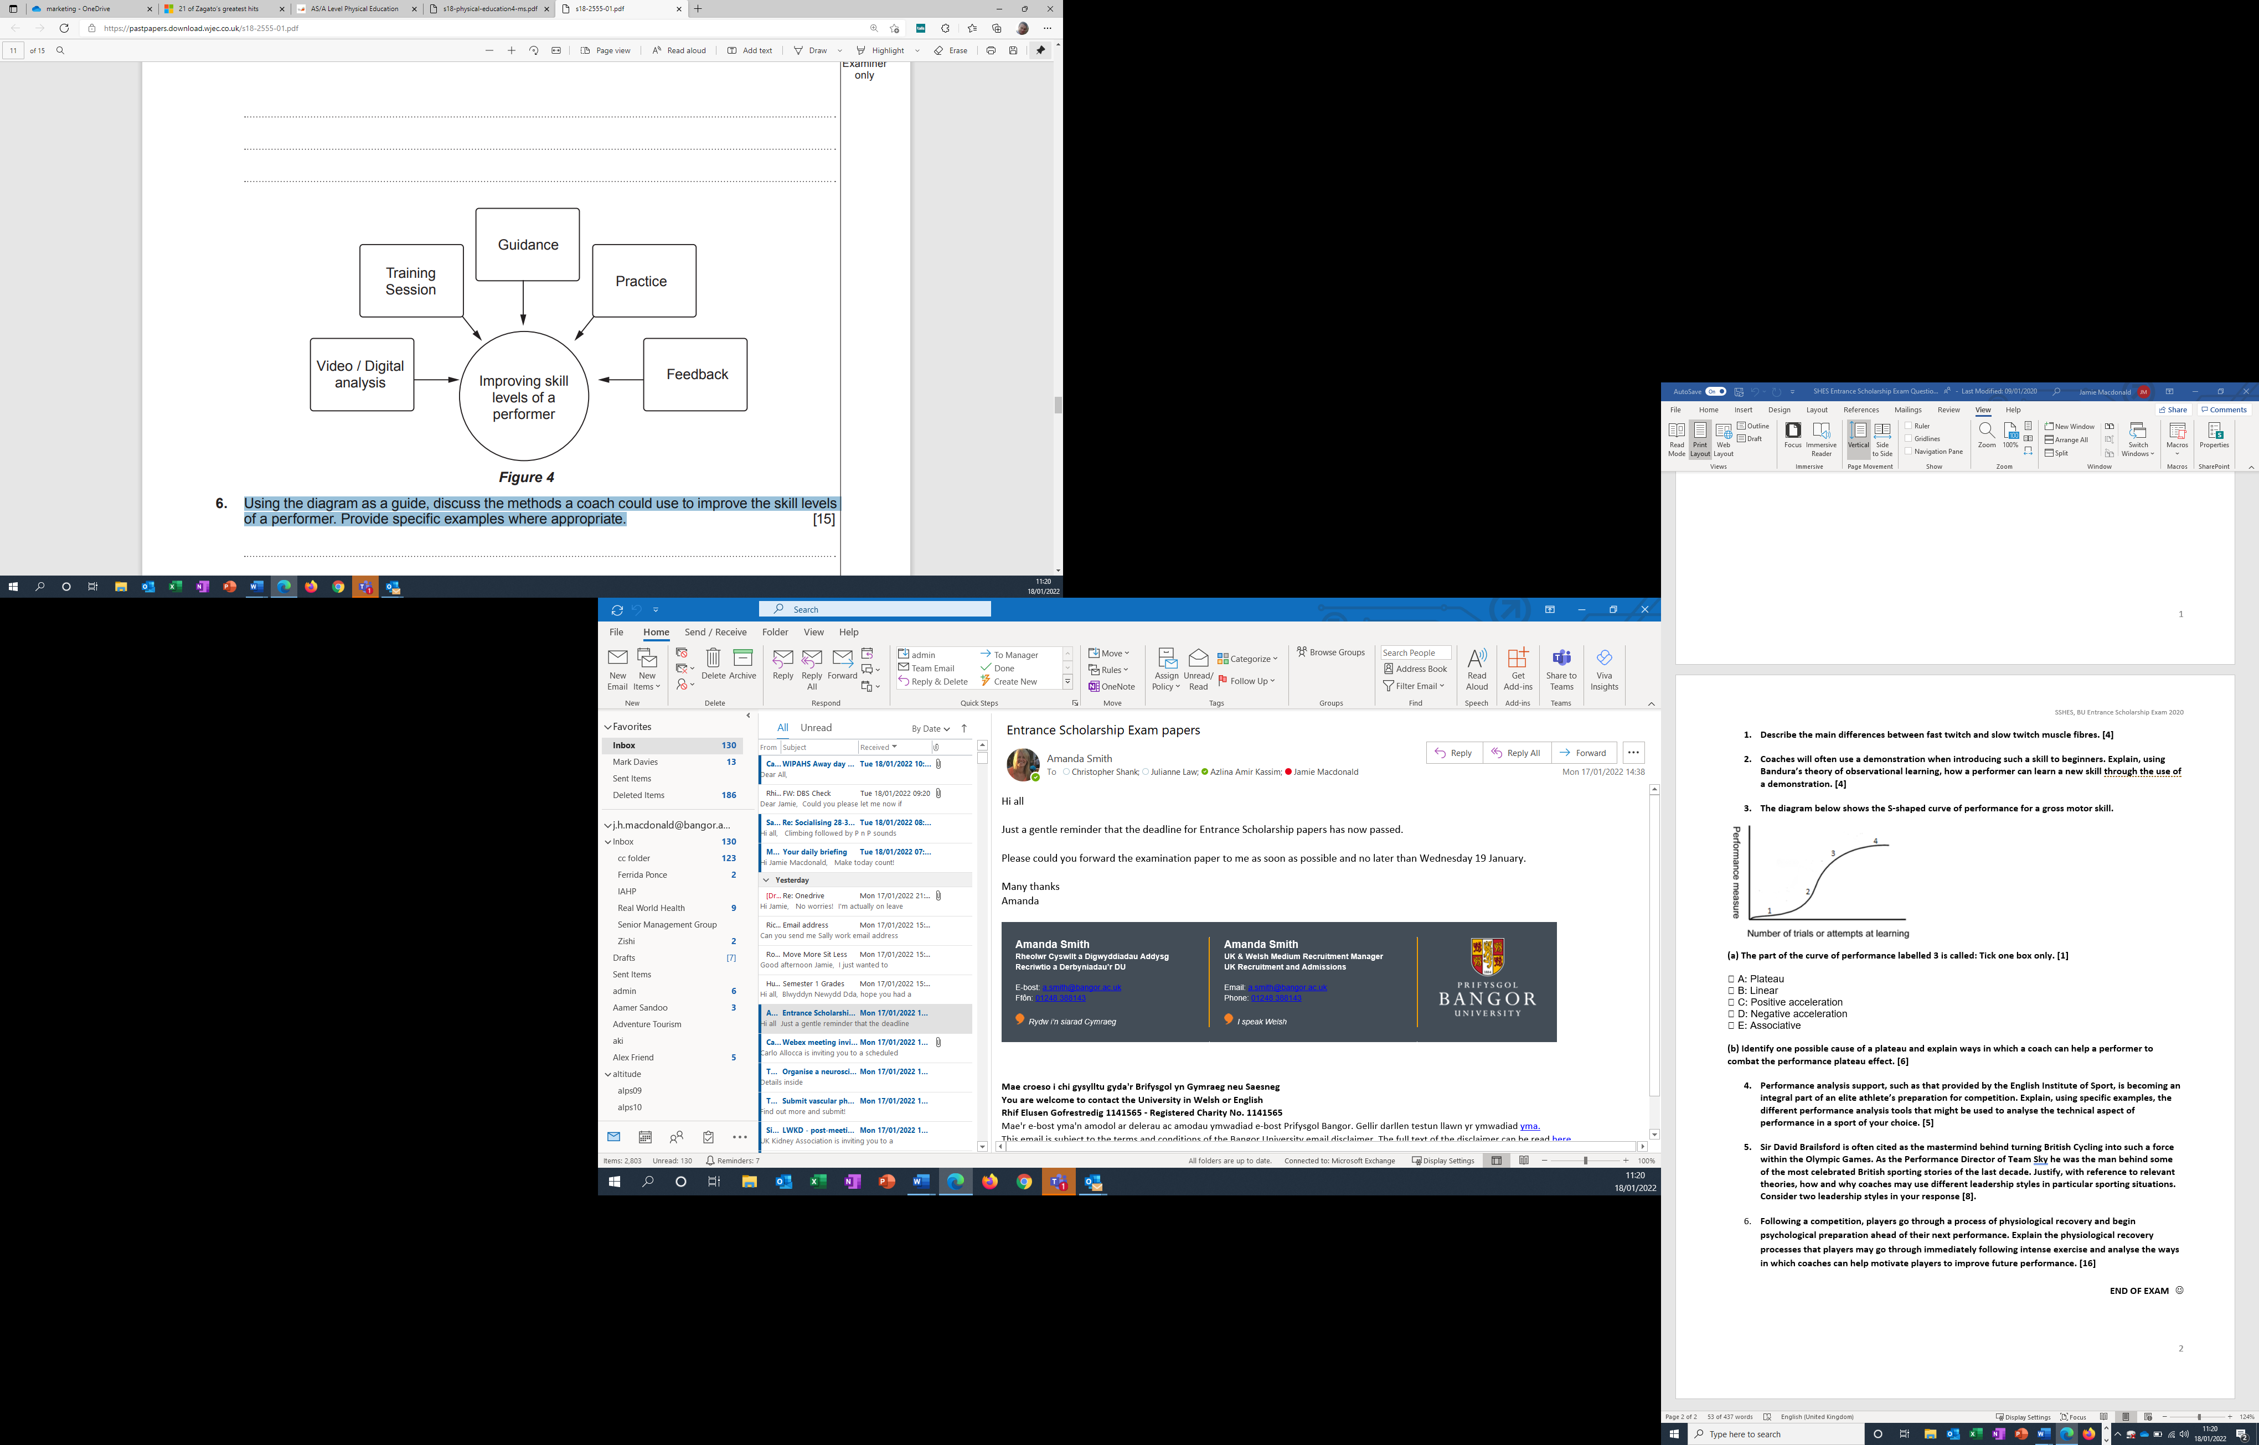**END OF EXAM** J