AdaptQoL Participant Information Leaflet (WP1)

Version 1.2, 18/08/2025

**AdaptQoL** is a national research study. We want to find out how assistive technologies (like wheelchairs and hearing aids) affect health and quality of life. Your assistive technology provider has suggested that you may be eligible to take part

# A box with the title of the study, AdaptQoL. There is a sub-heading that states Adaption and Quality of Life. There is black and white image in the shape of a light-bulb.

# Join our new research project, and help us to understand how assistive technologies affect health and quality of life!

**£20 Amazon** **voucher** for all interview participants

WHY HAVE I BEEN INVITED TO TAKE PART?

We are looking for assistive technology users to take part in interviews about   
their health and quality of life.

You have been invited to take part because:

* You’re aged 18 or older and use assistive technology
* Your support service felt that you would be eligible to take part
* We want to include a mix of people with different skills, strengths and difficulties
* We want to include a mix of people who use different types of assistive technologies

WHAT IS THE ADAPTQOL PROJECT?

We want to find out how assistive technology (like wheelchairs, communication aids, hoists and hearing aids) can affect health and quality of life. The term ‘quality of life’ can mean lots of different things, such as happiness, life satisfaction and well-being. We want to know what quality of life means to you, and the ways assistive technology can impact and improve your life. We will use the information you provide to create a new survey tool, called **AdaptQoL**, which will be used by assistive technology providers, like the NHS, to measure the benefits of different devices and aids.

WHY IS THIS RESEARCH NEEDED?

Each year millions of assistive technology devices are provided by the NHS and care services to help people do everyday tasks, like moving around, self-care and communicating. Our aim is to develop the **AdaptQoL** tool to help measure the benefits and impacts of assistive technology. This will help the NHS and social care to provide the best care possible to people who use these types of aids and devices. With your help we will make sure that the toolis accurate and reliable.

DO I HAVE TO TAKE PART?

No, it’s completely your choice, it’s OK if you don’t want to take part. If you do decide to take part you can stop at any time without giving a reason, it won’t affect any care you receive. If you would like a partner, carer or family member to take part with you, that is ok too.

AdaptQoL Participant Information Leaflet (WP1)

Version 1.2, 18/08/2025

WHAT WILL HAVE TO DO IF I TAKE PART?

You can contribute to the **AdaptQoL** project by completing the questionnaire provided with this leaflet and then taking part in an interview. In the interview you will be asked to discuss a range of topics including:

* What quality of life means to you
* Your thoughts on the ways impairment, disability and assistive technology affect quality of life
* Your opinion on how best to measure the benefits of different aids and devices

If you would like to take part in an interview, please complete the questionnaire sent with this leaflet and post it back to us using the pre-paid envelope (an online version is also available using the QR code below or on the front of the questionnaire). One of the project team will get in touch with you to arrange a convenient date for an interview. The interview will last up to an hour. If you say it is OK, the interview will be recorded. You can choose if you want to take part in an interview by yourself or have someone with you (like a friend, partner, carer or parent). The interview will be conducted online or over the phone, but if you prefer it can also be carried out in-person at a location of your choosing, such as your home. If you need any additional support to participate, such as sign language, please let the research team know.

WILL MY DATA BE PROTECTED AND CONFIDENTIAL?

Anything you tell us will be completely confidential – we will not share your data unless you tell us something which makes us seriously worried about your immediate safety or someone else’s safety. All data collected is subject to the UK’s data protection laws and will be handled in strict confidence and securely stored by Bangor University on secure servers.

ARE THERE ANY RISKS OR BENEFITS TO TAKING PART?

We do not think that there are any risks to you if you decide to take part. We may ask you some sensitive questions in the interview about your health and quality of life, but you can choose not to answer any questions which make you feel uncomfortable. Although we do not expect there to be any direct benefits for you, you will receive a **£20 Amazon gift voucher** as a thank you for taking part in an interview.

WHO IS FUNDING THIS PROJECT AND HAS IT BEEN REVIEWED?

The project is funded by Health and Care Research Wales (project number 02-24-026). This project has been reviewed and given favourable opinion by an NHS Research Ethics Committee (ref. no. 348110).

A QR code on a white background


**This information sheet is also available in several other accessible formats, including ‘Easy Read’, video, large print, electronic, and Welsh. Please scan the QR code to access other formats**

**GET IN TOUCH WITH THE PROJECT TEAM**

[**www.bangor.ac.uk/adaptqol**](http://www.bangor.ac.uk/adaptqol)

[**adaptqol@bangor.ac.uk**](mailto:adaptqol@bangor.ac.uk)

**Tel: 07792670053**



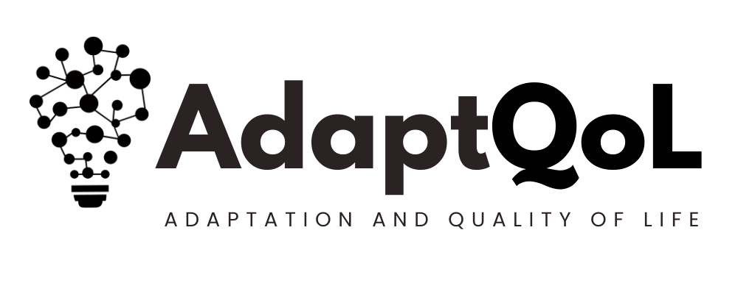

Please read the FAQ for some more detailed information about the project. If you have any further questions you can phone us, write to us or e-mail us.

If you would like to take part in this study, please complete the questionnaire provided and return it using the paid envelope (or online using the link in the questionnaire). A member of team will be in touch to arrange an interview

**WHAT DO I NEED TO DO NEXT?**

[**www.bangor.ac.uk/adaptqol**](http://www.bangor.ac.uk/adaptqol)

[**adaptqol@bangor.ac.uk**](mailto:adaptqol@bangor.ac.uk)

**Tel: 07792670053**



**Frequently Asked Questions (FAQs)**

Please read the FAQ for some more detailed information about the project. If you have any further questions you can phone us, write to us using the prepaid envelope, or e-mail us.

If you would like to take part in this research, please complete the questionnaire provided and return it using the pre-paid envelope (or online using the link/QR code in the questionnaire). One of the team will be in touch to arrange an interview

**The information in this FAQ is quite detailed and comprehensive. It’s ok if you just want to read the questions/answers that are relevant to you**

A box with the title of the study (AdaptQoL) in black letters. 
A black and white image in the shape of a light-bulb.If you have any questions which are not answered by the FAQ, please get in touch with us using the **contact details** on the previous page

**What is the full title of this study?**

The full title is: *Adaptation and Quality of Life (AdaptQoL): Development of a patient-reported outcome measure for people who use assistive technologies and other adaptive interventions*

**What is the AdaptQoL project?**

The AdaptQoL project is a national research study. The aim of the project is to develop a new survey tool (called AdaptQoL) which can be used to measure the benefits of assistive technologies like wheelchairs, hearing aids and hoists. We will develop the AdaptQoL survey tool by interviewing a wide range of assistive technology users, and then testing how reliable the tool is.

**Why is the AdaptQoL project happening?**

Each year millions of aids and devices (known as assistive technologies) are provided by the NHS and care services to help people do everyday tasks, like moving, self-care and communicating. We want to understand the relationship between assistive technology and quality of life.

In order to do this, we need to first find out what quality of life means to you and other assistive technology users. The term ‘quality of life’ can mean lots of different things, such as happiness, life satisfaction and well-being. We will analyse what you tell us to help create the AdaptQoL survey tool. We will design the AdaptQoL tool so that assistive technology providers can use it to measure the benefits of different devices and aids. This will help the NHS and social care to provide the best care possible to people who use assistive technologies.

**What do you mean by ‘assistive technology’?**

Assistive technology is a broad term which refers to many different devices and aids, such as wheelchairs, hearing aids, home adaptations, communication aids, environmental controls, aids for personal care and so on. The Medicines and Healthcare Products Regulatory Agency (MHRA) define assistive technology as “*products or systems that support and assist individuals with disabilities, restricted mobility or other impairments to perform functions that might otherwise be difficult or impossible*". Adaptive interventions extend beyond technology and can include human assistance to promote independence and even animal assistance such as guide dogs and other support animals.

These types of aids and devices tend to fit into 5 categories:

1. Mobility (e.g. wheelchair, walking stick, prosthetic limb)
2. Cognition (e.g. memory aid, personal digital assistant, voice recorder)
3. Communication (e.g. text-to-speech software, captioning app, eye-tracking device)
4. Self-care and daily activities (e.g. shower chair, adapted cutlery, toilet frame)
5. Sensory (e.g. hearing aid, screen reader, white cane)

**Who is running this project?**

The AdaptQoL project is being led by Dr Nathan Bray. The research tasks are being carried out by experienced researchers at Bangor University, with support from a range of organisations including: Valorem Health, Royal Hospital for Neuro-disability, Betsi Cadwaladr University Health Board, North Wales Society for the Blind, Swansea Rehabilitation and Engineering Unit, and the Barnsley Assistive Technology Team. This project is sponsored by Bangor University who have overall responsibility for the management of the research. Bangor University hold appropriate insurance policies to protect against harm and offer compensation.

**Who is funding this project?**

The project is funded by the Welsh Government, through Health and Care Research Wales (project number 02-24-026). The project steering group meets regularly to advise the research team, this group includes experienced researchers, health and social care professionals and service users.

**Why do you need information from me?**

Your experiences and opinions are important to us. Collecting information from assistive technology users is the best way for us to understand the relationship between assistive technology and quality of life. The information you provide will help us to achieve our research aims.

**Why am I being invited to take part in an interview for this project?**

We are looking for assistive technology users to take part in interviews. You have been chosen because:

* You’re aged 18 or older and use assistive technology
* Your assistive technology provider or support service felt that you would be eligible to take part
* We want to include a mix of people with different skills, strengths and difficulties.
* We want to include a mix of people who use different types of assistive technologies

We will check your answers on the questionnaire to make sure that you are eligible to take part. The criteria are:

* You have had a long-term impairment which resulted in   
  you using assistive technology
* You are able to communicate in English or Welsh
* You are aged 18 or older, you are able to understand the   
  project and you are able to provide consent

Unfortunately if you do not meet all of these criteria we will not be able   
to interview you.

**How long will the AdaptQoL project run for?**

If you decide to take part, your involvement will be quite brief – you will only be asked to take part in one interview initially. This is the first part of a larger project which will run for 2 years and we aim to recruit assistive technology users from across the UK. You may be given the opportunity to take part in other aspects of the project if you would like to.

**Do I have to take part in the AdaptQoL project?**

No - you are free to choose, and your decision will not impact the care or support you receive. Taking part in the project is completely optional. If you would like a partner, carer or family member to take part with you, please let the research team know.

**If I decide to take part, what will that involve for me?**

1. *Consent form and questionnaire*: First we have requested that you give your formal agreement (‘consent’) to participate in this research, this is at the beginning of the questionnaire provided with this leaflet. You will then need to fill in the rest of the questionnaire, which contains some questions about you, your health and your use of assistive technology. You can complete these online if you prefer, a link/QR code is provided in the questionnaire for an electronic version.
2. *Interview*: Once you return a completed questionnaire to us (by using the pre-paid envelope or online), a member of the research team will be in touch to arrange a date for an interview. In the interview you will be asked to discuss a range of topics including:
   * What quality of life means to you
   * Your thoughts on the ways impairment and assistive technology affect quality of life
   * Your opinion on how best to measure the benefits of different aids and devices

The interview will last up to an hour. If you say it is OK, the interview will be recorded. You can choose if you want to take part in an interview by yourself or have someone with you (like a friend, partner, carer or parent). Interviews will be conducted online or over the phone. If you prefer the interview can also be carried out in-person at a location of your choosing, such as your home. If you need any additional support to participate, such as sign language, please let the research team know.

**What should I do if I am not sure about taking part?**

Please get in touch with us if there is anything that is not clear or if you want to know more. You may also want to discuss the AdaptQoL project with your family and friends or a health care professional before making a decision.

If you would like to know more about this project, please contact us using the contact details provided earlier in this leaflet.

**What if I decide to take part, but later decide to withdraw?**

You can stop being part of this research at any time without giving a reason, even after you have completed an interview, there is no time limit on withdrawal. Withdrawing from the project will not affect the care you receive now or in the future.

If during the project you lose capacity to take part, you will be withdrawn from the project, but we will keep the information that you have already provided. Any data we do have will remain confidential and will not be used for any other purpose.

If you would like to withdraw, you can do this by contacting the AdaptQoL project office using the contact details provided in this leaflet.

**If I agree to take part, will you ask me to do more in the future?**

If you decide to take part, we will ask you whether or not you would like to be approached to take part in future aspects of this research. If you agree, you may be asked to participate in other optional activities. For example, completing additional questionnaire surveys. This is optional, and you can decide later.

**What will happen to the results of the project?**

We will share the results with all participants who take part (unless you tell us that you do not wish to know), as well as all the services who helped us recruit participants. We will also actively share the results with decisionmakers. We will write a clear summary of our findings and make this openly available to the public.

We also intend to publish the results in scientific journals, conferences, and newsletters. You will not be identified in any report or publication we write.

**What are the benefits of taking part?**

We are not certain that you will gain any direct benefit from taking part. By taking part, you will be helping us learn more about how assistive technology improves and impacts quality of life. The results of this research will help NHS and care services to measure the benefits of assistive technology and improve care.

**What are the disadvantages and risks of taking part?**

We do not think that there are any serious risks to you if you decide to take part.

We understand that completing the questionnaire and taking part in the interview will require some of your time. Some of the topics we discuss in the interview may be sensitive, but you do not have to answer any questions that make you feel uncomfortable or upset.

**Are there expenses or payments?**

You will receive a **£20 Amazon voucher** for taking part in an interview.

**What are your procedures for safeguarding, disclosures and support?**

Your safety and wellbeing are our top priority. While we will always try to maintain your confidentiality, there may be situations where we have to share your information with appropriate services. This would only happen if:

* Something you say makes us believe that you or someone else is at risk of serious harm
* We become aware of a safeguarding concern (e.g. involving a child or vulnerable adult)

Wherever possible, we would discuss this with you first and explain who we will inform and why.

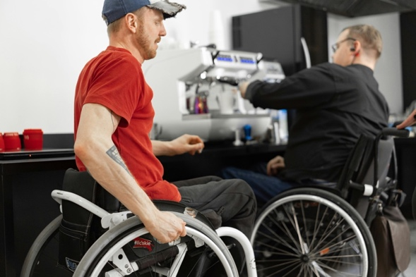If you feel upset or distressed at any point during or after the study, you may pause or stop your participation without giving a reason. Please use the contact details provided in this leaflet if you have any concerns or become distressed after the interview has concluded.

**How will you use information about me?**

We will need to use information from you for this research project.

This information will include:

* Your name and contact details
* The answers you give on the questionnaire
* This information you tell us in the interview

People will use this information to do the research or to check your records to make sure that the research is being done properly.

People who do not need to know who you are will not be able to see your name or contact details. Your data will have a code number instead.

Bangor University is the sponsor of this research and is responsible for looking after your information. We will not share your information related to this research project with other organisations.

We will keep all information about you safe and secure by:

* Storing your data on secure computer servers at Bangor University
* Not sharing your identifiable data outside of our organisation

Your data will not be shared outside the UK.

**How will you use information about me after the study ends?**

Once we have finished the study, we will keep some of the data so we can check the results. We will write our reports in a way that no-one can work out that you took part in the study.

We will keep your identifiable study data for a maximum of 1year. The study data will then be fully anonymised and securely archived for 10 years and then destroyed.

**What are my choices about how my information is used?**

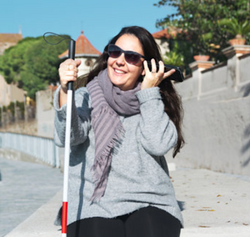You can stop being part of the study at any time, without giving a reason, but we will keep information about you that we already have. You have the right to ask us to access, remove, change or delete data we hold about you for the purposes of the study. You can also object to our processing of your data. We might not always be able to do this if it means we cannot use your data to do the research. If so, we will tell you why we cannot do this.

**Where can I find out more about how my information will be used?**

You can find out more about how we use your information:

* from our leaflet
* by asking one of the research team
* by sending an email to adaptqol@bangor.ac.uk
* by ringing us on 07792670053
* [www.hra.nhs.uk/patientdataandresearch](http://www.hra.nhs.uk/patientdataandresearch)

**Will my taking part in the project be kept confidential?**

Yes. We will follow ethical and legal practice and all information which is collected from you for the purpose of this research project will be handled in strict confidence and securely stored by Bangor University on secure servers. All data collected is subject to the UK’s data protection laws.

Throughout the research, to safeguard your rights, we will use the minimum amount of personally identifiable information possible. We are required to manage your records in specific ways for the research to be reliable. This means that we may not always be able to let you see or change the data we hold about you.

**Who has reviewed and approved this research?**

All research in the NHS is looked at by an independent group of people, called a Research Ethics Committee (REC), to protect your interests. This project has been reviewed and given favourable opinion by the NHS Seasonal REC (IRAS ref. no. 348110).

**What if there is a problem?**

If you have any concerns about this project or if you would like to make a complaint, please contact Dr Diane Seddon ([d.seddon@bangor.ac.uk](mailto:d.seddon@bangor.ac.uk)). Dr Seddon is a senior researcher at Bangor University and is independent from the research team.

**We hope that this information has helped you to decide if you would like to participate in this research. Please contact us if you have any further questions**