|  |
| --- |
|  |
| bangor university  B-Enterprising Impact Report |



# August 2024 to July 2025

## Background

### Who are we

The B-Enterprising Team are based in Bangor University’s Careers & Employability Service, and our aim is to provide opportunities for our students and graduates to develop their enterprise skills and to support those who want to start their own business or social enterprise or develop their freelance careers.

### The Team

|  |  |
| --- | --- |
|  | **Lowri Owen**  B-Enterprising Manager |
|  | **Kath Lewis**  Graduate Start-Up Coordinator |
|  | **Dr Beth Edwards**  Enterprise Education Development Coordinator |

## Our Mission

Bangor University is grateful for the financial support it receives from the Welsh Government, Santander Universities and Medr which has enabled us to offer an array of enterprising opportunities to our students.

Bangor University has a strong mission commitment to the economic, social and cultural wellbeing of Wales and provides its students with opportunities to develop their enterprise and entrepreneurial skills and to support those interested in taking their business ideas forward.  Included in the University’s Strategy 2030 is ‘the priority to aspire for ‘greater employability, start-up and commercialisation across North Wales’.

The University has encountered several challenges during the year and has had to work through the approved Business Case for Change. As a result, confirmation of the internal operational costs from the RWIF fund was delayed until late in semester 1 and the amount available was reduced. This resulted in the team having to

review our operational activities and be creative and innovative in our delivery.

It was decided to make it a requirement for students or graduates who wanted an appointment with the Graduate Start-Up Coordinator or who wanted to apply for funding to complete the online Enterprise & Business Start-Up Pathway first. The time taken by students to complete the pathway resulted in delayed appointments and allocation of the Enterprise Fund and delayed start-up dates, but as a result the students were better informed. A change in brand marketing policy meant that the B-Enterprising brand was discontinued and a corporate Bangor University brand was incorporated by the Careers & Employability Service.

### The value of Enterprise and Entrepreneurship Education

Learning about and experiencing enterprise whilst still at university can have several benefits. It gives students alternative perspectives on their career options and the confidence to set up their own business or social enterprise.  Enterprise competencies will be useful to those in employment, or those who become self-employed and work on a freelance or consultancy basis. It can help develop a ‘can-do’ confidence, a creative questioning approach and a willingness to take risks, enabling individuals to manage workplace uncertainty and flexible working patterns and careers.

*QAA Enterprise and Entrepreneurship Education 2018*

## B-Enterprising Opportunities

### For students and graduates:

* Regular one to one business mentoring
* An online Enterprise and Start-Up Pathway
* Funding for developing ideas and start-up through the Enterprise Fund and the Santander Ideas Development Fund
* Free shared office at the Incubation space at M-SParc on Anglesey (Until June 2025)
* Workshops and events to develop skills as well as specialist business start-up support.

### For staff:

* Funding from the Staff Enterprise Fund to develop enterprising projects and activities
* Taught sessions delivered.
* Item loaning.

The B-Enterprising team continue to collaborate with the pan Wales Enterprise Champion networks and with the local and national support network to provide opportunities to our students and graduates.

## Overview of the year

### Start-up Support

The Graduate Start-Up Coordinator supported 50 unique students to develop business ideas over 244 appointments during the year. Despite the number of appointments being higher than the previous year, the number of unique students supported is less due to a decision made by the University to concentrate the support on those close to business start-up and who have completed the online Enterprise and Business Support Pathway.

Video case studies of student and graduate start-ups can be found here: <https://bangor.cloud.panopto.eu/Panopto/Pages/Sessions/List.aspx?folderID=9b79bd99-ea68-4d55-8c37-b33f009360e6>

20 student/graduate start-ups were recorded for HEBCIS report in 2024-25 academic year. Whilst this figure is lower than the previous year, the internal target which were revised due to the reduced funding and support was achieved.

75 students have participated in the online Enterprise and Start-Up Pathway with 22 completing.

A Bangor University student, Aron Owen (Grade Stream) won the Graduate Start-Up of the Year in the annual Wales Start-Up of the Year competition.

https://startupawards.uk/2025-wales-winners/

You can access Aron’s video case study here: <https://bangor.cloud.panopto.eu/Panopto/Pages/Viewer.aspx?id=53e7c905-3b75-41b9-916d-b33f0094a803>

Students and graduates with close to business start-up were given the opportunity to apply for up to £5,000, through the Enterprise Fund and Santander Universities Ideas Development Fund. 22 students and graduates were successful in receiving funding.  100% of feedback respondents stated that the funding received enabled them to move forward and allowed them to spend time on developing their business idea or freelance career.

A free desk at the Incubation space at M-SParc was offered as part of the support for those who are close to or have just started their own businesses. Four businesses were successful in gaining a desk in the office during the year.

### Feedback From Students and Graduates

100% of feedback received from respondents stated that B-Enterprising support provided them with the information, skills and knowledge to take action and given the confidence to progress to the next stage.

‘As an international student, I had limited connections but Kath Lewis, my business mentor helped me in every single way she could. She helped me to convert my idea in an innovative way and helped me in getting grants for my business and this motivated me a lot. ‘

‘B-Enterprising have been amazing with their advice, support, and guidance ‘

‘My mentor has been encouraging and connecting me with professional for extensive assistance. I was always encouraged during the appointment to reshape my venture idea and provide resources for in-depth understanding. ‘

 ‘B-Enterprising helped me gain confidence, build valuable skills, and bring my vision to life. ‘

‘The one-to-one mentoring appointment is very useful and accessible to support all students and graduates to feel more confident about developing and setting up a business. ‘

### Student Christmas Market

The annual Student Christmas Market was held in December 2024 and featured 85 stalls by over 100 students, graduates and staff. Many students used the Christmas Market to test trade their ideas and the event also welcomed back alumni who were already trading. 83% of feedback respondents stated that the Student Christmas Market had helped them to develop their confidence to start a business and to be more enterprising

A video of the Student Christmas Market can be viewed here.

[Student Christmas Market 2024 - Final.mp4](https://bangoroffice365.sharepoint.com/:v:/s/STUSERV-StudentServicesStaff/EdAY5XSC555AsVv4wk8gFMoBfHrjB1FRnDC_cbiFzJL9MQ?e=0hWPCu)

*The best thing about part about being a stallholder at the Student Christmas Market...:*

*‘It was so lovely coming back (I attended last year) and seeing how much my stall has grown. Personally, I think the best part is the entire vibe and energy that the Christmas student market has with the Christmas music. Having a stall is a fantastic opportunity to learn how to price items, interact with customers and ge*t *experience selling’*

*‘.... being able to raise funds for myself, as a result of selling items that I had made, reinforcing the idea that they have value’*

*‘.... the chance to be a small business in a less stressful setting than a regular market.’*

*‘.... meeting other vendors, understanding selling points from people with more experience and networking’*

*‘It is a great opportunity to learn more about the dynamics of business and to learn more about your abilities as a stallholder and as a businessperson. it is also a great opportunity to gather feedback from members of the public, staff and students about products, things they'd like to see more of and things they like about the current products you'd be showcasing.’*

*‘It's a great place to find out who your customers are and whether there is a gap in the market that you can fill’*

### Academic staff support and funding

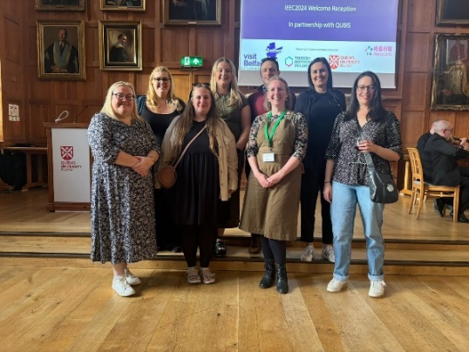

9 staff champions were actively engaged within the curriculum, which included 5 new staff and 9 taught sessions were delivered. 5 academic staff were supported to attend the International Enterprise Education Conference in September. This inspired staff and Bangor were selected to host an Enterprise Educators UK exchange event, led by one of the delegates at this conference.

Research is ongoing which seeks to identify the enablers and barriers for academic staff engaging with enterprise education. This is part of Beth’s PGCertTHE with the intention of sharing this in the future (for example, in journal publications or as an independent report).

The Staff Enterprise Fund of £5,000 per college was fully allocated and resulted in 7 projects being supported across the University. An eligibility criterion for the fund involved developing knowledge about the Entrecomp Framework (a reference framework to understand what is meant by an entrepreneurial mindset) and sharing/ disseminating with colleagues.

Previously funded projects have developed, for example, the School of Psychology and Sports Science have undertaken a mapping project of all undergraduate modules to the EntreComp framework, created a bespoke PowerBI dashboard for staff to understand the scores of modules, and a guide to support staff to develop modules to reflect enterprising competencies. Access to this report can be found here: <https://research.bangor.ac.uk/en/datasets/school-of-psychology-and-sports-science-entrecomp>

A member of academic staff has been supported to submit an EEUK fellowship application, with the outcome pending.

Dr Nia Young and the School of Education, supported by B-Enterprising, hosted an online EEUK Exchange event which attracted around 30 delegates. Recordings for the panel sessions are available to watch through the links below.

**Panel Discussion:  How has the Curriculum for Wales affected the way in which enterprise is embedded in Education?**

<https://youtu.be/0JFIE03ld1U>

**What can ITE teach us about how we teach enterprise to adults and children?**

[https://youtu.be/Dd3CrikqI2w](https://eur01.safelinks.protection.outlook.com/?url=https%3A%2F%2Fyoutu.be%2FDd3CrikqI2w&data=05%7C02%7Cb.a.edwards%40bangor.ac.uk%7Cf9d8c135ee1d4aa705a608ddd58af305%7Cc6474c55a9234d2a9bd4ece37148dbb2%7C0%7C0%7C638901514990981436%7CUnknown%7CTWFpbGZsb3d8eyJFbXB0eU1hcGkiOnRydWUsIlYiOiIwLjAuMDAwMCIsIlAiOiJXaW4zMiIsIkFOIjoiTWFpbCIsIldUIjoyfQ%3D%3D%7C0%7C%7C%7C&sdata=4bGq%2FlX8Ee9Sh9BRPsLE19NW3RlrQXq6CvX7HwuGrek%3D&reserved=0)

**Panel Q&A**

[https://youtu.be/w0ufuul3aR4](https://eur01.safelinks.protection.outlook.com/?url=https%3A%2F%2Fyoutu.be%2Fw0ufuul3aR4&data=05%7C02%7Cb.a.edwards%40bangor.ac.uk%7Cf9d8c135ee1d4aa705a608ddd58af305%7Cc6474c55a9234d2a9bd4ece37148dbb2%7C0%7C0%7C638901514991013999%7CUnknown%7CTWFpbGZsb3d8eyJFbXB0eU1hcGkiOnRydWUsIlYiOiIwLjAuMDAwMCIsIlAiOiJXaW4zMiIsIkFOIjoiTWFpbCIsIldUIjoyfQ%3D%3D%7C0%7C%7C%7C&sdata=aoRC1NzIH%2FzXSZDnW%2FonWXa3Xi8B3zVXOIMv54VM%2FX4%3D&reserved=0)

 Updates and opportunities from EEUK are regularly shared through the University’s Staff Bulletin, the Employability forum and communication with active EC’s.

Dr Beth Edwards and Kath Lewis were both nominated for Bangor University Student Led Teaching Awards during this academic year. Beth was shortlisted for the “Support Staff Member of the Year” award and Kath was shortlisted for the “Unsung Hero Award”.

<https://www.undebbangor.com/articles/shortlists-announced-for-student-voice-awards-and-student-led-teaching>

### Research and sharing of best practice

Dr Beth Edwards, in collaboration with an academic, has successfully been accepted to write a book chapter to showcase the work undertaken in Bangor. This book aims to be published in Autumn of 2025, titled: Applied Practices and Emerging Perspectives towards Entrepreneurship Education: Approaches, Outcomes, and Advances

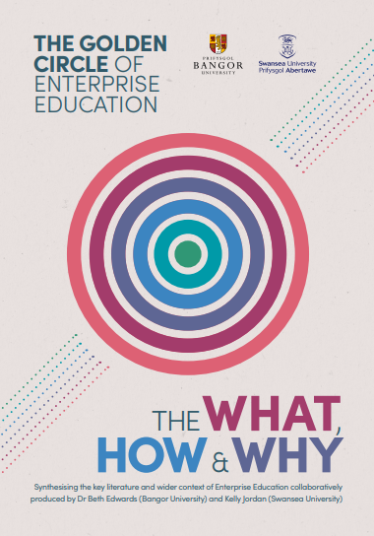

New for 2025, Dr Beth Edwards (Bangor University) and Kelly Jordan (Swansea University) have created a report suitable for teaching, learning and research staff in Higher Education, titled: THE GOLDEN CIRCLE OF ENTERPRISE EDUCATION, THE WHAT, HOW & WHY.

This can be accessed here: <https://research.bangor.ac.uk/en/publications/the-golden-circle-of-enterprise-education-the-what-how-amp-why>

### The Be’ Nesa’ Podcast

The ‘Be Nesa’ podcast, continues to grow from strength to strength with the launch of season 3 and involved entrepreneurs as well as employers. The podcast aims to provide listeners with knowledge of different career opportunities, including freelance work and owning a business. There have also been collaborative episodes with Business Wales.

The podcast can be listened to here: <https://shows.acast.com/be-nesa>