Bangor University Enterprise Development Fund (2022-2023)

- Context
The Bangor University Enterprise Development Fund is available for all staff in the three colleges to access with £5000 per college allocated each academic year. Once launched each year, applications will be reviewed against the specified criteria on a first come first served basis to consider the allocation of the requested funding. Whilst the funding is assigned per college, applications from individual schools are welcomed.

- Purpose
The purpose of this fund is to provide additional opportunities, training or events to enhance enterprise education. This can be for staff development, student skills and experience or another way to contribute to embedding enterprise into the curriculum. Applications will be reviewed against the Employability strategy points below:
- Embed employability and skills development within the curriculum, supported by extra-curricular activities.
- Develop a portfolio of inclusive employability, entrepreneurship, and enterprise opportunities.
- Provide students with opportunities to develop their business acumen, enterprise and entrepreneurial knowledge and skills, similar to those provided through Enterprise by Design
- Improve students’ aspirational thinking, knowledge and confidence regarding the diversity of career options available to them

- Outputs
The two requirements of receiving money from this fund are:
- that invoices will be provided upon receipt, and
- pictures/videos, reflection and other content (this is not an exhaustive list) to showcase the activity are provided for use to promote the fund and demonstrate the impact across the University.

- Application process
For the 2022-2023 academic year, applications will open on Monday 3rd October. To make an application, please complete this form: https://forms.office.com/r/s2FmHcWr6r
The more detail provided will enable your application to be processed more efficiently. Should an application be received which requires more information or specifications, I will get in contact and outline what further information is needed to progress the application.

Bangor University Enterprise Development Fund (2022-2023)

- Allocation and approval
- Applications that have a cost under £100 can be approved by myself upon completion of the online form.
- Applications with costings between £100.01-£500 can be approved by myself and a colleague from B-Enterprising.
- Applications over £500 will be discussed at B-Enterprising team meeting with service lead.

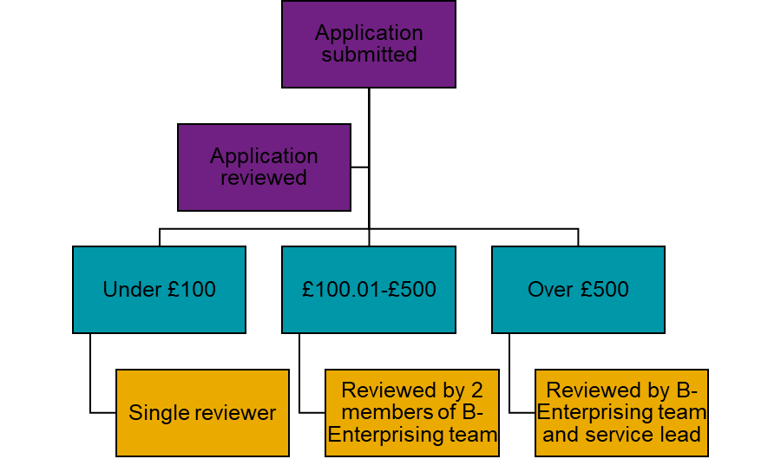

- Further information
If you have any questions, or want to arrange a meeting before submitting an application, please contact:

Dr Beth Edwards,
Enterprise Education Development Coordinator
b.a.edwards@bangor.ac.uk

Appendix
Information collected on the form:
This fund is available for academic staff across the University to apply for to enhance students and / or staff experience, skill development or confidence related to enterprise or entrepreneurship.
Funds will be allocated on a first come first served basis, with £5000 per college being available per academic year (October-July). Full information about the review process can be found here (put a link to full T&Cs document).
When completing this application, please provide as much detail as you can as this will allow for it to be processed quickly. Should we receive an application that requires more information or clarity, we will get in touch with you directly.

If you have any questions please contact Dr Beth Edwards (b.a.edwards@bangor.ac.uk).
Name
Email
Job title
College
Have you got approval from your relevant line manager:
Summary of idea:
Have you got a quote or information about the cost, including estimates: if yes, specify.
Cost code
Which of the below will be involved or impacted by your proposed activity?
- Academic Staff
- Students
- Local community
- A specific course
- A specific year group
- Other organisations
- Other
Would you require any support from B-Enterprising / Employability Service to organise/deliver this activity? If yes, please specify what would be needed and the amount of time.
Is there anything else you want us to know about your request? If yes, please specify.
By completing this form and making this request you confirm:
- You will be able to carry out this activity by the end of the academic year.
- You will provide invoices and relevant proof of purchases.
- You will provide feedback and relevant media to showcase the activity.
- You are happy to be contacted by the B-Enterprising team regarding this request.

