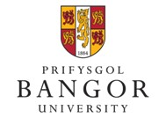

Student-led

Teaching and Learning

StrategY

2017 - 2020

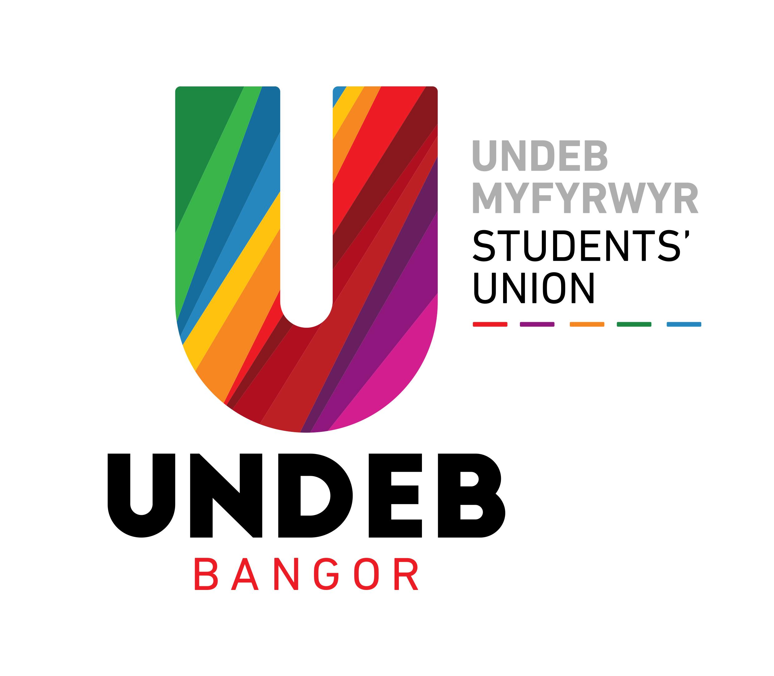

introduction

Our vision is to maintain our reputation as a University, internationally renowned for teaching and research, while fostering the intellectual and personal development of students and staff, providing a supportive multicultural environment, promoting widening access and embedding inclusiveness, and ensuring that its activities result in environmental benefit and social progress within a resilient economy. The evidence for this is contained in successive positive Institutional Review reports from the Quality Assurance Agency (QAA), high scores in external student surveys, and a reputation for sector-leading Welsh medium provision.

We are committed to an inclusive partnership, an approach defined in the Student Experience Strategy, ‘that goes beyond student representation and consultation, to collaboration based on an agenda of mutual respect.’ To build on this relationship, we made a conscious decision to work on this joint Teaching and Learning Strategy. Students are already represented, through the Students’ Union, on all major Task Groups and Committees involved with learning, teaching, student support, widening access and the wider student experience. The University has adopted inclusive policies and practices with regard to student participation and representation.

Our aim is that together we will make an exceptional teaching and learning experience.

Through student consultation and partnership working, we devised a student-staff steering group to oversee the development of this Strategy. We made the decision to focus on a limited number of strategic aims based on our student’s views of what was important to their learning experience. For each theme, we identified staff and students to lead discussions and develop content. Our Strategy, from beginning to end, has been authored in complete partnership, with our Students’ Union and student leaders. These strategic aims are in line with the University’s strategic plan and therefore are areas in which the University had prioritised and was already working to enhance.

STRATEGIC AIMS

- Developing a curriculum for the future

The University has a strong tradition of research-informed, student-focused teaching and learning. Innovative methods of delivery, a caring ethos, a strong sense of community, promotion of sustainability, and a wealth of extracurricular activities support this. An important development is our programme approval procedure. This will ensure that our curricula remain relevant to student and employer needs, and will ensure our graduates are well equipped for their future careers, both through developing our undergraduate internship scheme and by embedding graduate attributes into our curriculum.

In order to achieve this we will…

- Empower each School’s Staff Student Liaison committee to take ownership of student input into curriculum design, through processes such as: a new Student Advisors scheme; ensuring students are trained and supported to actively contribute and make informed decisions about curriculum development; and introducing Annual Curriculum Reviews to discuss the School’s course direction.

- Continue to invest in the paid Student Reviewer system, maintaining high levels of training and support for their involvement in revalidation and validation panels.

- Continue to embed diversity and inclusivity in the curriculum, to ensure that all students feel fully able to contribute and engage in their learning. This should include mentoring for staff and Postgraduates who teach, to ensure module content is diverse, relevant and representative of student population.

- Provide opportunities, embedded within the curriculum, for students to develop their skills, experiences and confidence to fulfil their goals, including increasing the number of opportunities for students to gain experience relevant to their careers and ambitions. We will also focus on actively promoting the Welsh language as an employability advantage, developing skills through varied and innovative Welsh medium study opportunities.

- Introduce programme-level evaluation to replace module evaluations, to allow students to give feedback holistically on their programme. Include additional questions on course diversity and inclusivity to ensure that where students have met with unnecessary barriers to learning this is fed into curriculum review and design.

- Broaden staff and employer contributions to curriculum development, ensuring we draw upon a diverse range of opinions and experience.

We will measure our success by…

- Achieving and maintaining a top quartile position for Learning Community NSS questions (Q21-22)
- Achieving and maintaining a top quartile position for Learning Opportunities NSS questions (Q5-Q7)
- Achieving 100% evidenced student and employer contributions to curriculum design from Schools undergoing a revalidation

Note:
The Destination of Leavers from Higher Education (DLHE) survey will run for the last time in respect of students graduating in 2016/17, the outcomes of which will be published in summer 2018. The University's target in respect of this is that the proportion of leavers obtaining undergraduate qualifications through full-time and part-time study who were employed, studying or both six months after leaving will be equal to or exceed the UK Performance Indicator benchmark.

The DLHE survey will be replaced by the Graduate Outcomes survey for students graduating from the 2017/18 academic year onwards. The census point has extended from 6 months after graduation for the current DLHE survey, to 18 months after graduation for the new Graduate Outcomes survey, so the outcomes of the first survey cohort are not expected to be published until early 2020. It is not yet clear what the performance indicator will be for the new survey, but it is likely that the University will set a target in line with our benchmark, as was the case with the DLHE.

- Assessment and Feedback

Diverse forms of assessment and timely informed feedback are at the heart of our learning process. Bangor University is committed to delivering a consistent, high quality, intellectually stimulating teaching and learning experience. In many respects, we are already amongst the best in the sector for delivering assessment and feedback, but we recognise that there are still many ways in which we can improve.

In order to achieve this we will…

- Implement consistently the University’s Assessment Framework, ensuring a diversity of assessment methods promoting rigour and stretch, timely and high quality feedback, and opportunities for students to develop reflective learning skills. Through diversifying assessment methods we will avoid over-reliance on examinations, promote innovative and inclusive assessment practices, and a wider range of feedback opportunities.

- Continue to promote Welsh medium study and provide workshops and support for Welsh language academic skills development. If Welsh medium teaching is not available on a module, we shall nonetheless actively encourage Welsh speaking students to submit assignments through the medium of Welsh, regardless of the language through which they are taught.

- Develop a best practice framework for our Virtual Learning Environment (Blackboard) to promote innovation and ensure parity across Schools.

- Embed opportunities for graduate skills development through assessment practices (eg presentations) into all levels of the curriculum.

- Encourage and support staff to integrate digital technologies (eg Panopto, blogs etc) and blended learning into teaching and assessment practices.

We will measure our success by…

- Maintaining a top quartile position for Assessment and Feedback NSS questions. (Q8-Q11)
- Achieving a top quartile position for Learning Resources NSS questions. (Q18-Q20)
- Exceeding the national average in subject areas for proportion of good degrees.
- Increasing the use of digital technologies, such as Panopto and Blackboard, across all School.
- Maintaining our position as the sector’s lead provider of Welsh medium education (FTE Welsh-medium students and credits offered) and continue to develop students’ Welsh language skills through training and support.

- Student Engagement and Effective Representation

Bangor University has been sector leading in many aspects of our student engagement in recent years. Our strongest Institutional performance in the National Student Survey comes from the Student Voice questions, where we ranked second in the UK and first in Wales for ‘Staff value students’ views and opinions about the course’. However, we recognise that there are still more opportunities for improvement and we would like to capitalise on these over the next cycle. We will continue to embed this culture of partnership working in all academic Schools, via the ‘Together We’ campaign, Directors of Student Engagement and Course Representatives as vehicles for student-led change.

In order to achieve this we will…

- Introduce a University-wide learning analytics solution to effectively monitor student engagement at a course level, creating a positive and effective intervention framework, and identifying trends and predictors to target support.

- Widen student involvement in the interview processes for appointing student administrators, directors of student engagement, and permanent full time academic staff to further embed partnership working.

- Introduce regular Course Representative ‘partnership working’ sessions with School Directors of Student Engagement prior to each Staff Student Liaison Committee to increase support for course representatives and encourage diversity within meetings.

- Develop a framework for consultation on proposed module changes and other enhancements at a University level, furthering our partnership work with students and to ensure compliance with the Competition and Markets Authority guidance on consumer law.

- Embed School-level ownership of the Together We campaign by creating a toolkit for use at Staff / Student Liaison Committees.

- Develop College-level Student Charters for joint honours students, including a focus on: improving communicating between Schools; reducing clashing deadlines and events; and a more holistic approach to induction.
- Update the Code of Practice for Course Representation to bring parity of experience to all Course Representatives. This will involve hosting training for Directors of Student Engagement to ensure familiarity with new Code of Practice.

- Ensure all additional course costs are clearly communicated to applicants and regularly updated in line with changes at modular level.

We will measure our success by…

- Continuing to achieve a University NSS overall satisfaction score of 90% or above.
- Remaining in UK top quartile for NSS questions relating to the student voice (Q23-26).
- Achieving 90% attendance from course representatives and staff at all school Staff Student Liaison Committees.
- Maintaining 100+ nominations in Undeb Bangor’s Course Rep awards.
- Improving response rates to all student surveys, including module evaluation, NSS, PTES and PRES.
- Maintaining strong student engagement, as measured by learner analytics, across all academic schools (target to follow once system has been established)
- Maintaining NSS satisfaction amongst joint honours

- Student Outcomes and Retention

Bangor University’s aim is to improve student outcomes, including progression, retention, completion, and degree classifications by developing University wide initiatives to support students, academically and pastorally.
CELT have developed the three R’s of retention (redirection, resubmission and reengagement) in order to maximise retention and completion. Small scale projects will take place in Schools with poor completion rates to discuss and implement ways in which more students can be retained and to open up ways in which they can be redirected to a suitable course in the event of failure in their current course.

In order to achieve this we will:

- Develop a holistic framework to promote and support student retention, including: the introduction of a supportive summer re-assessment period, and a system of learner analytics for early intervention and support.

- Revise the year one transition (from confirmation and clearing, through to end of year one) to ensure students are better inducted into a higher education learning environment. Particular attention should be given to developing students’ skills as independent learners and providing an experience tailored to students’ individual needs.

- Develop inclusive institutional approaches to ensure we continue to meet the needs of all our students, including widening participation students, mature students, disabled students, and other groups known to be at a higher risk of non-progression.

- Provide support for students who are struggling with transition between years of study or attainment, alongside challenge and stretch for those who seek it.

We will measure our success by…

- Maintaining completion rates above 80%.
- Retaining 40-50% of students through our interruption to studies service.
- Exceeding the national average in subject areas for proportion of good degrees.
- Ensuring all Schools retain at least 90% of their year one cohort.

Note: Our Learner Analytics target will be added once the project has been established.

Bangor University has a long track record of partnership working with our students and Students’ Union, Undeb Bangor. This document is an innovative example of our partnership work, and is unique in the UK. We realise that our goals are complex and aspirational, but we are confident that we can work together to achieve them.

Signed by:

_______________________ ___________________________

Ruth Plant Pro Vice Chancellor, Teaching & Learning
President, Undeb Bangor Bangor University

Appendix 1: Aims of the Teaching and learning Strategy
The aims of the Strategy are informed by the University’s Strategic Plan, and also by current developments and priorities in the UK HE sector. The strategy includes those priorities emerging from the Higher Education Academy’s engagement with Welsh HEIs. The Strategy is also informed by externally defined priorities including the Well-being of Future Generations (Wales) Act, the Teaching Excellence Framework and principles of sustainable development.

The overarching aims of the Teaching and Learning Strategy are to:

- Create an integrated plan to enhance teaching and learning at the University.
- Identify and disseminate effective practice across Colleges and Schools.
- Ensure that teaching and learning is informed by effective practice in the UK and elsewhere.

The Teaching and Learning Strategy achieves its aims by establishing Enhancement Projects, each with its own clearly defined targets. The University uses the widely agreed definition of quality enhancement from the QAA: “the process of taking deliberate steps at Institutional level to improve the quality of learning opportunities”. This definition has also been adopted by HEFCW (Circular W10/02HE 2010). Such ‘deliberate steps’ are a continuous process to be embedded within the University’s systems and structures. Enhancement Projects are major interventions in current provision and practices across the University with an impact on the majority of students.

The University’s aim is to have a small number of Enhancement Projects at any one time. Each Enhancement Project targets selected aims from the University’s Strategic Plan. It is not the intention to have Enhancement Projects for all of the aims and actions; this would lead to a proliferation of Projects. Enhancement Projects are an adjunct to established processes to achieve strategic aims; they are not to be viewed as the only way to achieve strategic aims. Links between the Enhancement Projects and the University’s Strategic Plan are in Appendix 1.

Appendix 2: Management and Oversight
The Teaching and Learning Strategy is the responsibility of the Pro Vice-Chancellor (Teaching and Learning), working closely with the Pro Vice-Chancellor (Students), the Bangor Students’ Union, the Pro Vice-Chancellor (Welsh Medium & Civic Engagement), the Pro Vice-Chancellor (Research) and the Chair of the Quality Assurance and Validation Task Group. The Pro Vice-Chancellor (Teaching and Learning) is supported by the Planning and Resources Office, the Centre for the Enhancement of Teaching and Learning (CELT), the Academic Registry, Information Services, and the Library Service, and academic Colleges and Schools.

Responsibility for monitoring the strategy rests with the Teaching and Learning Task Group, which is chaired by the Pro Vice-Chancellor (Teaching and Learning) and Pro Vice Chancellor (Students). The Teaching and Learning Task Group can devolve responsibility for implementation of particular aspects of the Strategy to other Task Groups. The Teaching and Learning Task Group reports to the University Senate.

Allocation of resources for teaching and learning is managed by the Pro Vice-Chancellor (Teaching and Learning) in discussion with the Planning Office. The Planning Office, through its regular engagement with Colleges, Schools and Central Support Services, ensures that resources are managed and allocated in accordance with the University’s strategic aims.

